O-45A MARBLE IN SHOT GLASS

Question Card:
Look into glass that has no water in it. Next pour water into the glass. What do you observe?

Materials:
shot glass
marble, clear (diameter - 1 inch)
cup
water

Construction Notes:
a. Glue an 8 to the bottom of the shot glass.
b. Glue the marble to the inside bottom of shot glass with water non-soluble glue. (Glue should dry clear.)

Introductory Statements:
In this investigation we have set up a fixed object lens arrangement where the object (8) is at a distance greater than the focal length from the lens (marble). If this is the case there should be an image. But where is the image?

Is it possible to change the focal length of the lens (marble)? If one does, then the location of the image will change. In this investigation you will change the focal length of the lens (marble). So investigate and have fun.

Procedure:
a. Look into the shot glass at the marble. What do you see?
b. While looking into the shot glass, pour in water to cover the marble. What do you see?
c. Pour out water from shot glass.
d. Look into the shot glass. What do you see?
e. Continue looking into shot glass as you bring the shot glass close to your eye. See anything now?

Results:
The marble acts like a converging lens with a very short focal length. Thus the image is very close to the marble and not seen unless ones eye is very close. This is with air around the marble. When one pours in water, the marble bends the rays less increasing the focal length and also the distance the image is from the marble. In this situation the 8 is now in view.

The equation that explains what happens is: n1 sin Ø1 = n2 sin Ø2.

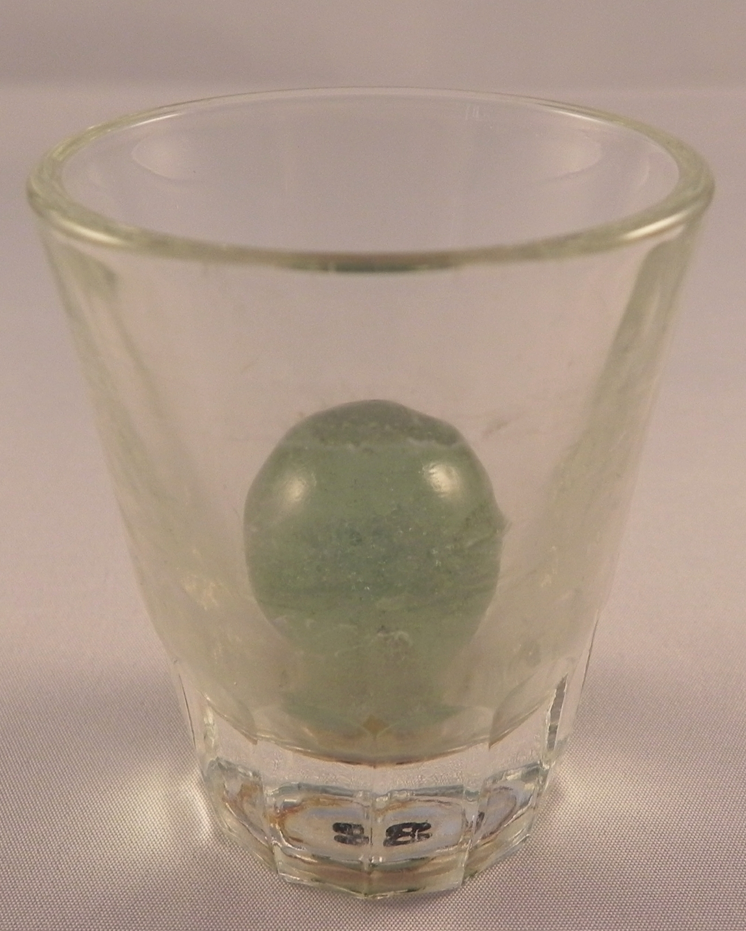
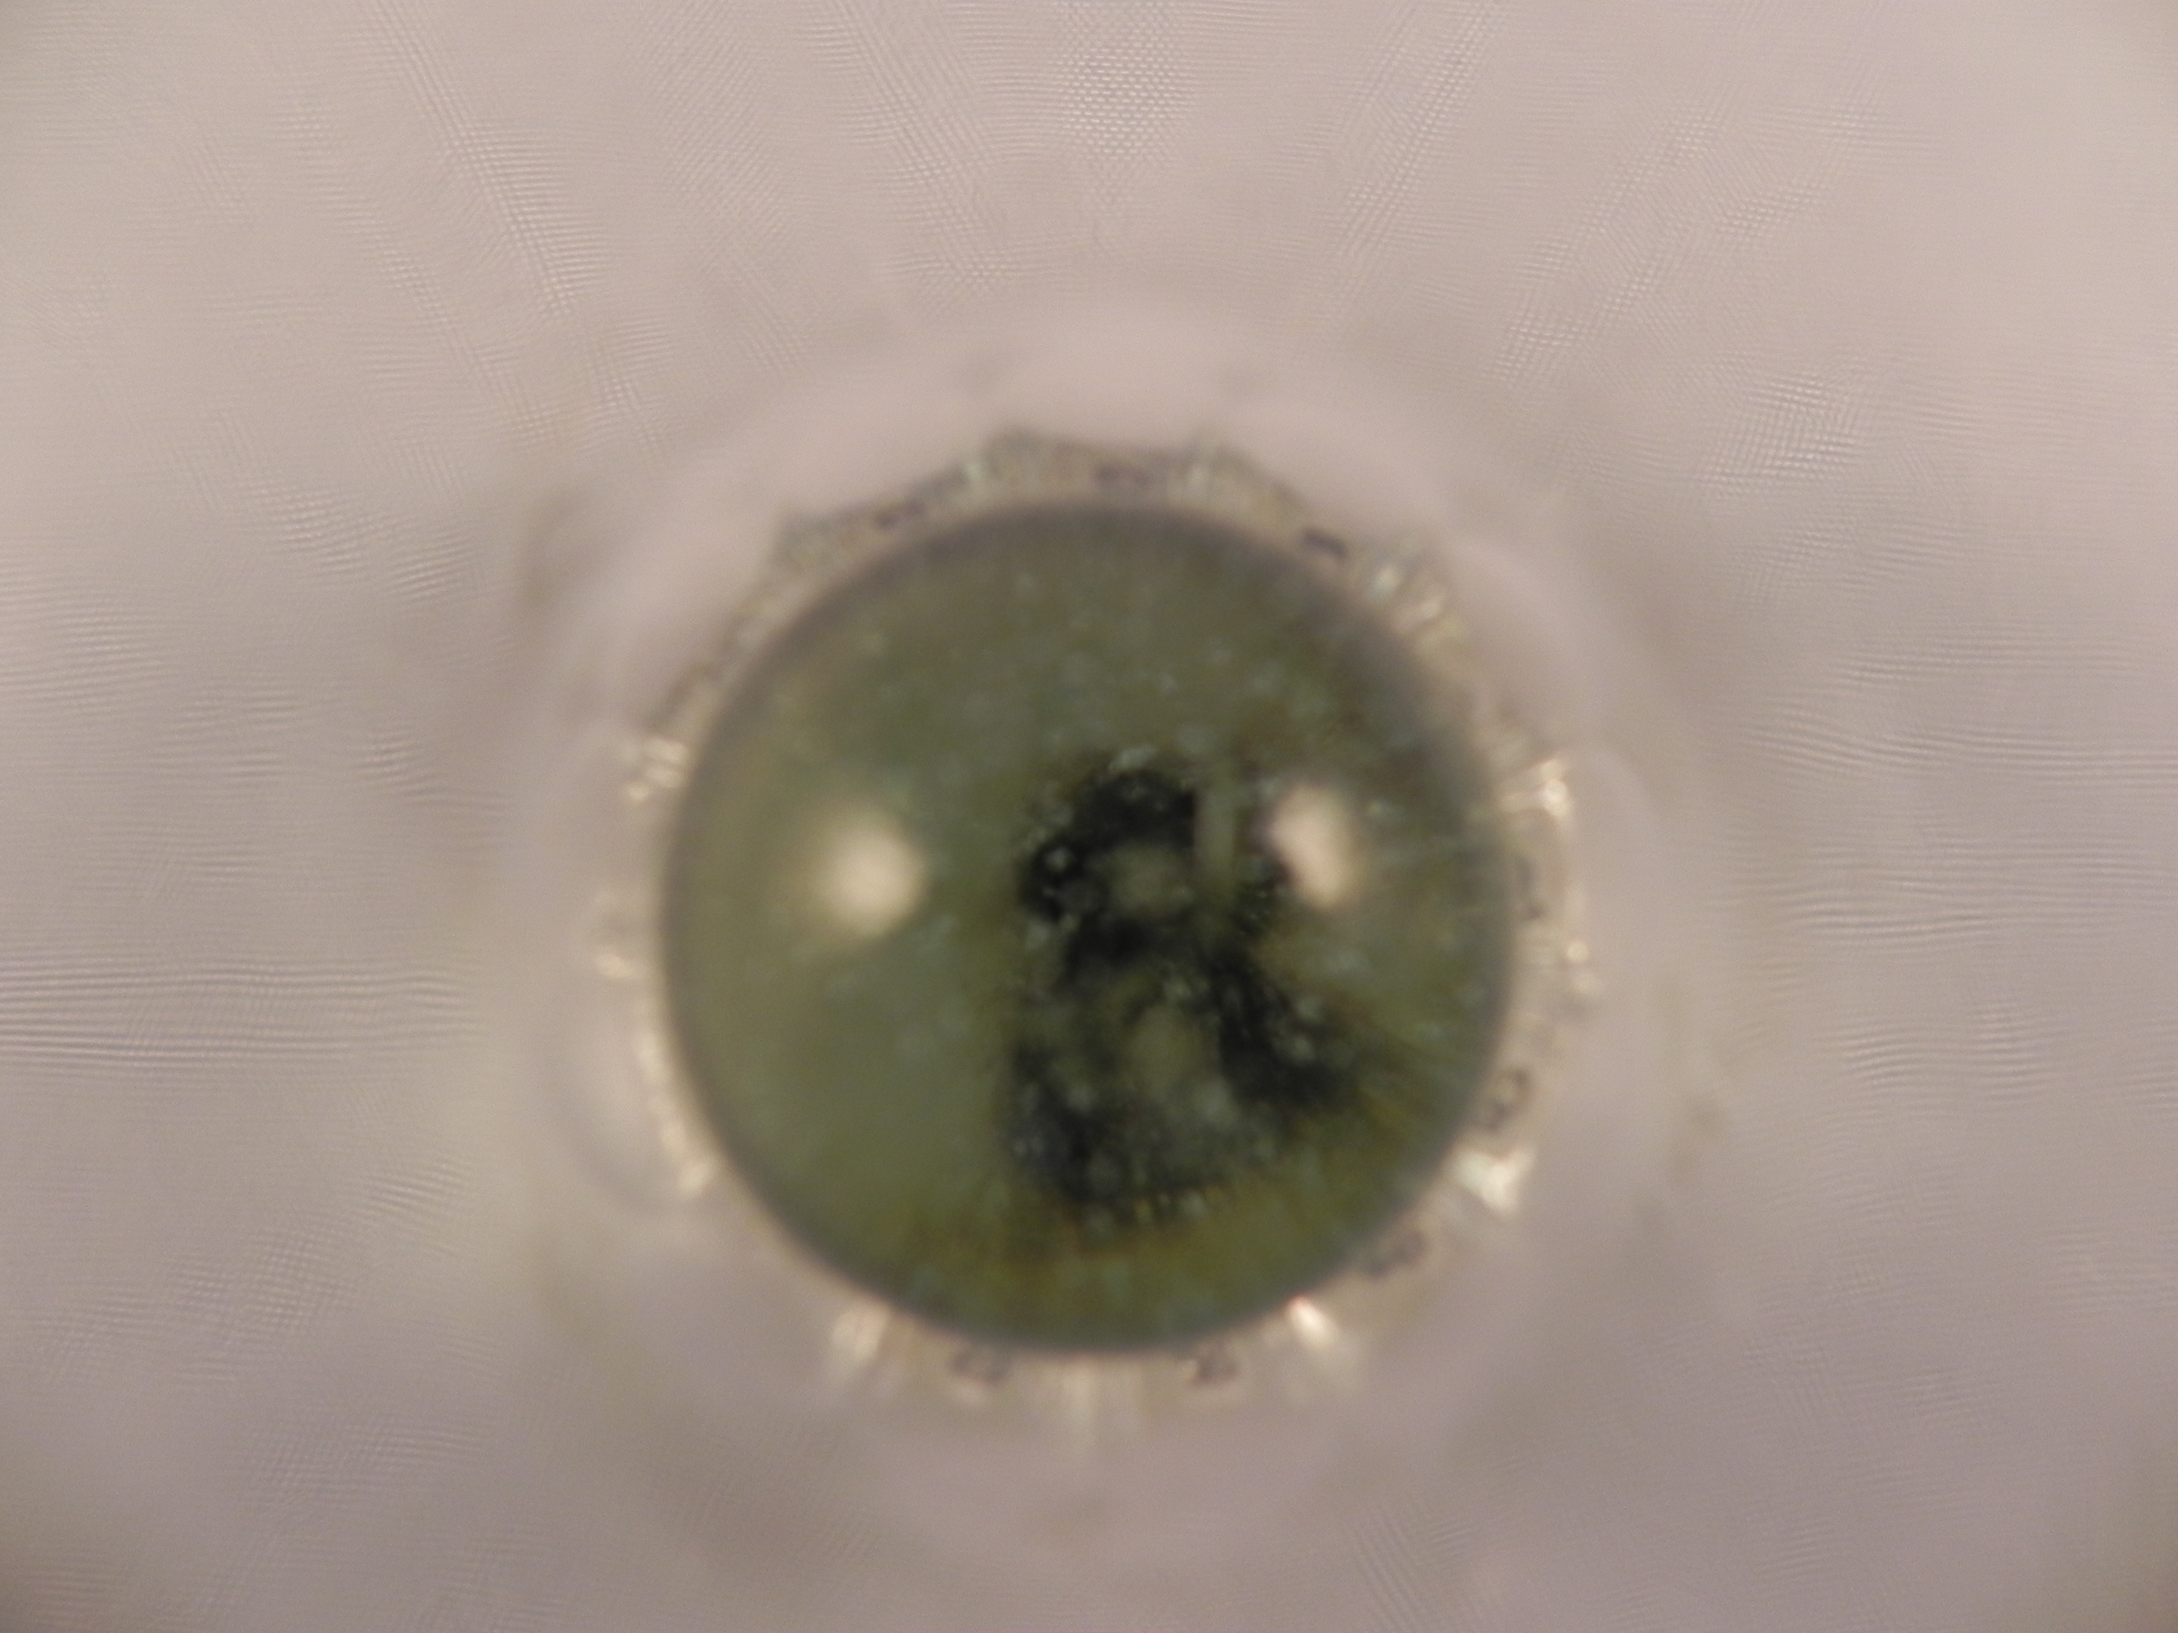
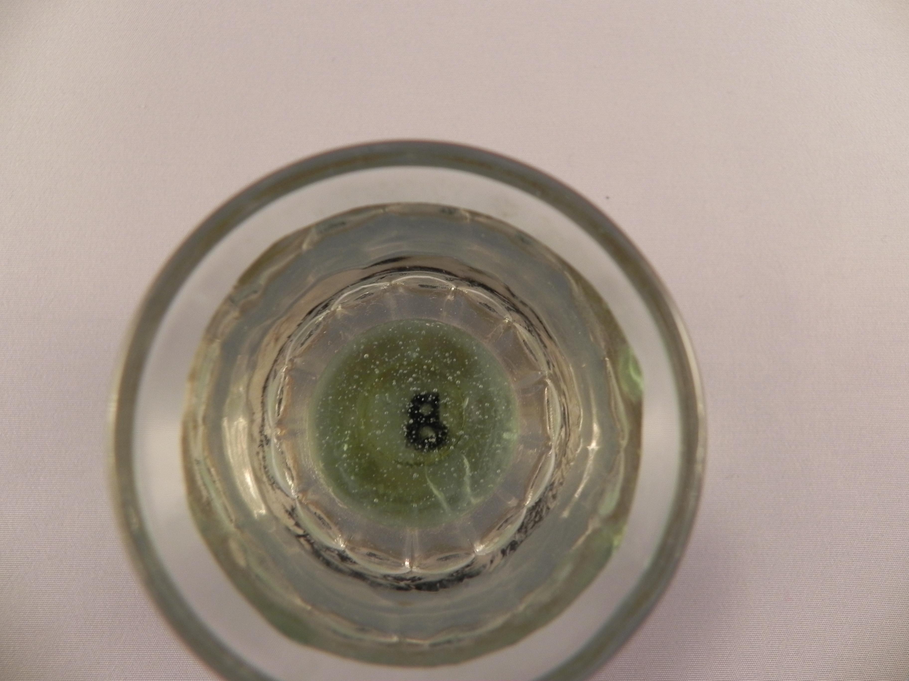
With air around the marble, n2 = 1.00. With water n2 = 1.33.

Marble in shot glass Looking close up into marble Water Around Marble in shot glass

