O-34B CABLE CAR
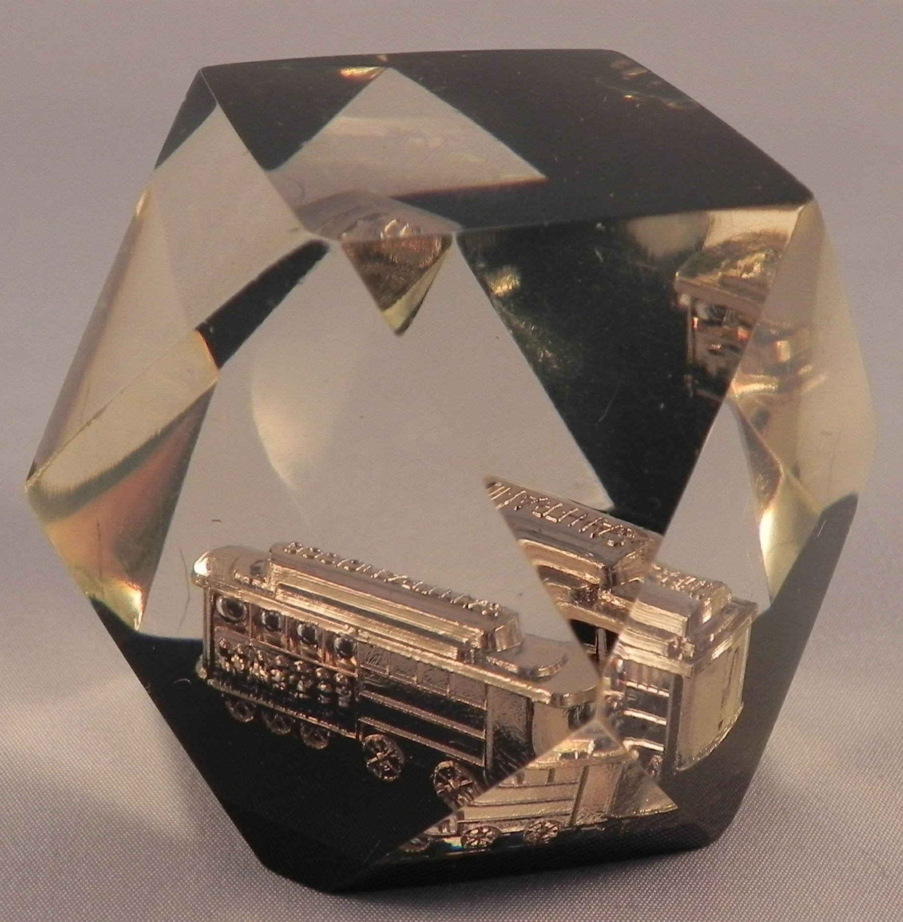
Question Card:

Look at me from various directions. Why do I change shape?

Materials:

Cable Car in Plastic (Cable car museum - San Francisco)

Introductory Statements:

Much interesting art work is accomplished by encasing objects in plastic.
Here a cable car is enclosed in plastic with numerous non-parallel sided.

Procedure:

a. Look at the cable car in the plastic. Can you explain the various images seen?

Results:

To properly analyze any view, one must take into account the plane of the plastic through which the light travels to ones eye. Knowing the orientation of the plane and the path of light, the direction of bending (refraction) can be determined. From this an explanation should be more easily forthcoming.



