Electrostatics Concept-Development 32-2

1. The outer electrons in metals are not tightly bound to the atomic nuclei. They are free to roam in the material. Such materials are good

(conductors) (insulators)

Electrons in other materials are tightly bound to the atomic nuclei, and are not free to roam in the material. These materials are good

(conductors) (insulators)

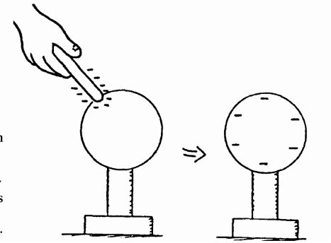
2. A rubber rod that has been rubbed with fur is negatively charged because rubber holds electrons better than fur does. When the rod touches a metal sphere, some of the charge from the rod spreads onto the metal sphere because like charges repel one another. When the rod is removed the charge spreads evenly over the metal sphere and remains there because the insulating stand prevents its flow to the ground. The negatively charged rod has given the sphere a negative charge. This is charging by contact, and is shown to the right.

Label the right-hand sphere below with the appropriate charges below for a positively-charged rod touching a metal sphere.

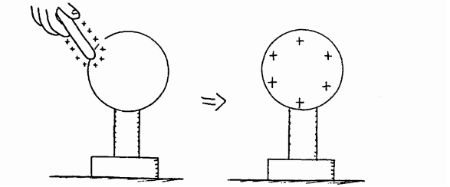
3. In the examples to the right, electric charge is

(created from nothing)
(simply transferred from one body to another)

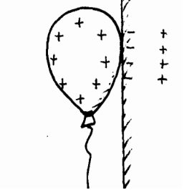
4. A positively - charged balloon will stick to a wooden wall. It does this by polarizing molecules in the wooden wall to create an oppositely- charged surface. Draw the appropriate charges on both the balloon and in the wall. Your completed diagram should be similar to Figure 32.13 in your textbook.

5. Consider the diagrams below. (a) A pair of insulated metal spheres, A and B, touch each other, so in effect they form a single uncharged conductor. (b) A positively charged rod is brought near A, but not touching, and electrons in the metal sphere are attracted toward the rod. Charges in the spheres have redistributed, and the negative charge is labeled. Draw the appropriate + signs that are repelled to the far side of B. (c) Draw the signs of charge in (c), when the spheres are separated while the rod is still present, and in (d) after the rod has been removed. Your completed work should be similar to Figure 32.8 in the textbook. The spheres have been charged by induction.
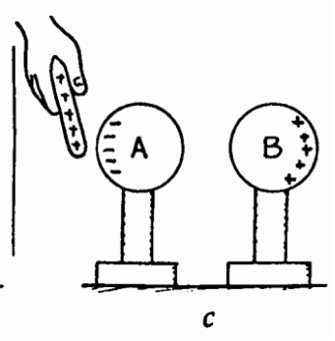
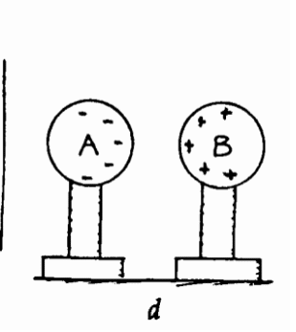
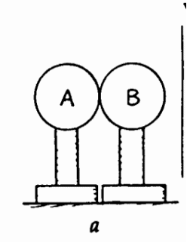
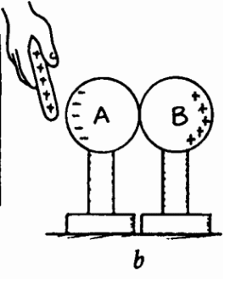
6. Consider below a single metal insulated sphere, (a) initially uncharged. When a negatively charged rod is nearby, (b), charges in the metal are separated. Electrons are repelled to the far side. When the sphere is touched with your finger, (c), electrons flow out to the sphere to the earth through the hand. The sphere is "grounded." Note the positive charge left (d) while the rod is still present and your finger removed, and (e) when the rod is removed. This is an example of charge induction by grounding. In this procedure the negative rod "gives" a positive charge to the sphere.

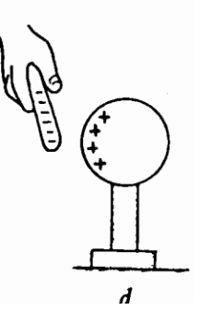
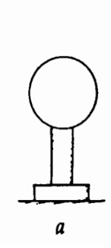
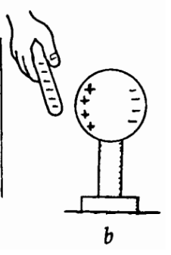
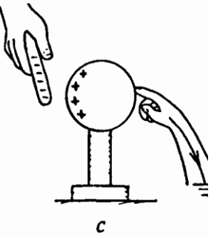
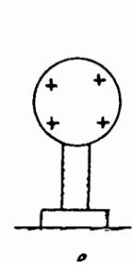

The diagrams below show a similar procedure with a positive rod. Draw the correct charges in the diagrams.


