MATTER AND ITS CHANGES 2A5

WHAT CHANGES OCCUR WHEN WATER FREEZES?

Materials: a small jar with a screw-on lid
a paper or plastic bag large enough to hold the jar

1. Fill a jar with water to the very top and screw the lid on very tightly. (Or cut top off a pop can.)

2. Place the jar of water inside the paper or plastic bag. (If use pop can without top, not need to put in bag.)

3. Place the jar and the bag in a freezer.

4. The next day, remove the jar.

5. What changes do you OBSERVE?
_______________________________________________________________________________________
_______________________________________________________________________________________

6. How does the volume of ice COMPARE to the volume of the liquid water originally in the jar?
_______________________________________________________________________________________
_______________________________________________________________________________________

7. Was energy involved in the change?
_______________________________________________________________________________________
_______________________________________________________________________________________

How?
_______________________________________________________________________________________
_______________________________________________________________________________________
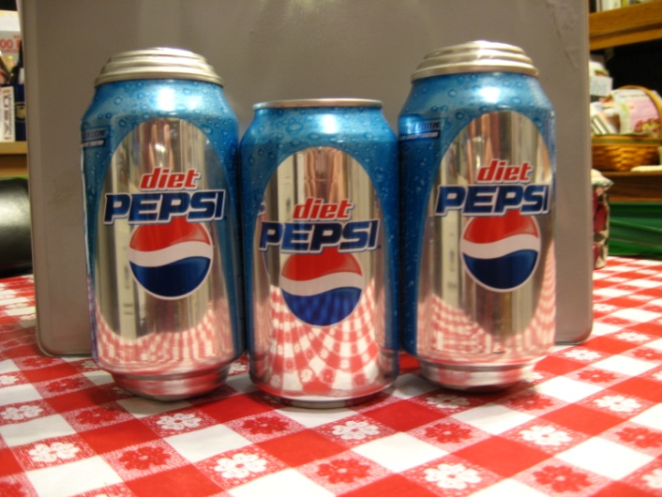
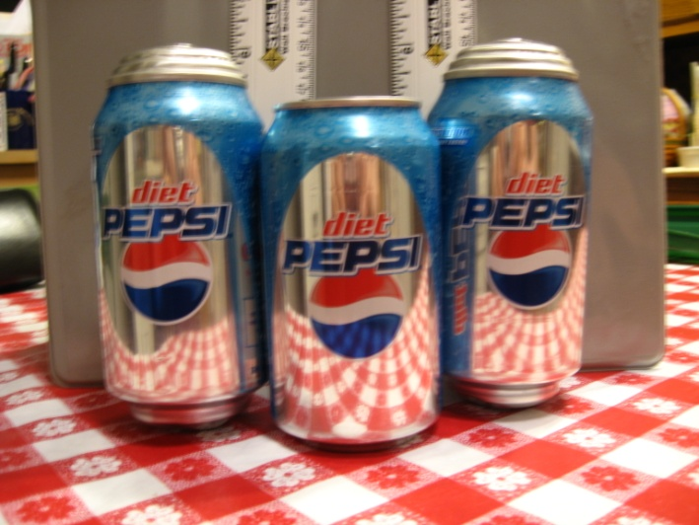
MATTER AND ITS CHANGES 2A5TN

WHAT CHANGES OCCUR WHEN WATER FREEZES?

IDEA: PROCESS SKILLS:
The phase change from liquid to solid Observe
involves release of energy to the Compare
surroundings. Explain

LEVEL: L/U DURATION: 60 Min.

ADVANCE PREPARATION: Collect jars and bags.

RESPONSES TO
SOME QUESTIONS: 5. The ice fills the jar and is outside the jar, around the lid, as well.

6. The ice volume is greater than the original liquid volume, but the volume difference is not a large percent of the original volume.

7. Energy was involved in the change. The liquid water lost energy in forming the solid. The molecules slowed down and eventually “locked into place.” The energy of movement they once had was lost to the surroundings as heat (EXOTHERMIC).

POINTS TO EMPHASIZE IN
THE SUMMARY DISCUSSION: Water is unusual in that it expands when it freezes. Almost all other substances contract.

