O-33A REAPPEARING COIN

Question Card:

Place coin in empty dish. Place your head so that you just cannot see the coin. Pour in water. Explain

Materials:

Small dish
coin
cup
water

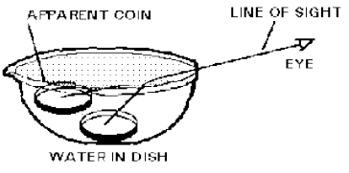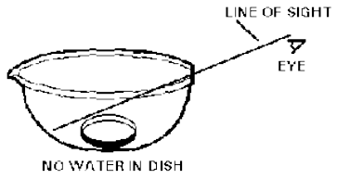Introductory Statements:

Viewing objects that are in water are done by all of us. Yet do we take into account that the light by which we see the object is influenced by the water-air boundary. Specifically there is refraction (bending) of light. Thus what we see is not the same size or at the same location that we think it is. This investigation will show you this.

Procedure:

a. Place the coin in the dish.
b. While looking at the coin in the dish, move the dish and/or your head so that the coin just goes out of view.
c. While continuing to look at the dish with coin (just out of view), pour water into the dish. What happens? Does the coin come into view? If so, where does the coin appear to be?

Results:

The coin should have come into view. This investigation offers clear evidence that viewing an object through water alters the location of the object as the only change was the addition of water to make the coin come into view. Looking at the rays of light drawn without and with water shows the refraction. Your eye when viewing the coin through the water has no idea that the light was bent (refracted) and thus interprets that the coin as straight ahead. If you ever go spear fishing, keep these phenomena in mind. Cause the fish isn't where you think it is.
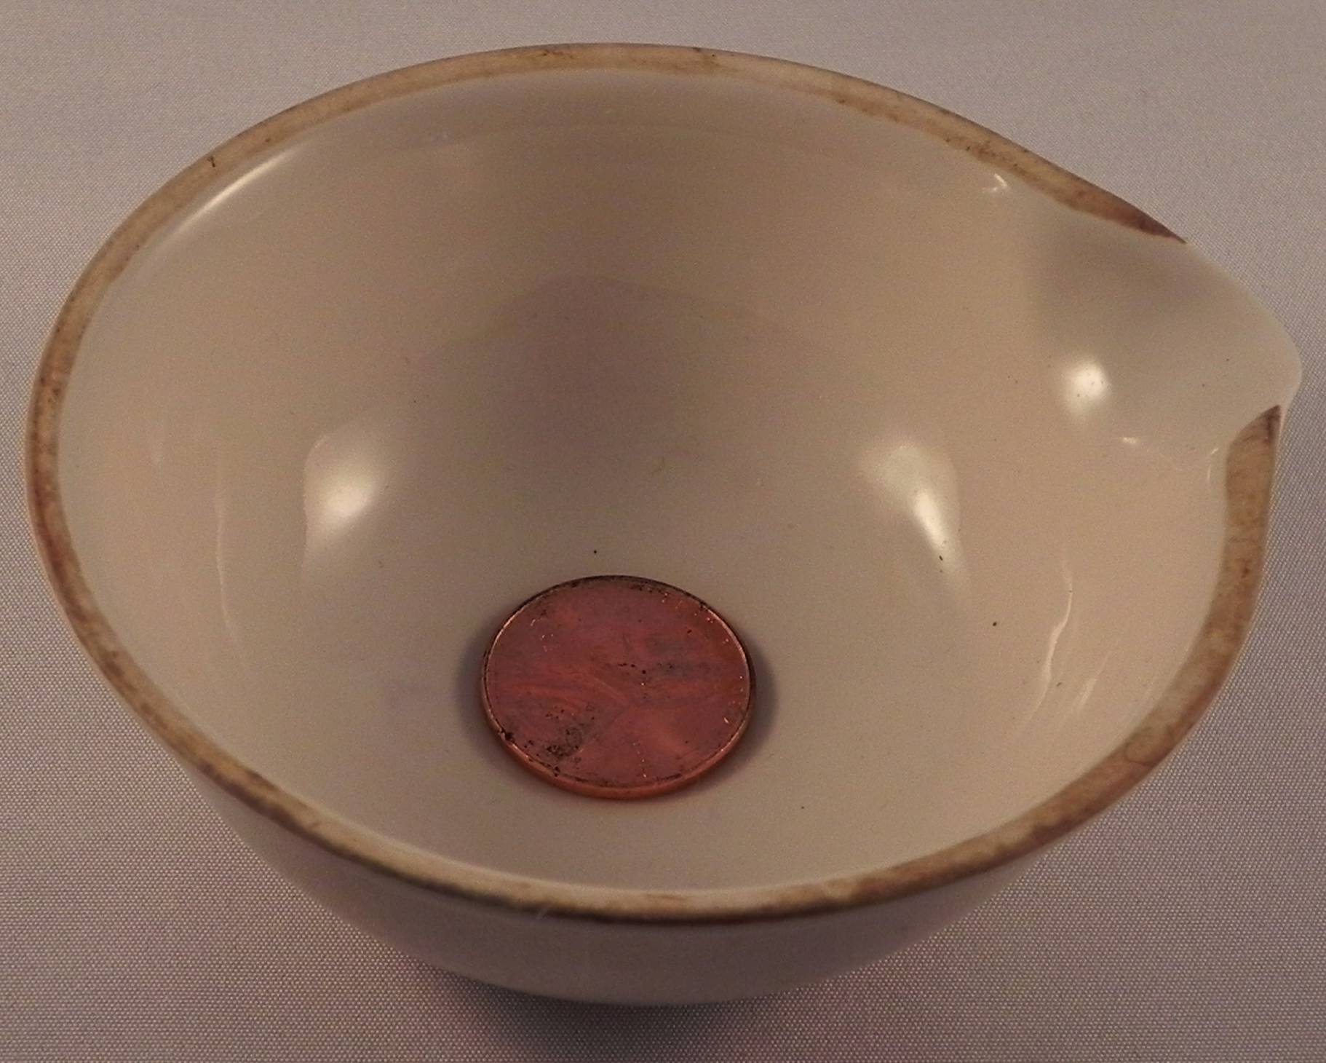
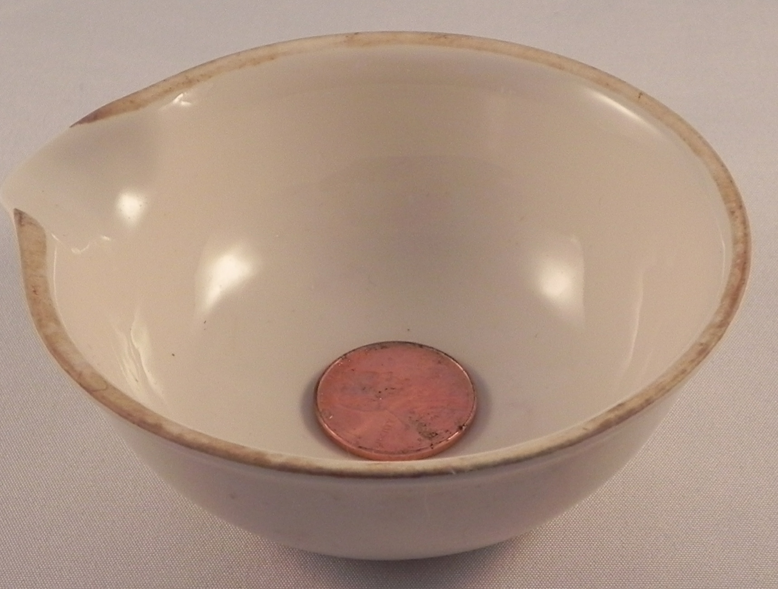

Penny seen through air Penny seen through water

