O-10 IMAGE LOCATION

Question Card:

Move the near candle towards and away from the plexiglas. What happens to the image seen in the plexiglas?
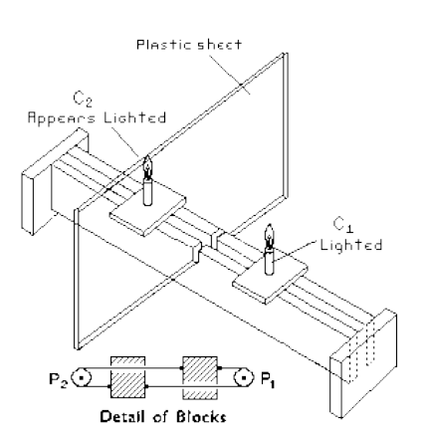
Materials:

Special frame (24 inches long)
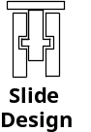
Plexiglas (11 x 17 inches) x 1/8 inches thick
Candles, votive (2)
Matches

Construction
The two slides are constructed and mounted in such a manner that when one is moved towards or away from the plexiglas, the other moves such that both are the same distance from the plexiglas. The slides are constructed so that they will slide in the side rails. Holes are drilled in each, screw eyes mounted and strings attached as shown. The two pulleys are mounded at each end of the apparatus.

Introductory Statements:
This is an interesting demonstration to perform once you have covered the topic of image location as seen in a plane mirror. It makes an excellent review exercise for your students.

Procedure:
a. Set up the apparatus before class on a table in the front and center of the room. Ideally the students should enter from the back.
b. Just before the students enter the room, light the front candle and turn off the lights in the room. (The room needs to be nearly darkened. If you can completely darken the room place a light or two near the back so the students can safely enter the room and be seated.)
c. Once the students are seated, draw attention to the fact that you can place your finger in the candle flame without being burnt.
d. Place your finger just above the un-lit candle behind the plexiglas. The students should see your finger in the flame.
e. Remove your finger from the flame and move the front candle to another position.
f Place your finger above the back candle. Once again the students will see your finger in the flame.
g. Turn on the lights and show the setup to your students. (A large mirror held above the apparatus at a 45o will allow the students to see from above.)

Results:
There should be no doubt in your students' minds that your finger was placed in the flame. Yet it was the image of the flame that the finger was in. Measurements will show that the image is as far behind the mirror as the object is in front.



