Behavior of Light

For Students of Baldwin Wallace College

Spring Semester 2008

Monday – Wednesday
10:00 – 11:15 am
Room 6
Wilker Hall

Faculty

Richard Heckathorn

This manual was the result of scanning, formatting and editing by
Richard D. Heckathorn

14665 Pawnee Trail
Middleburg Hts, OH 44130-6635

440-826-0834

from

OPERATION PHYSICS, a program to improve physics teaching' and learning, in upper elementary and middle schools, Is funded by the National Science Foundation, Grant #TEI-8751216.
Behavior of Light Introduction

This book will introduce students to many of the major principles governing the behavior of light, and to several applications based on these principles. Although there will be some discussion of the wave nature of light, the focus of this book is on investigation of optical phenomena that can be described and accounted for in terms of a light ray model (based on the rectilinear propagation of light). These phenomena include shadows and pinhole images, reflection, refraction, and the formation of images in mirrors and lenses.

The pedagogical strategy used in helping students to develop an understanding of these optical phenomena includes several stages of activities. Students first observe, describe, and discuss examples of the optical phenomena. Then, they observe and describe how beams of light behave in various controlled situations. Finally, they read and discuss "Focus on Physics" sections to learn how to draw light ray diagrams for the optical phenomena they have observed.

The book is divided into the following five sections:

1. Propagation of Light
2. Reflection and Mirrors
3. Refraction
4. Lenses
5. Wave Properties of Light

The Workshop Leader's Planning Guide for each of the five sections gives detailed information about the essential ideas and activities covered in the section. Section I is a prerequisite for all the other sections. Section III is a prerequisite for Section IV. Section V is independent of the other four sections, but is included because there are examples of optical phenomena (e.g., interference and polarization) that can only be explained in terms of a wave mode. The section on waves in the OPERATION PHYSICS Sound book would be an excellent complement to Section V in this book.

Throughout this book we will use the word "students" to refer both to the 4th through 9th grade teachers using these materials in an OPERATION PHYSICS workshop, and to their own pupils. We assume that both groups will come into the learning situation with very little prior formal education in the physics of light. However, it should be noted that the material in this book was designed for adult learners.

Despite having little prior formal education in the physics of light, students will come into the new learning situation with some preconceptions or "naive" ideas about the phenomena to be studied. The use of the term "naive" is not meant to be pejorative. The naive ideas are often based on the students' interpretations of their own prior experiences. Because these ideas often evolve in an uncritical and unstructured environment, however, they usually differ from the scientifically-accepted ideas.

There are a number of reasons why it is important that you be aware of the students' naive ideas and incorporate them into the learning activities. Research studies have pointed out the persistence of some naive ideas; students often retain them even after extensive classroom instruction. Certainly one of the reasons why naive ideas may be so persistent is that they are rooted in the students' own personal experience. Students feel comfortable with them and may be reluctant to give them up. As a consequence, you may find that when students are asked to think about some particular real-world phenomena, they may draw on their naive knowledge as well as their formal knowledge to answer. Predictions based on naive knowledge, of course, may be quite different from those based on the formal knowledge. However, students don't always recognize or become concerned with the inconsistency.

Current views of learning suggest that a student needs to construct his or her own understanding of new ideas. To construct a good understanding of new ideas, the student needs to connect these new ideas to his or her prior knowledge.

As implied above, to convince students to change their naive ideas may present quite an instructional challenge. Teaching strategies that are aimed at facilitating conceptual change are based on the premise that conceptual change can be a long and slow process. One of the first steps in this process is to help students become aware of their own existing naive ideas as well as those of others. Students should feel that they can express and openly discuss their initial ideas without the ideas being "put down" or ridiculed. The students then need to be exposed to discrepant events, or other forms of evidence aimed at encouraging them to recognize that their own naive ideas may not be fruitful. The formal scientific ideas can then be introduced (either by the instructor or by a suggestion from the students) as a way to make sense of some laboratory or
Behavior of Light Introduction

demonstration activity that cannot be explained in terms of the students' naive ideas. (The first and last chapters of the book, Children's Ideas In Science, cited in the Reference section provides an excellent discussion of the rationale for taking students' naive ideas into account in teaching, and for appropriate strategies for doing so.)

The instructional strategy following in this book, and in many of the other OPERATION PHYSICS books, involves the following steps:
1. elicit students' naive ideas,
2. provide appropriate observational experiences (including discrepant events);
3. engage students in discussions and provide appropriate reading material.

'Me students' naive ideas are elicited during the initial parts of demonstration/discussions or laboratory activities. In either case, opportunities are provided for the students to write down their ideas and then to share them with either their lab partners or with the entire class. When the instructor elicits the students' ideas, no judgment is made regarding their scientific accuracy. Ibis strategy of eliciting ideas is important because it makes students aware of their own ideas and also shows them that there are alternate views.

Many of the observations the students make during the demonstrations and laboratory activities become direct tests of their predictions, which had been based on their naive ideas. These observations should lead students to recognize a discrepancy in their own naive ideas, which should lay the groundwork for acceptance of new ideas. The activities and demonstrations then provide the appropriate experiences to help students develop an understanding of the main scientific ideas and become convinced of their utility (as compared with their previously held naive ideas).

In the summary discussion that follows each activity, the instructor should refer to the students' naive ideas and also suggest the formal scientific idea as a new way of thinking about the phenomena observed. The "Focus on Physics" sections provide the essential reading material that discusses the formal ideas and connects these new ideas to the students' prior observations. Students should be encouraged to read and think about this material carefully at home.

Fortunately, students' naive ideas are not entirely idiosyncratic. Research has documented that many students share the same ideas. Therefore, we have been able to develop a list of the common naive ideas that are associated with the material covered in this book. It is important to realize that students of all ages share many of these same naive ideas. In other words, most of the items in this list are applicable to teachers of grades four through eight as well as the students in those grades. (What does change with age and worldly experience, however, is the jargon through which these ideas are expressed. Younger children may have little to say about some of the ideas because they have not had the appropriate experiences.)

Following is a list of the major naive ideas that students can be expected to bring to the OPERATION PHYSICS workshops. The ideas are listed in the order in which they appear in the book. For each naive idea, the specific activity in which that idea is elicited or addressed is identified.

Behavior of Light Introduction

NAIVE IDEAS

1. Light does not go between its source and its resulting effects. Light does not exist independently in space. (1A1)

2. When light shines on an opaque material and illuminates it, light does not travel from the opaque material to the eye. (1B1D)

3. Lines drawn outward from a light bulb in a sketch represent the "glow" surrounding the bulb. (1B1, 1B2)

4. A shadow is something that exists on its own. Light pushes the shadow away from the object to the wall or ground and is thought of as a "dark" reflection of the object. (1C1, 1C5D)

5. Light is not necessarily conserved. It may disappear or be intensified. (1D1)

6. Light from a bulb only extends outward a certain distance, and then stops. How far it extends depends on the brightness of the bulb. (1D1)

7. The effects of light are instantaneous. Light does not travel with a finite speed. (1A2F, 1B1)

8. A mirror reverses everything. (2A1, 2A2D)

9. For an observer to see the mirror image of an object, either the object must be directly in front of the mirror or, if not directly in front, the object must be along the observer's line-of-sight to the mirror. The position of the observer is not important in determining whether the mirror image can be seen. (2B1D, 2D1F)

10. An observer can see more of his or her mirror image by moving further back from the mirror. (2B2)

11. The mirror image of an object is located on the surface of the mirror. The image is often thought of as a picture on a flat surface. (3B3, 2D1F)

12. The way a mirror works is the following. The image first goes from the object to the mirror surface. Then the observer either sees the image on the mirror surface or the image reflects off the mirror and goes into the observers' eye. (2C1)

13. Light reflects from a shiny surface in an arbitrary manner. (2C1, 2D1F)

14. Light is reflected from smooth mirror surfaces but not from non-shiny surfaces. (2C2, 2C3F, 2C4, 2C5F)

15. Curved mirrors make everything distorted. (2E1)

16. When light shines on a translucent material and illuminates it, light does not travel from the translucent material to the eye. (3A1D)
Behavior of Light Introduction

17. Light always passes straight through a transparent material, without changing direction. (3B1, 3B2F, 3B3)

18. When an object is viewed through a transparent solid or liquid material, the object is seen exactly where it is located. (3C1, 3C2, 3C3, 3C5F, 3D1, 3D2)

19. A lens forms an image of a self-luminous object in the following way. A "potential image" which carries information about the object leaves the self-luminous object and travels through space to the lens. When passing through the lens, the "potential image" is turned upside down and may be changed in size. (4B1D)

20. A diagram showing how a lens forms an image of an object has only those light rays drawn which leave the object in straight, parallel lines. (4B1D, 4C1F)

21. Blocking part of the lens surface blocks the corresponding part of the image. (4B1D)

22. A screen is necessary for an image to be formed. Without a screen, there is no image. (4B4D)

23. An image can be seen on the screen regardless of where the screen is placed relative to a lens. To see a larger image on the screen, the screen should be moved further back. (4B1D, 4B2, 4B3)

24. An image is always formed at the focal point of the lens. (4D1F, 4B2, 4E2F, 4E3)

25. The size of the image depends on the size (diameter) of the lens. (4B2, 4E1)

26. When a wave moves through a medium, particles of the medium move along with the wave. (5A1, 5B1)

27. Gamma rays, X-rays, ultraviolet light, visible light, infrared light, microwaves, and radio waves are all very different entities. (5B2F)

28. When two pulses traveling in opposite directions along a spring or rope meet, they bounce off each other and go back in the opposite direction. (5C1)

29. Colors appearing in soap films are the same colors that appear in a rainbow. (5C3)

30. Polaroid sunglasses are just dark glass or dark plastic. (5D1, 5D2)
BEHAVIOR OF LIGHT 1WL

WORKSHOP LEADER’S PLANNING GUIDE
PROPAGATION OF LIGHT

This section focuses on phenomena related to two ideas: the idea that light travels in a straight line and the idea that “seeing” an object implies that light must have traveled from the object to the eye. Students are also introduced to the practice of drawing light ray diagrams to describe the behavior of light.

Naive Ideas

1. Light does not go between its source and its effects. Light does not exist independently in space. (1A1, 1BID)

2. The effects of light are instantaneous. Light does not travel with a finite speed. (1A2F)

3. When light shines on an opaque material and illuminates it, light does not travel from the opaque material to the eye. (1B1D)

4. Lines drawn outward from alight bulb in a sketch represent the “glow” surrounding the bulb. (1B1D, 1B2)

5. A shadow is something that exists on its own. Light pushes the shadow away from the object to the wall or ground and is thought of as a “dark” reflection of the object. (1C1, 1C5D)

6. Light is not necessarily conserved. It may disappear or be intensified. (ID1)

7. Light from a bulb only extends outward a certain distance, and then stops. How far it extends depends on the brightness of the bulb. (1D1)

A. LIGHT IS A FORM OF ENERGY THAT CAN TRAVEL FROM A SOURCE TO AN OBJECT.

1. Discussion: “Dark Suckers”

Hand out articles and allow participants to read it to themselves. The purpose is to illustrate how naive ideas are validated by personal experiences.

2. Demonstration/Discussion: How Is a Radiometer Affected By Light?

The purpose of this demonstration is to present students with a situation from which they can infer that light is a form of energy that travels from a source to an object. A lamp bulb causes the blades of a radiometer to turn, and several questions are raised. It is not expected that students can develop a “scientific” understanding of how the radiometer works.

3. Discussion - Focus On Physics: The Speed Of Light

In this brief discussion, students reflect on their experience that light must travel very, very fast. The actual speed of light is then mentioned.

B. “SEEING” AN OBJECT REQUIRES LIGHT TO TRAVEL FROM SOME LIGHT SOURCE TO THE OBJECT, AND THEN TRAVEL FROM THE OBJECT TO THE EYE OF THE OBSERVER.

1. Demonstration/Discussion: What Is the Role Of Light In Seeing Objects?

The purpose of this demonstration/discussion is to encourage students to begin thinking that “seeing” an object requires that light must have traveled from the object to their eye. They are also introduced to the use of light ray diagrams to describe the behavior of light.

BEHAVIOR OF LIGHT 1WL

WORKSHOP LEADER’S PLANNING GUIDE
PROPAGATION OF LIGHT - 2

2. Overheads (3):

a) What Do the Lines Represent?
b) Light Spreads Out From Each Point On the Bulb
c) Seeing the Book

C LIGHT TRAVELS IN STRAIGHT LINES, THE EXISTENCE OF WELL DEFINED SHADOWS AND PINHOLE IMAGES PROVIDES EVIDENCE FOR THIS_ BEHAVIOR OF LIGHT.

1. Activity: What Are the Properties Of Shadows?

In this activity, students investigate and try to explain how the size of a shadow might change as an object is moved between a screen and a light source.

2. Activity: How Does a Pinhole Affect Light?

Students form a pinhole image of a light bulb on a screen. They observe that the image is upside down and that its size depends on the distance between the pinhole and the screen.

3. Discussion-Focus On Physics: Representing the Behavior Of Light By Drawing Light Rays

In this discussion, light ray diagrams are introduced as a way of describing the behavior of light. Ray diagrams are then drawn for the case of simple shadows and pinhole images. Use the following overheads to accompany this discussion.

4. Overheads (2):

a) Shadows
b) Pinhole Image

5. Demonstration/Discussion: Predicting And Explaining Multiple Shadow Effects

In this demonstration/discussion, the students are encouraged to predict and explain what happens in a situation where the shadow will include both umbra (darker) and penumbra (lighter) regions. If students have studied color addition of lights, an interesting supplement to this demonstration can be done with colored lights.

6. Overhead: Multiple Shadows

D. THE INTENSITY OF LIGHT FROM A SOURCE, OR THE BRIGHTNESS OF A PATCH OF LIGHT ON A PAPER, DECREASES WITH DISTANCE FROM THE SOURCE.

1. Activity: What Happens To Light as It Moves Further From Its Source?

Students investigate how the size and brightness of a patch of light on a piece of paper changes as the paper is moved further from a light source.

BEHAVIOR OF LIGHT 1A1D

DARK SUCKERS

“A LIGHT IN THE DARK: BELL LABS PROVE EXISTENCE OF DARK SUCKERS”
(Reprinted from the Bell Labs Newsletter)

For years it has been believed that electric bulbs emit light. However, recent information from Bell Labs has proven otherwise. Electric bulbs do not emit light, they suck dark. Thus they are now called dark suckers. The Dark Sucker Theory, according to a Bell Labs spokesperson, proves the existence of dark that dark has a mass heavier than that of light, and that dark travels faster than light.

The basis of the Dark Sucker Theory is that electric bulbs suck dark. Take for example the dark suckers in the room where you are. There is less dark in the immediate area of the dark suckers than there is elsewhere in the room. The larger the dark sucker, the greater its capacity to suck dark. Dark suckers in a parking lot have a much greater capacity than the ones in this room. As with all things, dark suckers don’t last forever. Once they are full of dark, they can no longer suck. This is proven by the black spot on a full dark sucker. A candle is a primitive dark sucker. A new candle has a white wick. You will notice that, after the first use, the wick turns black - representing all the dark which has been sucked into it. If you hold a pencil next to the wick of an operating candle, the tip will turn black because it got in the way of the dark flowing into the candle.

Unfortunately, these primitive dark suckers have a very limited range. There are, fortunately, portable dark suckers. The bulbs in these can not handle all of the dark by themselves, and require the use of additional dark storage units. When the dark storage unit, referred to by some as a battery, is full it must either be emptied or replaced before the portable dark sucker can operate again.

Dark has mass. When dark goes into a dark sucker, friction from this mass generates heat. Thus it is not wise to touch an operating dark sucker. Candles present a special hazard because the dark must travel in the solid wick instead of through glass. This generates a large quantity of heat, which makes it inadvisable to touch an operating candle.

Dark is also heavier than light. If you swim deeper and deeper, you notice that it slowly gets darker and darker. When you reach a depth of approximately 80 meters, you are in total darkness. This is because the heavier dark sinks to the bottom of the water and the lighter light floats to the top. The immense power of dark can be utilized to humankind’s advantage. Dark which has settled to the bottoms of lakes can be pushed through turbines to generate electricity. In this way, dark can be forced into the oceans where it can be safely stored.

Prior to the invention of the turbine, it was much more difficult to get dark from rivers and lakes to the oceans. The Indians recognized this problem and tried to Solve it. When on a river in a canoe traveling in the same direction as the flow of dark, Indians paddled slowly, so as not to stop the flow of dark. When they traveled against the flow of dark they paddled quickly to help push the dark along its way.

Finally, it becomes clear that dark is faster than light. If you stand in an illuminated room in front of a closed, dark closet, you notice that as you slowly open the closed door light slowly enters the closet. However the dark moves so quickly that you are not able to see the dark leave the closet.

In conclusion, scientists from the Bell Labs have noted that dark suckers make our lives easier and more enjoyable. So the next time you look at an electric bulb remember that its function is actually that of a dark sucker.

BEHAVIOR OF LIGHT 1A2D

HOW IS A RADIOMETER AFFECTED BY LIGHT
(Demonstration/Discussion)

Materials: radiometer (air-filled)
bright lamp (100 W frosted bulb mounted in socket works well)
piece of cardboard to block lamp

The purpose of this demonstration is to provide evidence that light is a form of energy that travels. This idea is not obvious to students, and they may come to believe it (as opposed to just memorizing it) only after they recognize it as being a reasonable and fruitful idea.

The radiometer blades are mounted in a partially evacuated bulb, so there is not a great deal of air resistance to their movement.

1. Place the radiometer on a level surface in clew view of all the students. Turn on the lamp and bring it close to the radiometer. (The lamp should be either to the left or to the right of the radiometer.) Have the class observe that the radiometer has begun rotating, and note in what direction the blades are rotating. The light colored sides of the blades lead the way.

2. Ask students to try to think of some explanations for why the radiometer turns. At this point you should only try to clarify the comments of the students, if necessary, but do not change or correct their comments.

3. Ask the students to predict what will happen if the cardboard were to be inserted between the bulb and the radiometer. Elicit some explanations for their predictions.

4. Now actually put the cardboard between the bulb and the radiometer. The radiometer should slow down and stop rotating.

5. Remove the card and again have the students note in what direction the radiometer is turning. Ask the students to predict what would happen if the lamp were moved to the opposite side of the radiometer, i.e. would the radiometer continue rotating in the same direction, or would its direction of rotation change? Have some students provide a rationale for their prediction.

6. Now actually move the lamp to the opposite side. The radiometer should continue rotating in the same direction.

7. Ask students to predict what will happen if the lamp were held directly above the radiometer.

8. Actually hold the lamp above the radiometer. The radiometer should continue rotating in the same direction as before (although perhaps a little slower).

9. Ask students if the explanations they proposed before for why the radiometer rotates should be changed in view of their observations.

POINTS TO EMPHASIZE
IN SUMMARY DISCUSSION: 1. From the observations in the demonstration, one may infer that light travels from the lamp to the radiometer. (Blocking or turning off the lamp causes the radiometer to stop turning.) Because energy is required to start the movement, the light must have provided the energy to cause the radiometer blades

BEHAVIOR OF LIGHT 1A2D

HOW IS A RADIOMETER AFFECTED BY LIGHT 2

to start to move. Due to friction in the turning device and due to air resistance, energy is also required to keep the radiometer blades turning Thus, students may accept the idea that light is a form of energy that can travel from a source to an object.

2. The formal scientific explanation of the radiometer is advanced, and requires students to understand about heat energy and the fact that the temperature of a gas is a measure of the average kinetic energy (speed) of the molecules. If students are prepared for this you can provide them with the following outline of the scientific explanation. (If they are not prepared it is best to leave them with their own level of explanations that are (reasonably) consistent with their observations.)

a. Black surfaces absorb more light than do light colored surfaces. The more light absorbed by a surface, the warmer it becomes. Thus, when light shines on the radiometer, the black surface of each blade absorbs more light, and becomes warmer than the light colored surface.

b. The average kinetic energy of the molecules in a gas is determined by the temperature of the gas. The higher the temperature of a gas, the greater is the average kinetic energy of its molecules. Because the black surfaces of the radiometer are warmer than the light colored surfaces, the gas directly next to the black surfaces is at a (slightly) higher temperature than the gas directly next to the light colored surfaces. Thus, the average kinetic energy of the molecules in front of each black surface is greater than the average kinetic energy of the molecules in front of the lighter colored surfaces.

c. The molecules in front of each surface collide with the surface and exert a force on the surface. The greater the average kinetic energy of the molecules, the greater will be this force. Thus, the molecules in front of the black surfaces exert greater forces on the black surfaces than molecules in front of the light colored surfaces exert on the light colored surfaces. Because the forces on the black surfaces are greater than the forces on the light colored surfaces, the radiometer is made to turn with the light colored surfaces leading the way.

d. The effect described above does not depend on the direction from which the light strikes the radiometer. Therefore, the blades will always turn in the same direction, regardless of the location of the lamp.

POSSIBLE EXTENSIONS: After the radiometer blades are turning, place the radiometer under a stream of cold water. Because the black surfaces will cool faster than the light colored surfaces, the direction of rotation will be reversed.

BEHAVIOR OF LIGHT 1A3F

FOCUS ON PHYSICS
THE SPEED OF LIGHT
(Discussion)

Once we accept the idea that light is a form of energy that travels, a natural question to ask is “How Fast?” Can you think about any evidence that tells you something about the speed of light? All your experience should point to the fact that light travels very, very fast. Some experiences that other students have mentioned are the following:

1. If you hold a book in front of a lamp so it is blocking your view of the lamp and then suddenly remove the book, you will claim you can see the lamp “immediately.”

2. If you are aware that sound also travels, then evidence shows that the speed of sound is much less than the speed of light. For example, if you are watching a baseball game and the pitcher throws a ball to the catcher, you can see the ball reach the catcher’s glove before you hear the corresponding sound. Also, most people are familiar with the fact that they always see lightning before they hear the corresponding thunder.

BEHAVIOR OF LIGHT 1B1D

WHAT IS THE ROLE OF LIGHT IN SEEING OBJECTS?
(Demonstration/Discussion)

Materials: frosted incandescent light bulb in socket
book
overheads: “What Do the Lines Represent?”
“Light Spreads Out From Each Point on the Bulb”
“Seeing the Book”

The purpose of this demonstration is to help students begin thinking that “seeing” an object implies that light must have traveled from the object to their eye. This is easier for students to accept if the object is self-luminous (i.e. gives off its own light, like a lamp), and more difficult to accept if the object is not self-luminous (like a book). Another purpose of this demonstration is to introduce students to the concept of representing the direction of traveling light by drawing light rays.

1. Dim the room lights and turn on the bulb. Ask students: “Is there anything happening between this bulb and your eye that enables you to see it?” Turn on the room lights and give students a few minutes to write down their id=.

2. Elicit ideas from a few of the students but do NOT comment on the correctness of the students’ ideas at this time. The ideas may include one or more of the following. (If they are not all explicitly mentioned by students, then add them to the discussion with the comment: “Here are a few more ideas mentioned by students the other day.”)

a. Nothing happens between the bulb and your eye. You just see the bulb where it is.

b. Something goes from your eye to the bulb (enabling you to see the bulb).

c. Something goes back and forth between your eye and the bulb (enabling you to see the bulb).

d. Something (light) goes from the bulb to your eye (enabling you to see the bulb).

3. Show the overhead, “What Do the Lines Represent?” Tell students the following: “This was drawn by a student who was asked to sketch what she thought was happening between the bulb and her eye. What do you think she meant by drawing these lines (pointing to the lines radiating outward from the bulb)?”

(Have students write down their ideas, then continue.)

“What do you think she meant by this line that was drawn from the bulb directly into the student’s eye?” (Point to that one specific line.)

Have students write down their responses, then share their ideas out loud.

4. After some discussion, promote the following set of idea s in response to the questions raised in steps 1 and 3 above: when students look at the bulb, light travels from the bulb to their eyes. The lines the student drew in the sketch (overhead) represent light traveling outward from the bulb in all directions. The line connecting the bulb and the student’s eye represents light traveling from the bulb to her eye. These ideas should be reasonable to the students. (You could mention the previous demonstration “How Is a Radiometer Affected By Light? as providing evidence that light travels.)

5. Mention that it is convenient to represent the direction that light travels by drawing straight line segments with arrows. The arrows point in the direction that the light travels. These lines are called “light rays.”

6. Discuss with students what is meant by the statement, “Light travels outward from the bulb in all directions.” Show the overhead, “Light Spreads Out From Each Point On The Bulb.” Emphasize that light travels outward in all directions from each point on the bulb. Evidence for this is that (almost) every student ran see each point on the bulb.
BEHAVIOR OF LIGHT 1B1D

WHAT IS THE ROLE OF LIGHT IN SEEING OBJECTS? 2

7. Have the book situated on a table near the bulb. Turn on the light bulb and turn off the overhead room lights. ‘Me students should be able to see the book. Ask students, “Is there anything happening between the lamp and the book, and/or between the book and our eyes, so that you can see the book? Draw a sketch to help describe your idea about this.”

After a few minutes encourage students to discuss their ideas and their sketches. Be nonjudgmental as you repeat the students’ ideas. One common idea that might emerge is the following: light from the lamp shines on the book and we can see it. In other words, students might not recognize that light must still travel from the book to their eye. (Part of their difficulty accepting this is that they don’t believe that light reflects from the book. They may realize that light reflects from a shiny surface, like a mirror, but they usually don’t think that light reflects from a non-shiny surface.)

Hopefully, at least one student will suggest the idea you eventually want to promote; namely, that light travels from the lamp to the book, reflects off the book and then travels from the book to the eye. Use the overhead, “Seeing the Book,” to illustrate this idea.

BEHAVIOR OF LIGHT 1B2

WHAT DO THE LINES REPRESENT?
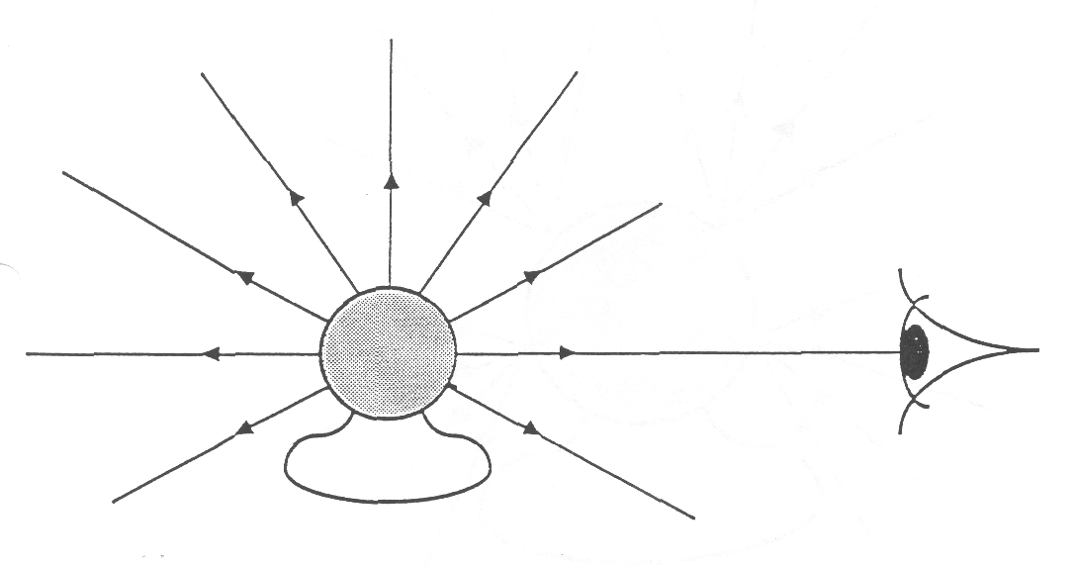

LIGHT SPREADS OUT FROM EACH POINT ON THE BULB
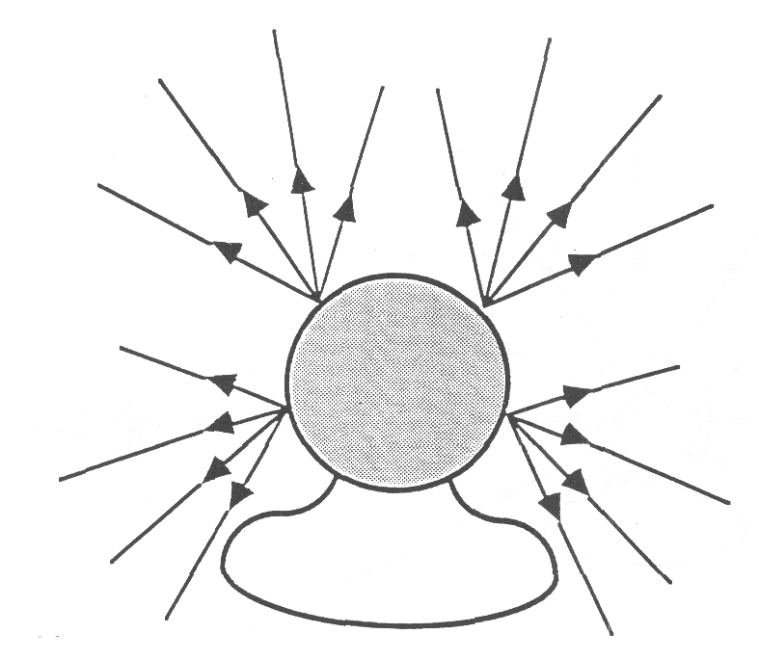

SEEING THE BOOK
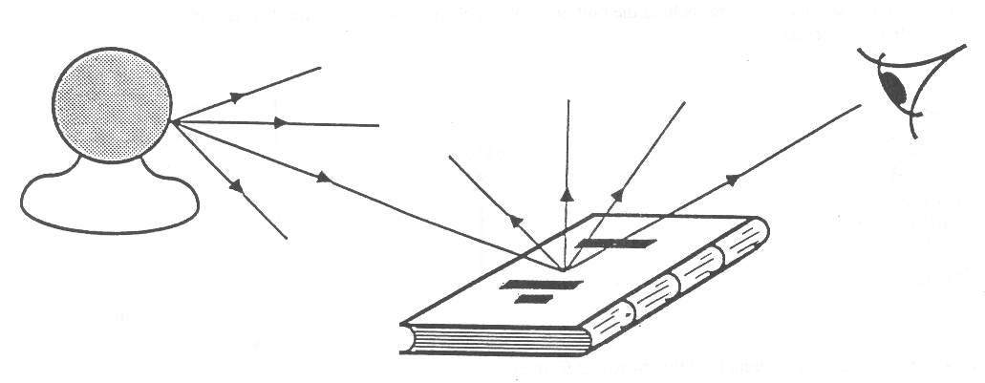

BEHAVIOR OF LIGHT 1C1

WHAT ARE THE PROPERTIES OF SHADOWS?

Materials: unfrosted bulb mounted in socket, with attached cord
cardboard figure
2 Manila file folders

1. Explain how you think shadows are made.
_______________________________________________________________________________________________
_______________________________________________________________________________________________
Discuss your ideas with your partner.

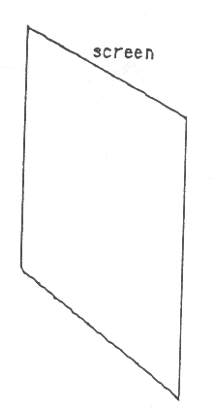
2. To investigate shadows, you will need a cardboard figure, a light source, and a screen. Mount one file folder upright and use one side of it as a screen. Place the bulb about 60 cm from the screen. Hold the cardboard figure upright, between the bulb and the screen, about 10 cm from the screen. Turn on the bulb. Stand the second file folder behind the bulb in a “V” to block its light from interfering with other students’ observations.

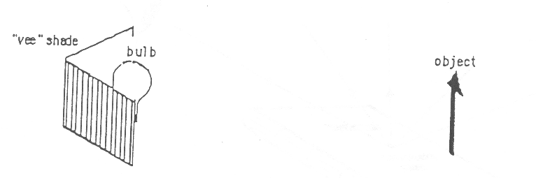

3. Draw a diagram to help explain how the shadow is formed.

4. Move the cardboard figure away from the screen and towards the bulb. Describe how the shadow changes.
_______________________________________________________________________________________________
_______________________________________________________________________________________________
_______________________________________________________________________________________________

BEHAVIOR OF LIGHT 1C1

WHAT ARE THE PROPERTIES OF SHADOWS? 2

5. Explain why the size of the shadow changed when you moved the cardboard figure. (You might want to draw a sketch to help with your explanation.)
___________________________________
___________________________________
___________________________________
___________________________________
___________________________________
6. If it can be arranged, block the outside light from entering the classroom. Use only one light bulb for the entire class, and stand so you are at least 3 meters from an unobstructed view of the bulb. With your cardboard figure about 10 cm from the screen, cast a shadow on the screen. Move the figure away from the screen and towards the direction of the bulb. Describe how the size of the shadow changes, if it changes at all.
_______________________________________________________________________________________________
_______________________________________________________________________________________________
7. How do your observations in step 6 compare with your observations in step 4?
_______________________________________________________________________________________________
_______________________________________________________________________________________________
8. Try to explain why there was a difference in the two situations.
_______________________________________________________________________________________________
_______________________________________________________________________________________________
9. This step needs to be performed outside on a sunny day, You will need the cardboard figure and the screen. Hold the screen perpendicular to the direct sunlight. Hold the cardboard figure parallel between the sun and the screen, about 10 cm from the screen. Observe the shadow of the figure. Now move the figure further away from the screen toward the direction of the sun. (Make sure you always keep it parallel to the screen. Be careful not to tilt the cardboard figure or the screen.) Describe what happens to the size of the shadow of the figure.
_______________________________________________________________________________________________
_______________________________________________________________________________________________
10. Compare your outside observations with your observations in step 6.
_______________________________________________________________________________________________
_______________________________________________________________________________________________
BEHAVIOR OF LIGHT 1C1TN

WHAT ARE THE PROPERTIES OF SHADOWS?

IDEA: PROCESS SKILLS:

Light travels in straight lines and can be Inferring
blocked by objects. Interpreting Data

LEVEL: L/U DURATION: 25-40 Min.

STUDENT BACKGROUND: To understand the formal scientific explanation for shadow formation, students would have to accept the idea that light travels from a source to the screen. If they do not accept this idea, the), will invent other explanations for the phenomenon of shadows.

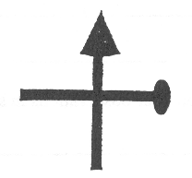
ADVANCE PREPARATION: One cardboard figure should be prepared for each group. A simple cross and arrow figure, about 8 cm wide by 10 cm high would be suitable. An example is sketched to the right, but any figure would do so long as it is asymmetric in both the vertical and horizontal directions. (This is so that the students can observe that the orientation of the shadow is identical to that of the object)

To obtain the best shadows, the light bulbs used by the students should be bright and have a small light emitting surface. A 40-60 W unfrosted incandescent bulb would be best. Try to eliminate reflections of the light from the table surface. (A piece of dull black paper would reduce reflections if it turns out to be a problem.)

For step 6, you should use a 100 W or 150 W bulb to provide enough light so that good shadows can be observed at one time by all the students in the room.

MANAGEMENT TIPS: Step 6 is important because it shows students how shadows behave when the light source is far away. It would be best to ensure that the majority (if not all) of the lighting in the room comes from the single 100 W or 150 W bulb. This means that all the shades will have to pulled down and/or blinds drawn. Also, all the students will need to perform this step at the same time. When students are performing this step, make sure they always keep both their screen and cardboard figures in a vertical plan . If they tilt the screen, their shadow will elongate, but not for the same reason the size increased in step 4
.
If the day is sunny, you may want students to carry out steps 9 and 10 during the activity period or you may assign those steps as homework. When students are using the sun as a source to investigate shadows, it is very important that they keep the cardboard figure and screen parallel to each other as they move the cardboard figure closer to and further from the screen.
POSSIBLE RESPONSES
TO SOME QUESTIONS: 4. The shadow increases in size, and may become somewhat less distinct as the cardboard figure moves away from the screen.
6. With the light source several meters away, the size of the shadow does not change appreciably as the figure is moved away from the screen.

BEHAVIOR OF LIGHT 1C1TN

WHAT ARE THE PROPERTIES OF SHADOWS? 2

9. With the sun as the source, and assuming the cardboard figure and screen are parallel to each other, as the cardboard figure is moved away from the screen the shadow will remain the same size.

POINTS TO EMPHASIZE

IN SUMMARY DISCUSSION: 1. Light travels in straight lines. If light, from some source, is blocked by an object, then a shadow is formed in the (three-dimensional) space behind the object. If a screen is located in that space behind the object, then a dark shadow can be observed on the screen.

2. Discuss with the students what they would see if they were within the region of the shadow, looking in the direction of the light source. They should realize that since the object blocks light from the source from reaching their eyes, they will not be able to see the light source.

3. Because light travels in straight lines, light passing by the perimeter of the object still goes straight to the screen. This is why the shape of the shadow is identical to the cross-sectional shape of the object.

4. Light diverges from a source and travels outward from the source in straight lines. If the source is very far away from the object casting a shadow, then the light that reaches the object is essentially parallel. In this case, the size

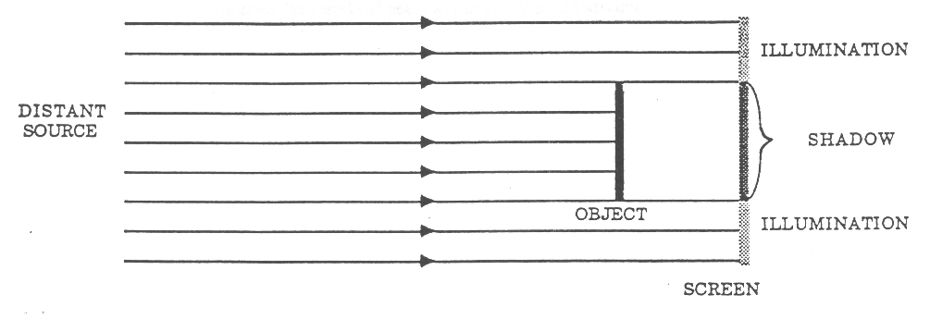

of the shadow will be the same regardless of how close or how far the object is from the screen. See the sketch above. This was the situation in step 6, with the indoor bulb, and in step 9, with the sun. (If the plane of the figure is perpendicular to the direction of light from the distant source, and if the plane is of the same shape and size as the figure.)

Actually, the criterion for “very far away” depends on the size of the light source. For a small source, like the bulb used in step 6, “very far away” need only be a few meters. For a very large source, however, like the sun (in step 9), the distance needs to be very large.

BEHAVIOR OF LIGHT 1C1TN

WHAT ARE THE PROPERTIES OF SHADOWS? 3

If the source is nearby, then light is not parallel when it reaches the object. Instead it is spreading out (diverging). In this case, the closer -the object is to the source, the larger the extent of the shadow region.

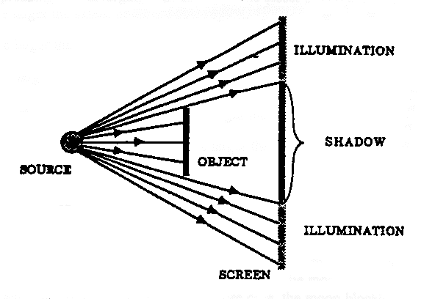

POSSIBLE EXTENSIONS: 1. Discuss solar and lunar eclipses. In the solar eclipse, case, the moon blocks
the sunlight and the earth is (at least partially) in the region of the moon’s
shadow. In the lunar eclipse case, the earth blocks the sunlight and the
moon is in the region of the earth’s shadow.

2. The article “Shadow Shapes,” by Feher and Rice provides some good
activities involving shadows (see “References” section).

BEHAVIOR OF LIGHT 1C2

HOW DOES A PINHOLE AFFECT LIGHT”?

Materials: lightbulb mounted in socket with cord attached
wax paper screen mounted on cardboard frame
aluminum foil mask mounted on cardboard
pin
Manila file folder

1 If necessary, construct the wax paper screen and the aluminum foil mask according to separate instructions.

2. Use the pin to poke a tiny hole near the center of the aluminum foil mask. Turn on the bulb. Stand the file folder in a “V” behind the bulb to block its light from interfering with other students’ observations. Hold the aluminum mask at arms length in front of the light bulb, with the pinhole aimed at the center of the bulb. (The aluminum mask should be between 25 and 50 cm from the bulb.) In your other hand, hold the wax paper screen up against the side of the aluminum foil facing you.

3. Slowly move the wax paper screen away from the aluminum foil and towards you. Describe what you observe on the screen.
_______________________________________________________________________________________________
_______________________________________________________________________________________________
4. What you should see on the screen is a pattern of light that is called a “pinhole image” of the bulb. Is the pinhole image right side up or upside down?

5. Try to explain how you think the pinhole image was formed. Draw a sketch to help with your explanation.

6. Describe how the pinhole image changes as you move the wax paper screen further away from the pinhole. (Consider the size, sharpness and brightness of the image.)
_______________________________________________________________________________________________
_______________________________________________________________________________________________
7. Poke another hole near the top of the aluminum foil mask, but make this hole larger than the pinhole you made in the center. (Make it about four times as large in diameter.) Use the wax paper screen to view the pinhole images caused by both holes. Describe how the images compare.
_______________________________________________________________________________________________
_______________________________________________________________________________________________
BEHAVIOR OF LIGHT 1C2

HOW DOES A PINHOLE AFFECT LIGHT”? 2

8. Make a prediction. Suppose you were to poke several additional (say four) tiny pinholes in the center of the aluminum foil mask in the vicinity of the previous hole. What do you think you would see on the wax paper screen as you moved it away from the aluminum foil? Write down your prediction and draw a sketch before actually poking the holes.
___________________________________
___________________________________
___________________________________
___________________________________
___________________________________
9. Poke several pinholes near the center of the aluminum foil and observe the pinhole images. Describe what you observe.
_______________________________________________________________________________________________
10. You should have observed in earlier parts of this activity that the sharpest pinhole images were also the dimmest. The brighter images tended to be less sharp (blurrier).

11. As in your last activity, poke a giant hole in the center of the aluminum foil (about 3 cm in diameter). What do you now observe on the wax paper screen as you move it further away from the aluminum foil? Why do you think this situation is different from your observation in step 3?
_______________________________________________________________________________________________
_______________________________________________________________________________________________
_______________________________________________________________________________________________
_______________________________________________________________________________________________
BEHAVIOR OF LIGHT 1C2TN

HOW DOES A PINHOLE AFFECT LIGHT?

IDEA: PROCESS SKILLS
Light travels in straight lines Observing
Communicating

LEVEL: U DURATION: 15-20 Min.

STUDENT BACKGROUND: A good understanding of pinhole images requires that the student accepts that light travels in straight lines, and that this behavior can be represented by drawing light rays.

ADVANCE PREPARATION: To get the best results, you should use one of the following types of bulbs as the light source : (1) A 25 W or 40 W clear, unfrosted bulb with a filament shape that has an easily recognizable orientation. This orientation will help the students to recognize that the pinhole image of the filament is upside down relative to the filament. Some clear decorative or appliance bulbs have a U-shaped filament, which would be ideal. The bulb will have to be mounted so the orientation of the filament shape is vertical. (2) A 40 W or 60 W “soft white” incandescent bulb whose shape has a definite orientation. The “soft white” type of bulb has a more uniform coating on its inner surface than the standard frosted bulb. Whatever bulb is chosen, it will have to be screwed into a standard bulb socket with a cord attached.

You will have to make the aluminum foil masks and the wax paper screens before class, or have the students make them during class.

To make one mask and screen set you will need the following materials: 2 pieces of medium or heavy stock cardboard, each about 20 cm square; 19 cm square piece of aluminum foil; 19 cm square piece of wax paper; masking tape or scotch tape; scissors. Cut out the center of each piece of cardboard, so you end up with a cardboard frame with sides that are about 3 cm thick. See sketch. Tape the aluminum foil to one of the frames, and the wax paper to the other.
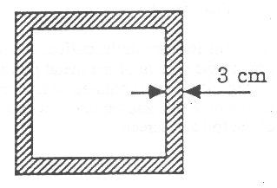

Make as many sets of frames as student groups working the experiment. You might find it best to finish the wax paper screens ahead of time, and have the students tape the aluminum foil to the cardboard frames.

With many light bulbs turned on in the room students might have some difficulty observing their own pinhole images. This is the reason the students are told to stand a file folder in a “V” behind their bulbs. The folder should be arranged to block light on three sides, and should reduce interference from other students’ bulbs.

BEHAVIOR OF LIGHT 1C2TN

HOW DOES A PINHOLE AFFECT LIGHT? 2

POSSIBLE RESPONSES
TO SOME QUESTIONS: 6. As the screen moves further from the pinhole, the pinhole image gets larger, remains firly sharp and clear, but gets dimmer. (Eventually it gets so dim that it is difficult to observe it.)

7. The pinhole image caused by the larger hole is much brighter and less sharp (blurrier) than the pinhole image caused by the smaller hole.

9. Several pinhole images should be observed. As the screen is moved further from the aluminum foil, the centers of the various images will separate further from each other. However, because the images are also getting larger, the dark space between the images may be getting smaller.

11. With the larger hole there will be no pinhole image formed. One may think of the larger hole as composed of many smaller holes nearly overlapping. You will only observe a pattern of diffuse light on the screen composed of a large number of nearly overlapping images. As the screen is moved further away, this diffuse pattern of light will spread out on the screen, and become dimmer.
POINTS TO EMPHASIZE
IN SUMMARY DISCUSSION: 1. It is not necessary to have lenses to produce an image on a screen. The pinhole-plus-screen arrangement works quite well, except that the pinhole image is not very bright. As the students will see later, lenses can produce images that are both very sharp and very bright.

2. There is no unique position for the screen in order to observe the pinhole image. A (reasonably) sharp pinhole image can be observed on the screen over a wide range of distances between the pinhole and the screen. (Eventually it becomes too dim.)

3. It is observed that the pinhole image is upside down. This provides evidence that light travels in straight lines. We make use of this fact when we draw light rays to “explain” why the pinhole image is upside down (See the following Focus On Physics for a discussion of this topic.)

POSSIBLE EXTENSIONS: Use cans for corn curls, coffee, peanuts, etc. Using a small nail, punch a hole in the bottom of the metal portion of the can. Use the plastic lid for a screen. If the lid is colored or has printing on it, cut out a square about 1.5 inches on a side and replace it with a piece of wax paper. Use this in place of the foil and screen.

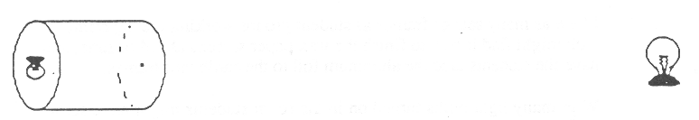
BEHAVIOR OF LIGHT 1C3F

FOCUS ON PHYSICS
REPRESENTING THE BEHAVIOR OF LIGHT BY
DRAWING LIGHT RAYS

The existence of shadows provides strong evidence that light travels in straight lines. We can represent this straight line (rectilinear) propagation of light by drawing arrows, called light rays. ‘Me figure below represents two ideas: light travels outward from each point on the bulb in all directions; and, light travels from the lamp to the eye in order for the observer to “see” the lamp bulb.
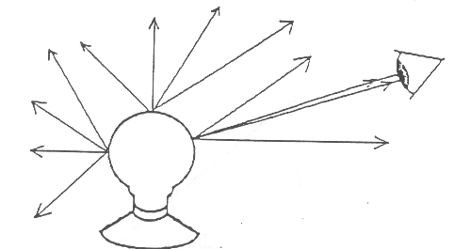

Although we realize that light travels outward in all directions from every point on the bulb, for convenience we only draw a few light rays to represent the two ideas. In general, when drawing a light ray diagram to describe or explain a particular optical phenomenon, we will usually only draw the minimum number of light rays necessary to represent the main ideas(s).

Below we show how the ray diagram can be used to describe and “explain” some simple shadow phenomena.
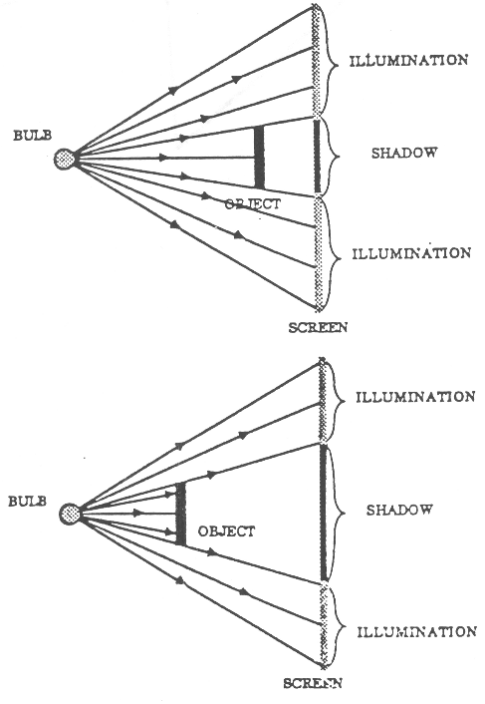
Shadows: The sketch to the right is a top view showing a small light source, an opaque object, and a screen. Several light rays are drawn representing light leaving the bulb and traveling toward the screen. The region on the screen which receives light is illuminated. The region on the screen that does not receive light, because the light was blocked by the object, is called the shadow.

To show what happens as the object is moved from the screen towards the light source, we have drawn another diagram with the object closer to the light. As can be seen from the diagram, the shadow region on the screen is now larger. This was what was observed in the lab, “What are the properties of shadows?”

Pinhole Image: The pinhole image observed on the screen was simply a pattern of light in the shape of the original bulb (but upside-down). For each point on the bulb, only light that traveled in one particular direction was able to pass through the pinhole and hit the screen; light traveling in all other directions from that point was blocked and did not hit the screen. This guaranteed that the pattern of light observed on the screen could be matched, point-by-point, with light leaving each point on the bulb.

BEHAVIOR OF LIGHT 1C3F

FOCUS ON PHYSICS 2
REPRESENTING THE BEHAVIOR OF LIGHT BY
DRAWING LIGHT RAYS

The sketch below shows that the upside-down image comes about because we draw the light rays as straight lines. The existence of upside-down pinhole images provides strong evidence to support our contention that light travels in straight lines.

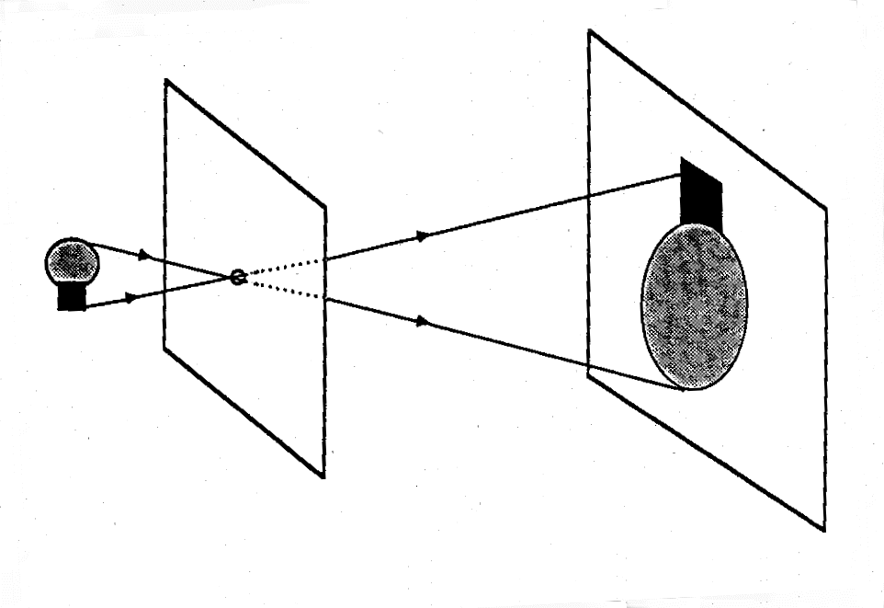
BEHAVIOR OF LIGHT 1C4

SHADOWS

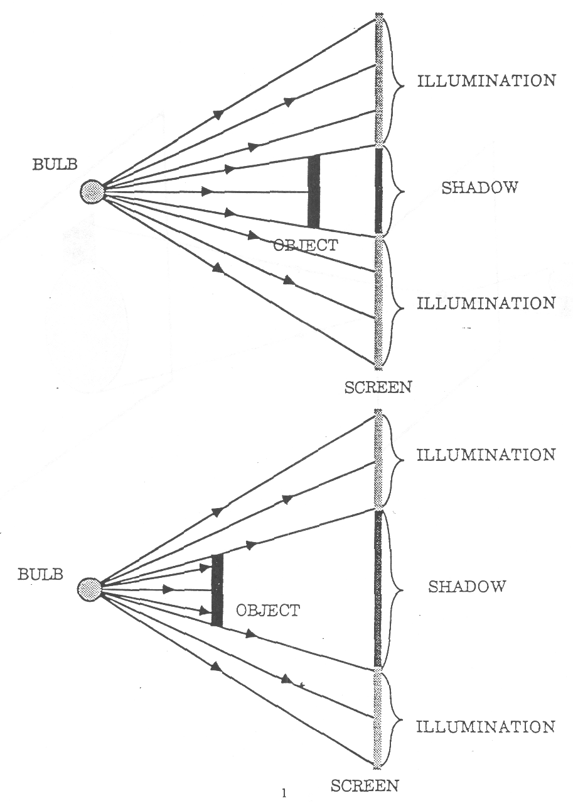
BEHAVIOR OF LIGHT 1C4

PINHOLE IMAGE

BEHAVIOR OF LIGHT 1C5D

PREDICTING AND UNDERSTANDING MULTIPLE SHADOW EFFECTS
(Demonstration/Discussion)

Materials: two clear, small filament bulbs, mounted in electric lamp sockets
large white screen
book, or some other large opaque object that can be used to cast shadows
masking tape
overhead, “Multiple Shadows”

The purpose of this demonstration is to further challenge students’ understanding of shadows by demonstrating shadows with both umbra and penumbra regions.
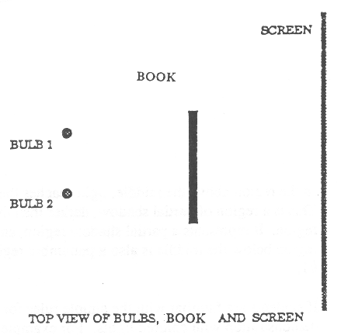
Set up the apparatus as sketched in the top view to the right. The two bulbs and the book stand upright on a table. The screen can also be mounted on the table, or it ran hang from a nearby wall. Arrange the separation of the two light sources (before showing this to students) so they produce partially overlapping shadows on the screen. Each shadow BY itself should be large and dark. The overhead lights will need to be turned off or dimmed significantly.

It is assumed that students under-stand how to explain the formation of a shadow with a single light source. Begin the demonstration by turning ON one lamp and showing the shadow it produces. It might be helpful to put pieces of tape on the screen to show the left and right boundaries of the shadow. Then turn OFF the first lamp and turn ON the second lamp. Again, put pieces of tape to show the left and fight boundaries of the shadows. (If everything is set up correctly there should be a region of overlap.)

Leave the second lamp ON and ask the following question: “If I were to turn ON both lamps at the same time, what would I observe on the screen. Draw a sketch to help describe and explain your prediction. “ (After letting them think about it for a minute, turn OFF the second lamp and cam on the overhead room lights.)

After giving the students an opportunity to think about this, engage the class in a discussion.

On the following page (and also on the overhead “Multiple Shadows” is a sketch of the phenomena involved in this demonstration. The sketch shows a TOP VIEW sketch of the situation. (Mention to students that the top view sketch is the most convenient for showing the behavior of the light in this situation.) Two light rays are drawn from each lamp, pass by the outer edges of the object and then go to the screen. The two light rays drawn from each one of the lamps determine the boundary of the shadow region due to the object blocking light from that lamp only.

On the sketch, the top and bottom regions of the screen receive light from both lamps. Therefore the top and bottom regions are fully illuminated. The middle region represents the area which receives no light, because the book blocks the light from both lamps. Since no light reaches the screen in that region, it is a full (dark) shadow region. This full (dark) shadow region is called the umbra region.

BEHAVIOR OF LIGHT 1C5D

PREDICTING AND UNDERSTANDING MULTIPLE SHADOW EFFECTS 2
(Demonstration/Discussion)

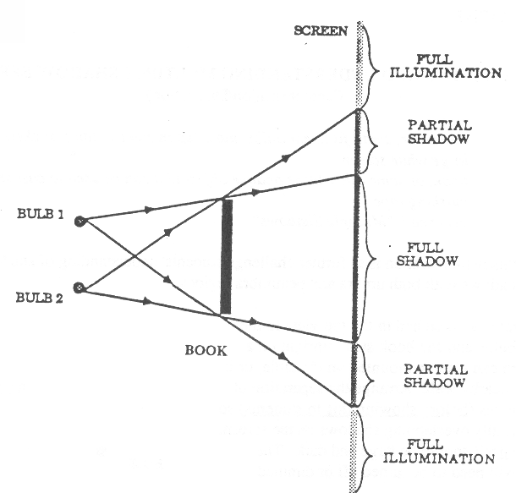

In the region above the middle, light reaches the screen from lamp #1, but light from lamp #2 is blocked. This is a region of partial shadow, darker than the top and bottom regions, but brighter than the middle region. It represents a partial shadow region, and is known as a penumbra region. In a similar way, the region below the middle is also a penumbra region. It receives light only from lamp #2, but not from lamp 41.

If students are familiar with the simple rules for color addition of lights then you can continue this demonstration with colored lights. For example, suppose you put a red filter in front of bulb #1 and a green filter in front of bulb 412. Then the Lop and bottom regions will appear yellow (red + green = yellow), the region above the middle will appear red, the middle region will appear black, and the region below the middle will appear green.

BEHAVIOR OF LIGHT 1D1

WHAT HAPPENS TO LIGHT AS IT MOVES
FURTHER FROM ITS SOURCE?

Materials: frosted bulb (at least 60 W) mounted in socket, with electrical cord
piece of dark cardboard, 25 cm square
letter-size piece of white paper
scissors
ruler
Manila file folder

1. Stand the piece of cardboard against the bulb.

2. Cut a 1.5 cm square hole in the center of the cardboard so the opening is touching the middle of the bulb.

3. Turn on the lamp. Stand the file folder behind the bulb in a “V” to block its light from interfering with other students’ observations.

Hold the piece of white paper against the cardboard and note the illuminated patch of light on the paper. Slowly move the paper away from the cardboard and describe how the size and brightness of the illuminated patch of light on the paper changes.
_______________________________________________________________________________________________
_______________________________________________________________________________________________
_______________________________________________________________________________________________
4. Explain why the size of the patch of light on the paper changed.
_______________________________________________________________________________________________
_______________________________________________________________________________________________
_______________________________________________________________________________________________
5. Explain why the brightness of the patch of light on the paper changed.
_______________________________________________________________________________________________
_______________________________________________________________________________________________
_______________________________________________________________________________________________
6. Suppose the paper were moved much further away from the cardboard (several meters). In that case, you would probably not observe any perceptible illumination on the paper. Does that mean the light only traveled out a certain distance and then just stopped (disappeared)? Explain you answer.
_______________________________________________________________________________________________
_______________________________________________________________________________________________
_______________________________________________________________________________________________
BEHAVIOR OF LIGHT 1D1TN

WHAT HAPPENS TO LIGHT AS IT MOVES FURTHER FROM ITS SOURCE?

IDEA: PROCESS SKILLS
Light spreads out from its source Communicating
and decreases in intensity Using Spatial Relationships

LEVEL: U DURATION: 15 Min.

STUDENT BACKGROUND: It is important that students have an understanding that light travels from a source to an object.

ADVANCE PREPARATION: A 10 watt soft white frosted light bulb would be best to use in this activity, although a somewhat lower wattage bulb would be okay. The “soft white” type of frosted bulb should be used because it presents a more uniform emitting surface than the standard frosted bulb.

The cardboard in which the students cut out a small, square window should be entirely opaque. Heavy dark or black cardboard would be best.

MANAGEMENT TIPS: The room lights should be dimmed or turned off during this activity.

With many light bulbs turned on in the room, students might have some difficulty making the necessary observations. This is the reason the students are told to stand a file folder in a “V” behind their bulbs. The folder should be arranged to block light on three sides, and should reduce interference from other students’ bulbs.

An alternative method is to cut the 1.5 cm square hole in a can for potato chips or other snacks. The hole must be at a distance from the bottom of the can equal to the height of the middle of the bulb. Place the can upside down over the bulb. The can could get too hot if left over the bulb too long.
RESPONSES TO
SOME QUESTIONS: 3. As the paper is moved away from the cardboard, the patch of light gets larger and dimmer.

4. Light coming from the bulb surface and through the opening is spreading out in all directions As the paper is moved away, the light which originally came through the opening is spread out over a larger and larger area on the paper.

5. Only a certain amount of light comes through the opening. As the paper is moved further away, the same amount of light is spread over a larger area, hence is less concentrated. Therefore, the illuminated region of the paper appears much dimmer.

BEHAVIOR OF LIGHT 1D1TN

WHAT HAPPENS TO LIGHT AS IT MOVES FURTHER FROM ITS SOURCE? 2

6. It is a common naive idea that light from a bulb just travels out a finite distance and stops. Actually, the light continues traveling and spreading out, until it strikes the paper. The illumination on the paper becomes so dim, however, that the eye cannot perceive it as any different from background illumination.

POINTS TO EMPHASIZE
IN SUMMARY DISCUSSION: 1. Light emitted from a light bulb spreads out in all directions. The previous transparency, “Light Spreads Out From Each Point on the Bulb,” could be used here to make the claim that light actually travels outward in all directions from each point on the bulb.

2. The brightness of a patch of light illuminating a sheet of paper depends on how much light from the source strikes a given sized portion of the paper. The more light that strikes the same sized portion of the paper, the brighter it will appear.

3. The light does not stop traveling at a certain distance from the bulb (unless it hits an absorbing surface). Instead, the light spreads out further and further and becomes less and less intense.

4. Consider holding a very large piece of paper in front of the source. A certain amount of light from the source strikes the paper, and the patch of light on the paper has a certain brightness. As the paper is moved further away, two things happen. The patch of light increases in size and the brightness of the patch of light decreases. These two effects are observed because the same amount of light is spreading out over a larger and larger area.

POSSIBLE EXTENSIONS: A variation of this experiment would give very different results. Suppose you tried to perform this experiment by looking directly at the part of the frosted bulb observed through the cardboard window, rather than looking at a patch of light on a paper illuminated by the bulb. As you moved further away, you would probably not observe significant decreases in the brightness of the bulb. Apparently, the human perceptual system can accommodate for changes in the amount of light entering the eye from a bulb so that the brightness of a light bulb remains nearly constant over a wide range in distances from the bulb.

BEHAVIOR OF LIGHT 2WL
WORKSHOP LEADER’S PLANNING GUIDE
FOR REFLECTION AND MIRRORS

The activities in this section should lead participants to an understanding of the properties of mirrors. The emphasis is on describing how light reflects from surfaces, the properties of mirror images, and how light ray diagrams can be used to describe how mirror images are formed. There is also a brief investigation of the unusual properties of curved mirrors.

Naive Ideas:

1. A mirror reverses everything. (2A1, 2A2D)

2. For an observer to see the mirror image of an object, either the object must be directly in front of the mirror or, if not directly in front., then the object must be along the observer’s line-of-sight to the mirror. The position of the observer is not important in determining whether the mirror image can be seen. (2B1D, 2D1F)

3. An observer can see more of his or her mirror image by moving further back from the mirror. (2B2)

4. The mirror image of an object is located on the surface of the mirror. The image is often thought of as a picture on a flat surface. (2B3, 2D1F)

5. The way a mirror works is the following. The image first goes from the object to the mirror surface. Then the observer either sees the image on the mirror surface or the image reflects off the mirror and goes into the observer’s eye. (2C1)

6. Light reflects from a shiny surface in an arbitrary manner. (2C1, 2D1F)

7. Light is reflected from smooth mirror surfaces but not from non-shiny surfaces. (2C2, 2C3F, 2C4, 2C5F)

8. Curved mirrors make everything distorted. (2E1)

A. A MIRROR INVERTS THE RELATIVE POSITION OF OBJECTS OR PARTS OF AN OBJECT ALONG THE DIRECTION PERPENDICULAR ITS SURFACE.
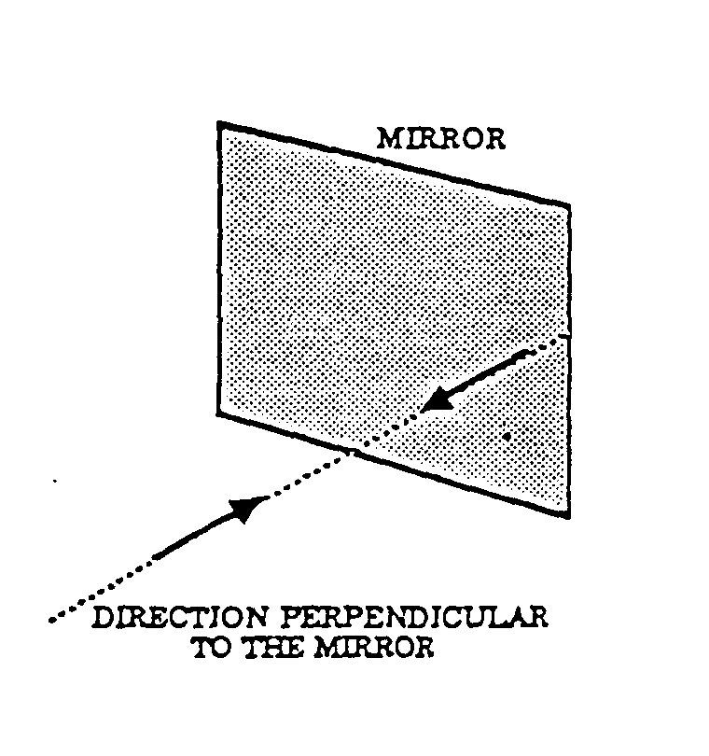
1. Activity: How Do Things Appear In a Mirror?

Students investigate the appearance of the mirror images of various figures they draw and try to infer what the mirror actually does.

2. Demonstration/Discussion: Does a Mirror Really Reverse Letters?

This demonstration leads students to the conclusion that a mirror does not reverse letters located in a plane parallel to its surface. An optional discussion focuses on why our own mirror images appear to be left-right reversals of ourselves.

B. THE MIRROR IMAGE OF AN OBJECT APPEARS TO BE LOCATED THF SAME DISTANCE BEHIND THF MIRROR PLANE AS THE OBJECT IS IN FRONT, MEASURED ALONG A LINE PERPENDICULAR TO THE MIRROR PLANE.

1. Demonstration/Discussion: From Where Can You See an Object’s Reflection In a Mirror?

A series of tasks are presented to encourage students to verbalize the criteria they would use to predict whether or not an observer, from a given location, would be able to see the mirror image of an Object.

2. Activity: How Much Of Yourself Can You See In a Mirror?

In this activity, students discover that the amount Of themselves they can see in a mirror does NOT depend on their distance from the mirror.
BEHAVIOR OF LIGHT 2WL
WORKSHOP LEADER’S PLANNING GUIDE
FOR REFLECTION AND MIRRORS - 2

3. Activity: Where Is the Mirror Image?

In this lab activity, students use a half-silvered mirror to determine where the mirror image of an object appears to be located.

C. LIGHT REFLECTS FROM A MIRROR SURFACE TN A WELT, DEFINED MANNER. SUCH THAT THE ANGLE OF REFLECTION EQUALS THE ANGLE OF INCIDENCE, LIGHT REFLECTS DIFFUSELY FROM A NON-SHINY SURFACE. THAT IS, INCIDENT LIGHT SEEMS TO BE REFLECTED IN ALL DIRECTIONS.

1. Activity: How Does Light Reflect From a Mirror Surface?

Students study the reflection of a beam of light from a flat mirror surface. They use a protractor to measure angles of reflection and incidence, and the), infer from data that the two angles are equal.

2. Activity: How Does Light Reflect From a Non-Shiny Surface?

By aiming light onto one card and using this card to illuminate a second card, students can infer that light must have reflected off of the first card. They also investigate how the light reflected from the card differs from light reflected from a plane mirror and from a crinkled piece of aluminum foil.

3. Discussion -Focus On Physics: Regular and Diffuse Reflection

4. Overhead
a) Regular and Diffuse Reflection
b) Close-up View of Diffuse Reflection

5. Discussion-Focus On Physics: What Is the Difference Between a Plane Mirror and a Piece of Paper?

D. RAY DIAGRAMS CAN BE USED TO DESCRIBE SOME OF THF PROPERTIES OF THE IMAGES FORMED BY PLANE MIRRORS.

1. Discussion-Focus On Physics: Drawing Ray Diagrams To Describe How Plane Mirrors Form Images

This discussion shows how to use ray diagrams to describe where a mirror image is located and to determine whether or not an observer at a given position would be able to see it.

2. Overheads: a) The Mirror Image
b) Can an Observer See a Mirror Image?

3. Discussion-Focus On Physics: Student Difficulties In Understanding Image Formation by a Plane Mirror

This is an article reprinted from the November 1986 issue of The Physics Teacher.

E. DEPENDING ON THE TYPE OF CURVED MIRROR (CONCAVE OR CONVEX). THE POSITION OF THE OBJECT RELATIVE TO THE MIRROR IMAGES FORMED WITH CURVED MIRRORS MAY BE UPSIDE DOWN OR RTGHTSIDE-UP, AND MAY BE LARGER OR SMALLER THAN THE OBJECT.

1. Activity: What Do Curved Mirrors Do?

Using a spoon, students study some of the unusual image-forming proper-Lies of convex and concave mirrors.

BEHAVIOR OF LIGHT 2A1

HOW DO THINGS APPEAR IN A MIRROR?

Materials: Mirror

1. Neatly print your first name, or just the first four letters of your first name, in the blocks below, one letter per block. Use capital letters only. Hold the mirror upright on the line marked “mirror line” with the shiny side facing the letters of your name.
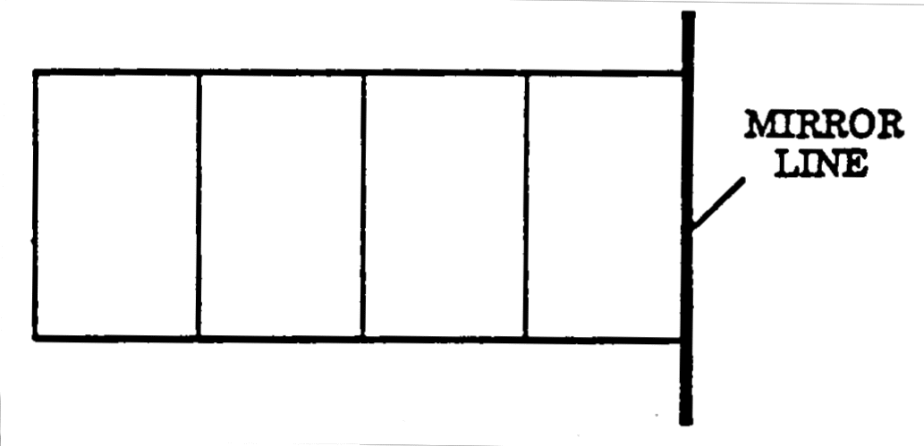

2. In the blocks below, sketch what the letters of your name look like in the mirror.
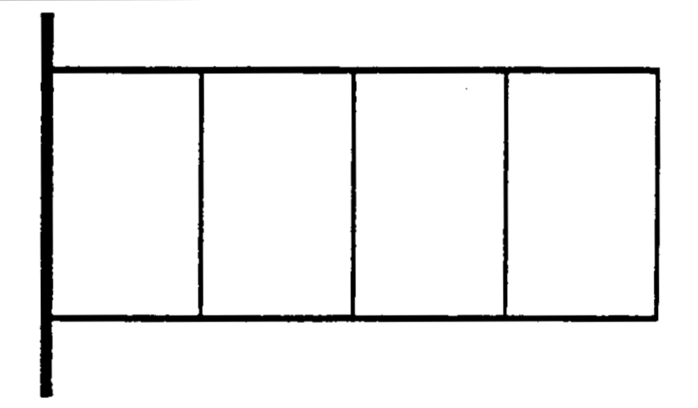

Describe how the mirror view of the letters are different than the actual letters you drew.
_______________________________________________________________________________________________
_______________________________________________________________________________________________
3. Do you think the mirror view of the letters you drew in step 2 would look the same as the actual letters in your name? Try it by putting the mirror next to the letters. Describe what you observe.

4. Draw 3 different letters in the blocks below which will look exactly the same as their mirror view (You may want to practice this on a piece of scrap paper first.) Use the mirror to check out your letters.
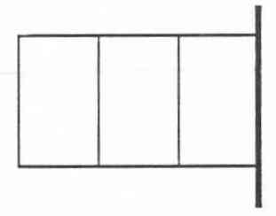

BEHAVIOR OF LIGHT 2A1

HOW DO THINGS APPEAR IN A MIRROR? 2

5. In the large square below, draw a design (not letters of the alphabet) that will look exactly the same as its mirror view. Make the design as interesting as you can, and you should first practice on a sheet of scrap paper. Use the mirror to check out your design.
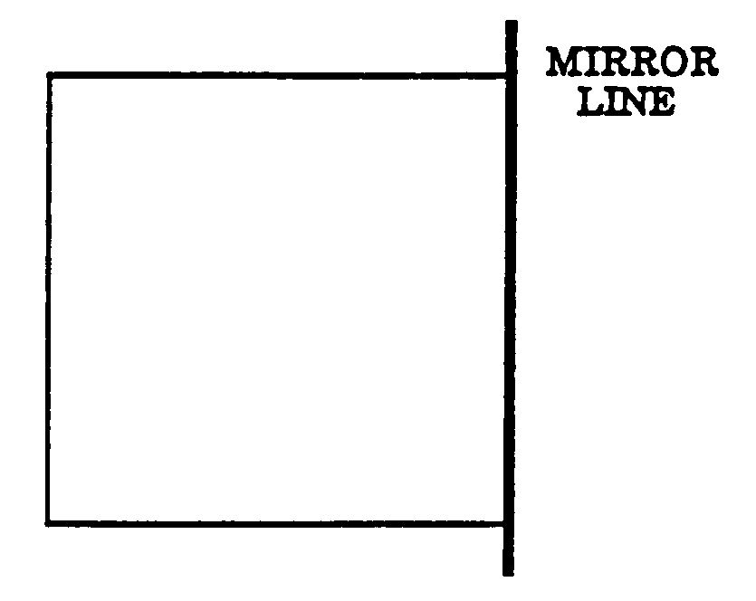

6. Suppose you were teaching a friend over the telephone how to make a sketch whose mirror view would look exactly the same. What general instruction(s) or rule(s) would you need to tell your friend?
_______________________________________________________________________________________________
_______________________________________________________________________________________________
_______________________________________________________________________________________________
_______________________________________________________________________________________________
7. View the mirror image of the arrow drawn below, then describe how the mirror image of the arrow compares with the actual arrow.
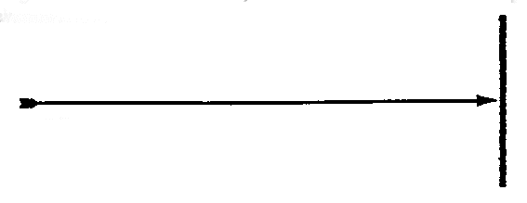

_______________________________________________________________________________________________
_______________________________________________________________________________________________
8. After thinking about the previous parts of this lab activity (especially steps 6 and 7), describe what a mirror does.
_______________________________________________________________________________________________
_______________________________________________________________________________________________
_______________________________________________________________________________________________
_______________________________________________________________________________________________

BEHAVIOR OF LIGHT 2A1TN

HOW DO THINGS APPEAR IN A MIRROR?

IDEA: PROCESS SKILLS:
A mirror inverts the relative position of Using Spatial Relationships
objects, or parts of an object, along the Predicting
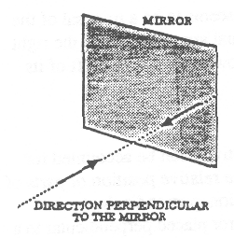
direction perpendicular to its surface.

LEVEL: LIU DURATION: 20 Min.

ADVANCE PREPARATION: 1. Mirror edges may be taped for safety in handling.

2. Mirror files can be purchased at hardware or large discount department stores. Often, the stores can cut the tiles to an appropriate size.

MANAGEMENT TIPS: Students should print capital letters only in steps 1 and 4.
RESPONSES TO
SOME QUESTIONS: 4. The capital letters A, H, 1, M, 0, T, U, V, W, X will look exactly the same in the mirror view.
5. All objects drawn within the square, and the placement of objects within the square, must have front-back symmetry. Below are examples of two drawings.
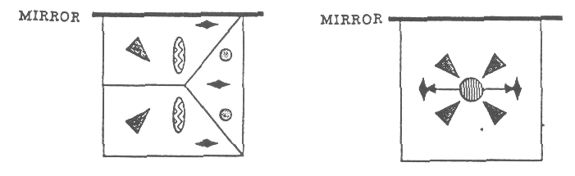

6. This will be a difficult question for students to answer. One possible response would be that the parts of the drawing actually closest to the mirror will appear, in the reflection, to be closest to the mirror. This means that the relative position of different parts of the figure along the direction perpendicular to the mirror surface will appear reversed in the mirror image.

If the mirror is to be held perpendicular to the paper, and to the right of the drawing, a way of determining whether the drawing will be okay is to draw a vertical line directly through the center of the drawing, parallel to the mirror surface. Then, fold the paper in half along that line. The two halves of the drawing should then fit on top of each other exactly.

7. The mirror image of the arrow seems to be a reversal of the actual arrow. Whereas, the actual arrow head is to the right of its tail, the mirror image arrow head is to the left of its tail.
BEHAVIOR OF LIGHT 2A1TN

HOW DO THINGS APPEAR IN A MIRROR? 2

POINTS TO EMPHASIZE
IN SUMMARY DISCUSSION: The students’ observations in this activity can be accounted for by assuming that a mirror inverts the relative position of parts of their drawings, only along the direction, perpendicular to the mirror surface. Thus, consider a mirror placed perpendicular to a piece of paper and to the right of some letters written on the paper. Parts of the letters to the right of other parts will appear, in the mirror image, to be to the left of the other parts. The demonstration/discussion, “Does a Mirror Really Reverse Letters,” should follow this activity.

POSSIBLE EXTENSIONS: Some words and numbers read the same forward and backward. These are called palindromes. They will look the same when viewed in a mirror placed to their right and perpendicular to the paper. Some examples of palindromes are the following:

TOT MOM MUM

Note that to be a palindrome, each letter and the entire word must have symmetry. Have the students invent other palindromes front-back.

BEHAVIOR OF LIGHT 2A2D

DOES A MIRROR REALLY REVERSE LETTERS?
(Demonstration/Discussion)

Materials: large mirror, at least 12 “ x 12 “
sheet of clear acetate (the stuff used for overheads)
extra sheet of acetate (to carry out an optional demonstration)
piece of cardboard
bold black marking pen for writing on acetate

Everybody is familiar with the observation that if you hold up some writing in front of a mirror, all the writing appears to be “left-right” reversed. The purpose of this demonstration is to help students recognize that, as a matter of fact, the mirror does not left-right reverse letters placed in the plane parallel to its surface.

To prepare, do the following: Using the bold marking pen, print the word “MIRROR” in large letters on both the clear acetate and the cardboard. Keep both of these out of view of the students until you are ready for them.

1. Begin by showing students the large mirror. Then ask the following question: “Suppose I wrote down the word “MIRROR” and looked at its image in the mirror. How would it appear, and why?”

If you ask for students’ comments most would say that the word “MIRROR” would appear reversed in the mirror, and they might just say that this is what a mirror does (reverses letters.)

2. Obtain the acetate and show students the word “MIRROR” printed in bold letters. Hold the acetate in front of the mirror so that both the word “MIRROR” on the acetate and the mirror face the students. Notice, in this case, the mirror image of the letters looks exactly the same as the letters. There is no left-right reversal of letters!

3. Turn the acetate around so the students observe the other side of the letters. Now the letters will actually be seen as left-right reversed. Hold this in front of the mirror. Notice that the mirror image also appears left-right reversed. Thus, when you see left-right reversed letters in a MIRROR, it is because the letters are already reversed when held in front of the mirror.

4. To emphasize the last point made above, put down the acetate and bring out the cardboard with the word “MIRROR” printed on it. Show this to the students, then turn it around and face it toward the mirror. Under these circumstances, and only under these circumstances, will the mirror image appear with letters left-fight reversed? The point is that the mirror did not reverse the letters. You reversed them when turning the word around to face the mirror.

5. When we look at the mirror image of a work written on paper, we always note that the letters appear to be left-right reversed. We therefore tend to make the claim that “the mirror reverses the lettering.” While it is certainly true that the letters appear left-fight reversed, we should remember that the mirror is not reversing the letters. Instead, in a sense, we have already reversed the letters by turning the paper around so the lettering faces the mirror.

BEHAVIOR OF LIGHT 2A2D

DOES A MIRROR REALLY REVERSE LETTERS? 2
(Demonstration/Discussion)

THE FOLLOWING STEPS ARE OPTIONAL:

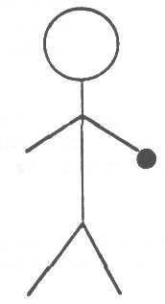
6. Students are no doubt familiar with looking at themselves in a mirror and noticing that their images appear to be left-right reversals of themselves. You could demonstrate this by positioning yourself so most students can see the back of your head and the mirror image of your face. Raise your right hand and touch your right ear. They should observe that your mirror image appears to be raising its left hand and touching its left ear. The explanation for this apparent left-right reversal is related to the discussion above.

You can help students to understand what is happening by drawing a stick figure of a person on another sheet of acetate. Draw only a head, body, arms, and legs, similar to the sketch to the right. Do not draw any features, like facial features, that would enable you to tell whether the stick figure is facing toward you or away from you. Put an identifying mark on one of the figure’s arms, so you can distinguish between the two arms. We will assume that you put the mark on the arm that is on the right side of the drawing. Then, if you think of the figure as facing you, the mark will be on the left arm. If you think of the figure as facing away from you, the mark will be on the right arm.

7. Hold the acetate in front of the mirror so that both the stick figure and the mirror face the students. The mirror image of the stick figure will look exactly the same as the figure drawn on the acetate. Now, assume that the figure drawn on the acetate is the back view of the person. Then the identifying mark will be on the right arm. If, now, you think of the mirror image figure as a front view, then the identifying mark will be on the image figure’s left arm. In this case, it will appear like the mirror image view of the stick figure is a left-right reversal of the stick figure. This represents what we normally observe in our everyday experience with mirrors. However, notice how this came about. The apparent left-right reversal came about because we assumed that the mirror image was a front view/back view reversal of an actual person.

Remind students of what they learned in the activity, “How Do Things Appear In a Mirror?” There they learned that a mirror inverts the relative position of parts of an object (e.g. a person) along the direction perpendicular to its surface. Thus, when they stand in front of a mirror, the mirror actually inverts the front and back view. Our mirror image, then, will appear to be a left-right reversal of ourselves.

BEHAVIOR OF LIGHT 2B1D

FROM WHERE CAN YOU SEE AN OBJECT’S REFLECTION IN A MIRROR?
(Demonstration/Discussion)

Materials: 30 cm x 30 cm (12” x 12”) mirror tile, mounted upright on a table
cardboard cover for above mirror
dowel rod, 2-3 cm wide and at least 30 cm tall mounted so it can stand upright on the
table in front of the mirror.

The purpose of this demonstration/discuss ion is to encourage students to verbalize the criteria they use to predict whether they would or would not be able to see the mirror image of an object. A common criterion students often use is that they assume the object must be located along their line-of sight to the mirror; that is, that their eye, the object, and the mirror must lie along a straight line. Another criterion that students often use to guide their predictions is that they assume the object must be in front of the mirror for its image to be seen. Applying either of these criteria, of course, will not lead to correct predictions in many situations.

The demonstration is best carried out if there is a table set up at the front of the room. Mount the mirror tile upright in the center of the table, facing the class. The sketch below is a top view showing the various positions for the rod and your position (the observer). These positions will be explained in the steps following the sketch.

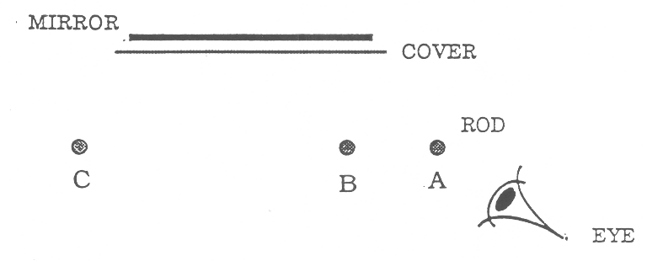
1. Begin with the mirror uncovered and without the rod on the table. Direct the class’s attention to the mirror and then cover it with the cardboard cover. Mount the dowel rod (or equivalent) in position A, which is about 15 cm in front of the mirror and about 15 cm to the right of the right edge (see sketch). Bend down so your eye is in the position shown. (The rod is along your line-of-sight to the center of the mirror.) Ask the class the following question:

“If the mirror were uncovered, would I be able to see the mirror reflection of the rod?”

Ask each student to write his or her prediction on a sheet of paper, along with a brief justification.

2. Move the rod to position B, about 15 cm in front of the mirror and about 5 cm to the left of its right edge. Your position remains the same as before. Ask the same question as in step 1, and have the students write, down their predictions and justifications.

3. Finally, move the rod to position C, which is 15 cm in front of, and 5 cm to the left of the left edge of the mirror. Again, repeat the same question and have the students write down their predictions and explanations.

4. After students have finished writing down their predictions and explanations for the three questions, encourage a class discussion of their responses. You should be prepared for some students to put forth the criteria mentioned in the introduction to this demonstration. Try not to make judgments as to whether students’ comments are correct or not. Instead, help students recognize that they can test their ideas by actually carrying out the demonstrations. When you think students are ready, uncover the mirror and have several students actually perform the experiments. (At the end of this session you should give all students the opportunity to look for themselves.) Help the students recognize which of the proposed justifications (criteria) seem appropriate, and which do not.

5. We suggest that you do not provide a formal scientific explanation at this time. In a later activity students will observe how light reflects from a mirror and will then be able to “understand” their observations in this activity.

BEHAVIOR OF LIGHT 2B2

HOW MUCH OF YOURSELF CAN YOU SEE IN A MIRROR?

Materials: large mirror tile (30 cm x 30 cm)
meter stick
masking tape

DEMONSTRATION:

1. Look at the instructor standing in front of the mirror. How much of his or her body do you think the instructor is able to see in the mirror?
_______________________________________________________________________________________________
2. What can the instructor do, if anything, to see more of his or her body in the mirror?
_______________________________________________________________________________________________
3. Explain your response to the question above.
Draw a sketch to help with your explanation.
___________________________________________
___________________________________________
___________________________________________
ACTIVITY: Work in Groups of 3 or 4:

4. Have one member of your group hold the mirror flat against a wall with the top of the mirror a little higher than the top of your head. Stand with your face against the mirror and have a third member of your group put two pieces of tape on the mirror, one next to the top of your head and one next to the bottom of your chin.

5. Slowly move back from the mirror and keep observing the reflection of your face. Describe how the size of the reflection of your face compares with the distance between the two pieces of tape.
_______________________________________________________________________________________________
_______________________________________________________________________________________________
6. Try to explain your observations in step 5.
_______________________________________________________________________________________________
_______________________________________________________________________________________________
7. Remove the two pieces of tape from the mirror. Have one member of your group hold the mirror flat against the wall with the top of the mirror at the level of the top of your shoulders. Stand about 1 meter from the mirror. Describe how much of your body you can see in the mirror.
_______________________________________________________________________________________________
8. Place two pieces of masking tape on your clothing, one at the very top of your mirror reflection and one at the very bottom. Use a meter stick to measure the (vertical) distance between the two pieces of tape. Record that distance below.

Distance between two pieces of tape _____________cm

9. Step back about two or three Limes as far from the mirror (about 2-3 meters). Adjust the two pieces of masking tape on your clothing, if necessary, so that one is at the very top of your mirror reflection and one is at the very bottom. Use a meter stick to measure the (vertical) distance between the two pieces of tape. Record that distance below.

Distance between two pieces of tape _____________cm

10. Compare the amount of your body you can see in the mirror now with the amount that you saw when you were much closer (step 7). Can you see much more, about the same or much less?
_______________________________________________________________________________________________
BEHAVIOR OF LIGHT 2B2TN

HOW MUCH OF YOURSELF CAN YOU SEE IN A MIRROR?

IDEA: PROCESS SKILLS:

The amount of yourself that you can see in a plane Observing
mirror does not depend on your distance from the mirror. Measuring

LEVEL: U DURATION: 30 - 40 Min.

ADVANCE PREPARATION: There needs to be sufficient wall space and floor space. Students must mount the mirror against a vertical flat wall, and must be able to stand back from the wall at least two meters. If the classroom is not sufficient, the relevant parts of the activity might be performed either in a corridor or outside.

MANAGEMENT TIPS: Step 1 is performed as a demonstration. You should mount a mirror tile on a wall so that the top of the mirror is somewhat below the top of your head. Stand back about 0.5 meters from the mirror and look at your image. Arrange the set-ups so that none of the students can see your image in the mirror. (Actually, that raises another interesting question. Is what you see in the mirror the same as what the student would see?) For step 1, you should ask the question: “How much of me do you think I can see in the mirror now?” After the students write down their responses, ask: “What can I do, if anything, to see more of my body in the mirror?”

After the students write down their responses to Steps 2 and 3, engage them in a class discussion. However, DO NOT tell or demonstrate what actually happens. Their curiosity should be piqued, and they can find out by performing the remainder of the activity.

In steps 8 and 9 make sure the students place the tape at the appropriate places and measure the vertical distance between the upper and lower pieces. When they move further back, they may see a slightly different part of their body. In step 10, however, they are asked about the extent of their body (how much) they can see, not what part of their body they can see. You may need to remind students of that.
RESPONSES TO
SOME QUESTIONS: 2. The majority of students will probably say that the instructor can see more of themselves by moving further back.

3. Many students will just say that they remember that they can see more of themselves by moving further back. If you encourage the students to provide a justification for why they think that, you will find that many explanations are similar to one or the other of the following two.

a. (See the sketch below). A student may think of the mirror as “looking at her” with an angle of view of fixed size. As she moves further away from the mirror, a larger part of her body could fit into this angle.
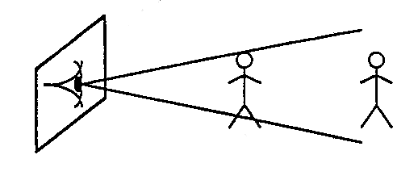

BEHAVIOR OF LIGHT 2B2TN

HOW MUCH OF YOURSELF CAN YOU SEE IN A MIRROR? 2

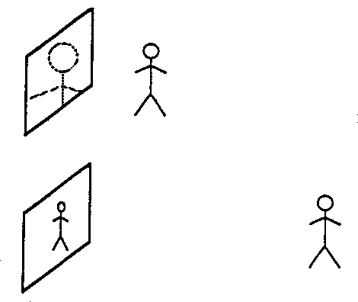
b. (See sketch below). A student may conceive of the mirror as “containing” her image within its borders. The student recalls, from experience, that an object appears to decrease in size as she moves away from it. Therefore, she thinks that her image would also decrease in size as she moves further away, and therefore, more of it would fit inside the mirror. (Actually, both the mirror and the image decrease in size proportionally, so the same amount of the image fits inside the mirror regardless of her distance from it).

5. As the student moves back, the size of his or her image becomes smaller and smaller compared to the distance between the pieces of tape. (From this observation, it is possible to infer that the mirror image is NOT on the surface of the mirror, but is further back).
10. Students should conclude that they will see about the same amount of themselves further back as they did when they were closer. Some students have such a strong expectation that they will see more further back, they might interpret their data incorrectly. They might observe a small change (either because they bend their body, are not careful in their measurements, or see a slightly different portion of their body when backing up) and conclude that they do see (much) more. You may have to go over the data with them to convince them.
POINTS TO EMPHASIZE
IN SUMMARY DISCUSSION: 1. As long as you stand upright and parallel to the mirror, the maximum amount of yourself that you can see in the mirror is independent of your distance from it.
2. The explanation for the above observation is presented in the diagrams on the following page, which can be used to make a transparency for discussion purposes. However, students will not appreciate the diagram until after they have been introduced to the Law of Reflection. A detailed explanation is provided in the article: “Student Difficulties in Understanding Image Formation by a Plane Mirror.” A copy of the article appears later in this section.
POSSIBLE EXTENSIONS: 1. Have the students determine the relationship between the maximum amount of themselves they can see in a mirror and the size of the mirror. It turns out that they can see exactly twice the height of the mirror. A good follow-up question to this is: “What is the minimum sized mirror in which you can just see your entire body?” (The answer is that the mirror must be one half your height.).
2. Have the students investigate what can be done with a plane mirror that would enable them to see more of themselves. (In the lab activity, the mirror was held fixed against the wall). The answer is that they can tilt the mirror. The more they tilt it, the more of their image they can see.
BEHAVIOR OF LIGHT 2B2TN

HOW MUCH OF YOURSELF CAN YOU SEE IN A MIRROR 3

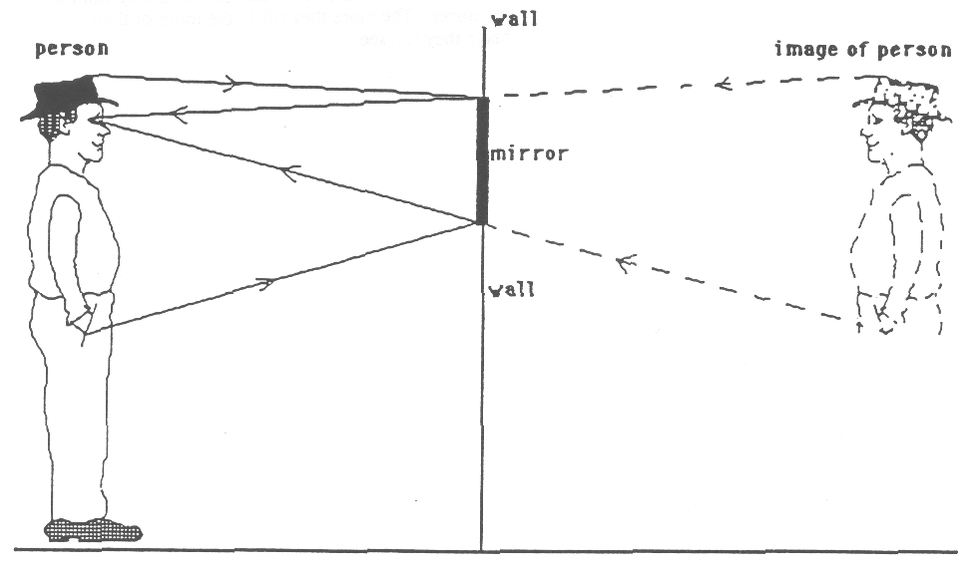
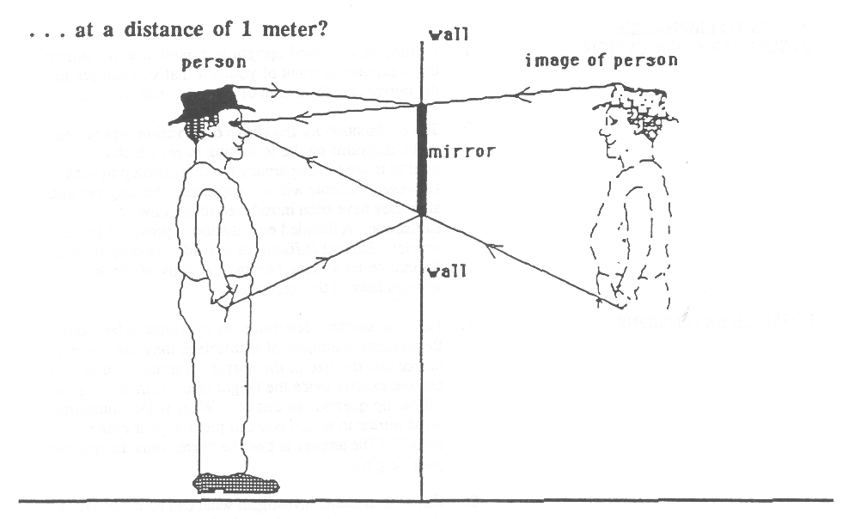
. . . at a distance of 2 meters?

BEHAVIOR OF LIGHT 2B3
WHERE IS THE MIRROR IMAGE?

Materials: regular (fully-silvered) mirror ruler
half-silvered mirror or colored plastic substitute small piece of clay
two identical light bulbs, mounted in bulb sockets 8 /12 “ x 11” sheet of black paper

1. Mount one of the light bulbs in front of the fully silvered mirror and turn it on. We will use the term 11 mirror image” of the bulb when referring to the reflection of the bulb that you see in the mirror. As you look at the mirror image of the bulb, just exactly where are your eyes focusing - on the surface of the mirror or somewhere else? In other words, where is the mirror image of the bulb located? In this activity you will find out, using a clever device called a half-silvered mirror.
_______________________________________________________________________________________________
_______________________________________________________________________________________________
2. Examine the half-silvered mirror, as well as the fully silvered (normal) mirror. Describe how the two types of mirrors are similar. Describe how they are different.

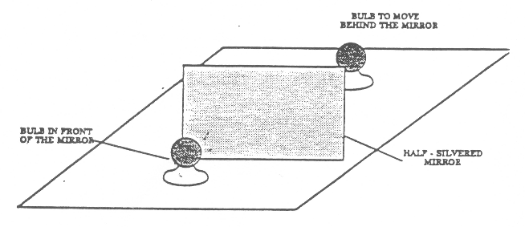
3. Lay the black sheet of paper on the table. Mount the half-silvered mirror upright in the middle of the black paper. (A small piece of clay may help.) Make sure that the mirror is perpendicular to the paper. Place one of the bulbs upright in front of the center of the mirror. Turn the bulb on. Bend down so you can see the mirror image of the bulb. Take the second bulb, turn it on, and move it around behind the mirror until it seems to fit EXACTLY INTO the image of the first; that is, the second bulb and the image of the first bulb should look like a single bulb. Do this carefully. Both you and your partner looking into the mirror from different angles should agree on the correct placement of the second bulb behind the mirror.

4. Use the ruler to measure the distance in front of the mirror between the mirror surface and the front of the first bulb. Also measure the distance behind the mirror between the mirror surface and the front of the second bulb. Record both measurements below.
Distance from the mirror to bulb in front _______________ cm.
Distance from the mirror to bulb behind _______________ cm.

5. Compare these two distances. Are they nearly the same or very different?
_______________________________________________________________________________________________
6. Repeat steps 2 and 3, but with the first bulb about twice as far from the mirror. Measure and record the new distances below.
New distance from the mirror to bulb in front _______________ cm.
New distance from the mirror to bulb behind _______________ cm.

7. Compare these two distances. Are they nearly the same or very different?
_______________________________________________________________________________________________
8. Because the second bulb and the mirror image of the first are seen as one, they must both be located at exactly the same place.

Based on your two sets of measurements in this activity, hypothesize a general relationship between the distance the bulb is in front of the mirror and the distance its mirror image (the second bulb) appears to be behind the mirror.
_______________________________________________________________________________________________
_______________________________________________________________________________________________
Discuss your hypotheses with other students.
BEHAVIOR OF LIGHT 2B3TN

WHERE IS THE MIRROR IMAGE?

IDEA: PROCESS SKILLS:
The mirror image is located the same Observing
distance behind the mirror as the object Hypothesizing
is in front, measured along the perpendicular.
LEVEL: U DURATION: 15 Min.

STUDENT BACKGROUND: It would be helpful to begin this lab with a discussion of
how your eye-brain system can localize an object. When
you look at a book, for example, light travels from the book
into each eye. Because the light entering each eye from the
book is coming from a slightly different direction, the image
of the book on the retina of each eye is slightly different.
Your eye-brain system uses this “binocular disparity” as a
cue to help see depth and determine the location of the
book. (You can convince students that each eye “sees”
something slightly different by having them look at a
nearby object and alternately open and close each eye.)

This discussion will be helpful in convincing the students that when they look at the mirror image of the bulb in step 2 of this activity, their eye-brain system is localizing the image behind the mirror (where the second bulb is located).

ADVANCE PREPARATION: The size of the light bulbs you should use in this activity will depend on the size of the half-silvered mirrors. It would be best if the total height of the bulb and socket did not exceed the height of the half-silvered mirror. Thus, if you have a small, half-silvered mirror (say 1.5” x 1.5” or smaller), you could use small 1.5 volt flashlight type bulbs mounted in small sockets that will keep the bulbs vertical and steady. You will also need 1.5 volt dry cells and appropriate lead wires to light the bulbs. If your half silvered mirrors are larger, you can use 110 volt incandescent bulbs mounted in sockets with electrical cords attached.

Furthermore, if the half-silvered mirror is larger than 3” x 3”, the students will need to use a different way of mounting it upright rather than using a piece of clay. Handle the mirror by the edges to avoid damaging the silvered surface.

For results to be most accurate, all measurements in steps 3 and 5 should be made between the part of the bulb closest to the mirror and the surface of the half-silvered mirror that is silvered. You can determine which surface of the mirror is silvered by touching a pencil point to each surface. The side on which the pencil and its image touch each other is the silvered side.

BEHAVIOR OF LIGHT 2B3TN

WHERE IS THE MIRROR IMAGE? 2

RESPONSES TO
SOME QUESTIONS: 1. With the fully silvered mirror, you can only see
reflections (mirror images). With the half-silvered
mirror, you can see both mirror reflections and objects
on the other side.
5 & 7. The distances should be reasonably close (to within 0.5
cm, if the measurements are made carefully).
8. The data should show that the distance the second bulb
is placed behind the mirror is approximately equal to the
distance between the first bulb and the front of the
mirror. The interference, then, is that the image of the
bulb is located the same distance behind the mirror as
the bulb is in front.
POINTS TO EMPHASIZE
IN SUMMARY DISCUSSION: 1. Mention to students that when they look at the mirror
image of the first bulb, their eyes are focusing on where
the second bulb is located. When the second bulb is
removed their eyes are still focusing at the same place.
This means that the location of the mirror image is
behind (rather than on) the mirror. They should also
hold the bulb in front of the fully silvered mirror, and
when looking at its mirror image, think about where
their eyes are focusing (behind the mirror).

2. The results of this activity can be summarized by what
we will call the MIRROR IMAGE RULE: The mirror
image of an object appears to be located the same
distance behind the mirror as the object is in front,
measured along a line perpendicular to the mirror plane.

POSSIBLE EXTENSIONS: Have the students place the original bulb in front of and off
to the side of the mirror, and then carry out step 3. They
will have to look through the half-silvered mirror from
slightly off to the other side to see the image. If we extend
the mirror line in both directions as a dotted line, the
students should discover that the distance from this extended
line to the image equals the distance from this extended line
to the bulb, measured along the perpendicular.
Look in a mirror square (about 30 cm) through a camera or
camcorder with a manual focus adjustment. Focus your
image in the mirror and read the distance measurement on
the barrel of the lens. Notice this measurement is twice the
distance to the mirror. Then read the distance measurement
on the barrel of the lens. Notice this measurement is twice
the distance to the mirror. (An automatic focus mechanism
will focus on the mirror itself, not the image.)

BEHAVIOR OF LIGHT 2C1

HOW DOES LIGHT REFLECT FROM A MIRROR SURFACE?

Materials: light source producing a narrow beam
mirror
small piece of clay
ruler
protractor

1. Look at your own image in the mirror. Try to explain what is happening between you and the mirror so that you can see your image. (Draw a sketch if you can.)
_______________________________________________________________________________________________
_______________________________________________________________________________________________
_______________________________________________________________________________________________

Discuss your explanations with other students.

2. Obtain the data sheet for Trial A. Set up the light source so that a single beam of light is aimed along the line labeled “I”, which stands for incident (or incoming) beam of light. Use a piece of clay to mount the mirror upright on the paper so its front surface is aligned with the mirror line.

3. Using a ruler, carefully trace on the paper the path of the light that reflects off the mirror. Label this line “R”, which stands for “reflected beam of light.”

4. Move the mirror to “Trial B” and, using a piece of clay, mount it upright on the mirror line. Aim the light beam so it strikes the mirror from a different direction than it did in step 2. Label and trace the two light beams “I” and “R”.

5. Move the mirror to the mirror line for “Trial C” and mount it. Aim the light beam so it strikes the mirror from a direction very different from either step 2 or step 4. Again, label and trace the two light beams “I” and “R”.

6. By looking at the three trials, describe what happens to the direction of the reflected beam of light when you change the direction of the incoming beam of light.
_______________________________________________________________________________________________
_______________________________________________________________________________________________
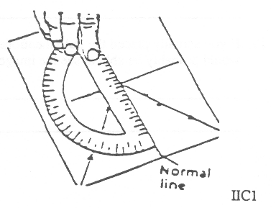
7. Look at Trial A. Using a protractor, draw a line perpendicular to the mirror line. This perpendicular line should begin at the point where rays “I” and “R” meet at the mirror line. This perpendicular line is called a “normal line.” (“Normal” is derived from the ancient Latin word for carpenter’s square, “norma.” Thus, it is associated with a perpendicular line.)

BEHAVIOR OF LIGHT 2C1

HOW DOES LIGHT REFLECT FROM A MIRROR SURFACE? 2

8. For Trial A, use a protractor to measure the angle of incidence. This is the angle between the normal line and the light ray “I.” Write this number in the second column of the table.

9. Now measure the angle of reflection. This is the angle between the normal line and the reflected ray “R.” Write this number in the third column of the table.

10. For Trials B and C, draw normal lines according to the instructions in step 7. ‘Men measure the angle of the incidence and angle of reflection for each of the two trials, and record your numbers in the table.

11. Look at the information in the table. How does the angle of reflection compare to the angle of incidence for each trial?
_______________________________________________________________________________________________
_______________________________________________________________________________________________
12. What happens to the angle of reflection as the angle of incidence is increased?
_______________________________________________________________________________________________
13. If you are given an angle of incidence and a mirror line, how could you predict the angle of reflection without using a light source?
_______________________________________________________________________________________________
_______________________________________________________________________________________________
14. Below is a sketch showing the top view of a small light bulb positioned in front of a mirror. Three light rays are drawn, representing light leaving the bulb and traveling in three different directions toward the mirror. Using your protractor and the relationship you inferred in step 11, carefully draw the three reflected rays of light.
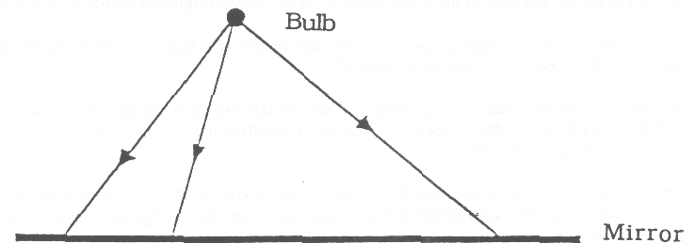

15. In the above sketch the three light rays reflecting off the mirror seem to be heading in all different directions. Using your ruler, determine whether the three reflected rays appear to all come approximately from the direction of a single common point on the other side of the mirror. Show this common point on your sketch.

16. What do you think this point represents?
_______________________________________________________________________________________________
_______________________________________________________________________________________________
17. If you actually placed the bulb mentioned above in front of a mirror and then looked into the mirror, you would probably be able to see the image of the bulb. Where would the mirror image of the bulb be located?
_______________________________________________________________________________________________
_______________________________________________________________________________________________

BEHAVIOR OF LIGHT 2C1

DATA SHEET FOR “HOW DOES LIGHT REFLECT FROM A MIRROR SURFACE?” 3

Note. . . When the word mirror is used, it is referring to the reflection surface of the mirror. Most mirrors that we use have the reflecting surface on the back of the mirror. The mirrors you will be using will be of this type. Thus when you are asked to ‘mount the mirror on the mirror line, you should mount the reflecting surface ‘back of the mirror’ on this line.

TRIAL A
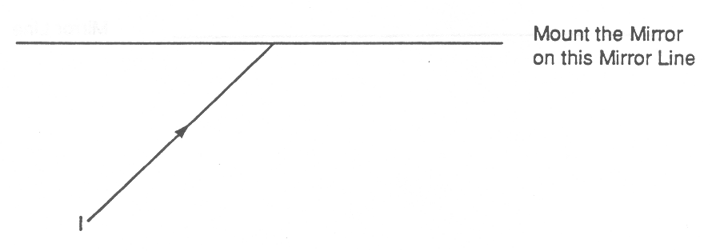

TRIAL B

2c1
TRIAL C

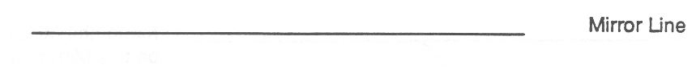

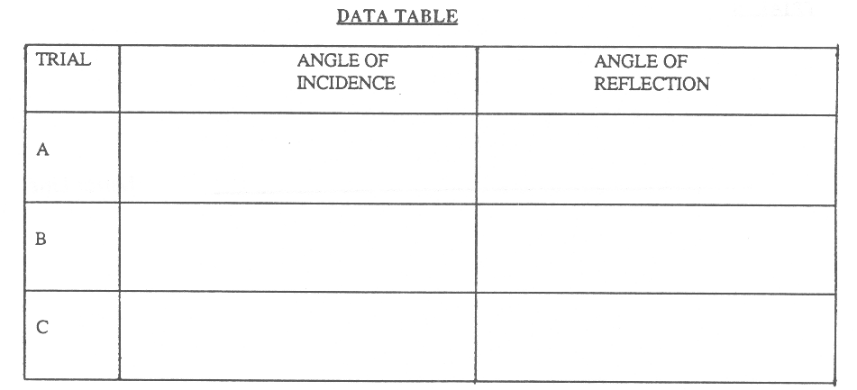

BEHAVIOR OF LIGHT 2C1TN

HOW DOES LIGHT REFLECT FROM A MIRROR SURFACE?

IDEA: PROCESS SKILLS:
When a beam of light reflects from a mirror, Measuring
the angle of reflection equals the angle of Formulating Models
incidence.

LEVEL: U DURATION: 20 Min.

STUDENT BACKGROUND: Students need to know how to draw and measure angles with a protractor. In addition, they should have some familiarity with mirrors and reflected light.

ADVANCE PREPARATION: Each student will need a light source that produces a single beam of light. You can use the cardboard light source box that is designed to be used with the Elementary Science Study kit on Optics. This box has a clear bulb mounted in its center and rectangular windows around the four sides. Cover three of the windows with opaque masks and use a single slot mask for the fourth opening. You can create your own out of ice cream cartons or other boxes.

A second option is to use a flashlight with an appropriate mask. Make the mask out of cardboard. Cut out a circle identical in size to the plastic disc that just fits inside the front of the flashlight. Using a razor (or knife) cut out a slot about 2 mm wide by 22 mm long in the center of the cardboard disc. Instead of cutting cardboard, you may make a mask out of opaque tape. You have to experiment with the positioning of the flashlight so the beam it produces will be easily observed along the surface of the paper. (One suggestion is to hold the flashlight near the edge of the table and partially below the surface This way the light beam will skirt the surface of the table
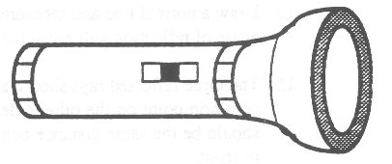
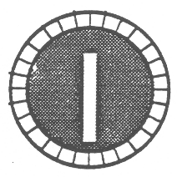

MANAGEMENT TIPS: 1. The first question is meant to encourage students to think about how a mirror works. Most students have probably never thought about this before. After giving them some time to write down their ideas, engage the whole class in a discussion to share ideas. At this point you can accept all student ideas as worthy of consideration. As they perform more experiments, they will be lead to think about the role that light plays in the formation of mirror images. It is very doubtful that students will suggest this role without having learned it before.

2. The experiment will work best if the room lights are off.
3. If the reflected light beams are not visible on the paper, it might help to tilt the mirror slightly forward.
4. Since the light beams have a certain width, when tracing the paths of the incident and reflected beams on the data sheets, the students should consistently align their ruler with one edge of the beam or with the middle of the beam. (If a flashlight beam is used, it is easiest to use the middle of the beam.)
5. When tracing the incident and reflected beams, the ruler may get in the way of the mirror. To avoid this problem, the student can trace only those parts of the “I” and “R” beams away from the mirror surface, then remove the mirror and extend the two lines to intersect at the mirror line.
BEHAVIOR OF LIGHT 2C1TN

HOW DOES LIGHT REFLECT FROM A MIRROR SURFACE? 2

RESPONSE TO
SOME QUESTIONS: 1 See the comments under #I in Management Tips.

6. One possible description would be similar to the following. As the incident beam approaches the mirror closer and closer to its surface, the reflected beam leaves the mirror closer and closer to its surface.

8. The angle of incidence for Trial A is 400.

9. The angle of reflection should be about 400.

11. The data should show that the angle of reflection is approximately equal to the angle of incidence.

12. It increases

13. Draw a normal line and measure the angle of incidence. The angle of reflection will equal the angle of incidence.

15. The three reflected rays should all appear to come from a single common point on the other side of the mirror line. This point should be the same distance behind the mirror line as the bulb is in front.

16. This point corresponds to the position of the “image” of the bulb. If you were actually to set up the bulb and mirror according to the sketch and look into the mirror, this is where you would see the image. (Refer to the previous activity: “Where Is the Mirror Image?”)

17. The image of the bulb would be located the same distance behind the mirror that the bulb was in front of the mirror.

POINTS TO EMPHASIZE
IN SUMMARY DISCUSSION: 1 When light reflects from a mirror, the angle of incidence equals the angle of reflection. This important relationship is known as the Law of Reflection. The fact that light behaves this way allows one to make predictions about reflected light. It also is the reason why mirror images are good reproductions of the actual objects.

2. Steps 14 through 17 should lay the ground work for the students to begin to understand how mirror images originate. Light leaves each point on the object and heads toward the mirror. The light reflects off the mirror according to the law of reflection and then may enter an observer’s eye. The brain of the observer then traces back this reflected light, in straight lines, to where it apparently came from. This is where the image appears to be located.

3. Steps 14 through 17 also provide the background for deriving the mirror image rule that was discussed in the activity “Where Is the Mirror Image? ‘Me rule is that the mirror image of an object appears to be located the same distance behind the mirror plane as the object is in front, measured along a line perpendicular to the mirror plane.

BEHAVIOR OF LIGHT 2C2

HOW DOES LIGHT REFLECT FROM A NON-SHINY SURFACE?

Materials: light source producing a narrow beam of light
Mirror
2 white cards
piece of aluminum foil the same size as the cards

1. Set up the light source, mirror and one index card as shown in the top view diagram below. Hold the mirror perpendicular to the table, about 10 cm from the light source. Hold card A perpendicular to the table, about 10 cm from the mirror.
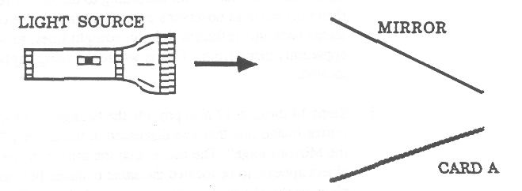

2. Aim the beam of light at the mirror and reflect it onto the white card (card A). Describe what you observe on card A.
_______________________________________________________________________________________________
_______________________________________________________________________________________________

3. Explain what you see on card A.
_______________________________________________________________________________________________
_______________________________________________________________________________________________

4. Crumple up the piece of aluminum foil and then unfold it. Replace the mirror with the crinkled piece of aluminum foil and repeat step 2. Describe what you see on the card.
_______________________________________________________________________________________________
_______________________________________________________________________________________________

5. Why is the pattern of light on the card in step 4 different from that observed in step 3?
_______________________________________________________________________________________________
_______________________________________________________________________________________________

6. Replace the aluminum foil with the second white card (card B), holding it perpendicular to the table in the same position as you previously held the foil. While looking at the side of card A facing card B, move card B in and out of the beams of light by raising the card off the table and then lowering it. Do this several times. Describe what happens on card A when card B is put in the beam.
_______________________________________________________________________________________________
_______________________________________________________________________________________________

7. Explain why card A has light on it. Where did the light come from?
_______________________________________________________________________________________________
_______________________________________________________________________________________________
BEHAVIOR OF LIGHT 2C2TN

HOW DOES LIGHT REFLECT FROM A NON-SHINY SURFACE?

IDEA: PROCESS SKILLS:

Light reflects diffusely from a non-shiny Observing

surface Inferring

LEVEL: L/U DURATION: 15 Min.

STUDENT BACKGROUND: Many students (especially those younger than 11, but also older ones)
will have trouble recognizing that light reflects from a non-shiny
surface. This idea, however, is crucial if one is to understand how
objects are seen.

MANAGEMENT TIPS: The room lights should be dimmed or turned off for this activity.
Use a light source described in the Management Tips section of the
Teachers Notes for the previous activity, 2C1, “How Does Light
Reflect From a Mirror Surface?”
You may need to go around the room and help each group with step
6. Even though it only takes a few seconds to make the observations,
students will miss the crucial point if they do not do it correctly.
RESPONSES TO
SOME QUESTIONS: 2&3 A vertical band of light should be seen on the card. This
represents the beam of light that was reflected by the mirror.

4&5 A random pattern of light should be observed on the card.
This results from mirror reflections from the many surfaces of
the aluminum foil that are oriented in different directions (and
resulting from “crinkling” of the surface).

6&7 When card B is put into the path of the light beams, card A
becomes uniformly illuminated, although not very brightly
illuminated. Because this only happens when card B is put
into the light beam path, you can infer that light must reflect
from card B to card A.
POINTS TO EMPHASIZE
IN SUMMARY DISCUSSION: 1. A narrow beam of light reflects from a plane mirror as a
narrow beam of light (step 2). If the mirror surface is crinkled
so it is made up of many small “mirrored” surfaces oriented in
directions, then a narrow beam of light is reflected as many
tiny beams going in many different directions (step 4). On the
card you observed many tiny spots of light
.
2. When a narrow beam of light strikes a non-mirror surface, like
a piece of paper, the light seems to reflect (almost uniformly)
in all directions. In the latter case there are no spots of light
seen on the paper, just uniform illumination. One possible
inference is that the paper is made up of a very large number of
tiny microscopic surfaces, so small that you cannot see them.
The light reflects off these tiny surfaces uniformly in all directions.

3. Discuss the Focus on Physics section: “Regular and Diffuse
Reflection.”
BEHAVIOR OF LIGHT 2C3F

FOCUS ON PHYSICS
REGULAR AND DIFFUSE REFLECTION
(Discussion)

1. In a previous activity, you observed that parallel narrow beams of light striking a mirror surface are parallel narrow beams of light. Each beam reflects according to the Law of Reflection: the angle of reflection equals the angle of incidence. When light behaves this way it is called regular or specular reflection. Below is a sketch of several parallel beams of light striking a mirror surface.
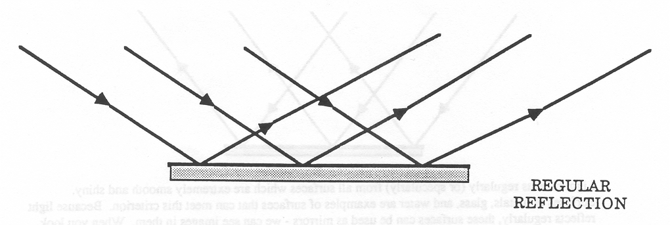

Light reflects regularly (or specularly) from all surfaces which are extremely smooth and shiny. Surfaces of metals, glass, and water are examples of surfaces that can meet this criterion. Because light reflects regularly, these surfaces can be used as mirrors - we can see images in them. When you look into such a “mirror surface,” your image appears to be an equal distance behind the surface as you are in front.

2. You had also observed a classroom activity that paralleled narrow beams of light striking a non-mirror surface (like paper) and reflected in all directions in front of the paper. This is called diffuse reflection.

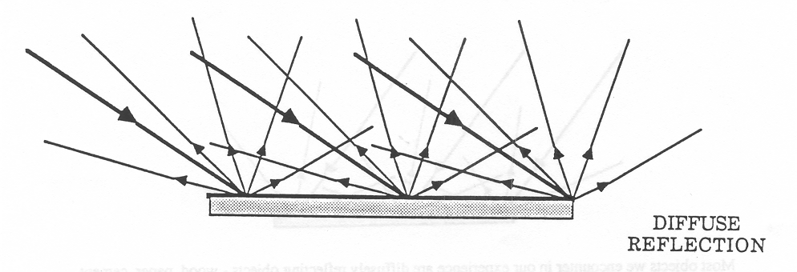

Most objects we encounter in our experience are diffusely reflecting objects - wood, paper, cement, clothing, skin, etc. Consider a piece of paper that is illuminated by light. When you look at the paper, fight diffusely reflecting from each point can enter your eye, enabling you to see the paper at its actual position. Instead of seeing any “image,” you just see the illuminated paper.

The fact that most objects that we encounter in our everyday experience are diffusely reflecting enables us to see them.

BEHAVIOR OF LIGHT 2C3F

CLOSE-UP VIEW OF DIFFUSE REFLECTION 2

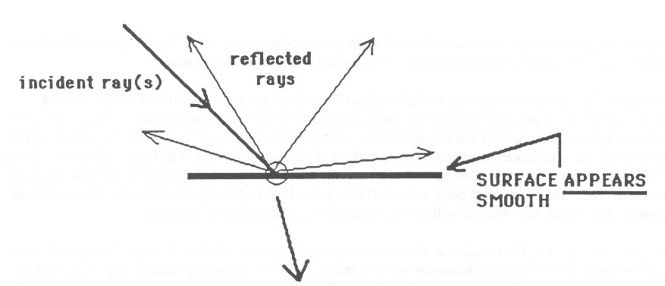

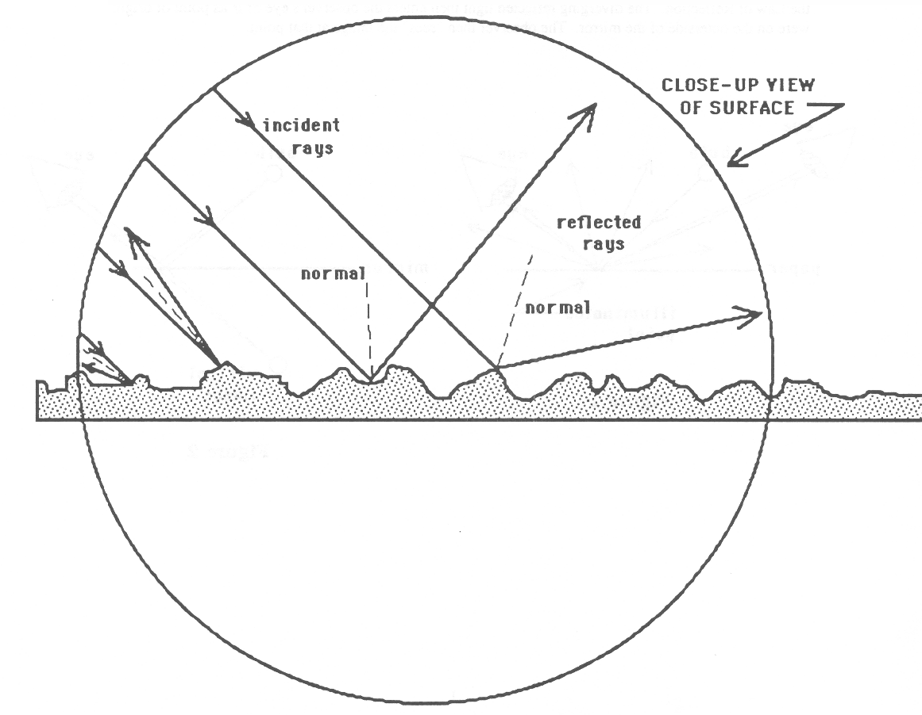
BEHAVIOR OF LIGHT 2C5F
FOCUS ON PHYSICS
WHAT IS THE DIFFERENCE BETWEEN A PLANE MIRROR AND A PIECE OF PAPER

Suppose a light bulb is placed near a sheet of white paper and a plane min-or. If the paper and the mirror reflect light, why do they appear different? Why doesn’t the paper act like a mirror?

The answer has to do with the way the light reflects from the paper and the mirror; the light reflects diffusely from the paper, but regularly (or specularly) from the mirror. Figures 1 and 2 below represent a top view light ray diagram for the two situations. As represented in Figure 1, light diverges from a point on the bulb and goes toward the paper. At the surface of the paper this light is diffusely reflected from each point in all directions. Light diverging from a point on the surface of the paper enters the observer’s eye, who then “sees” the illuminated point at the surface. Since light from the bulb diffusely reflects off every point on the surface, the observer will see the entire illuminated surface of the paper.

As shown in Figure 2, the situation at the plane mirror surface is very different. Light diverging from a point on the bulb goes toward the mirror where it reflects from the surface specularly; that is, according to the Law of Reflection. The diverging reflected light then enters the observer’s eye as if its point of origin were on the outerside of the mirror. The observer then “sees” the image at that point.

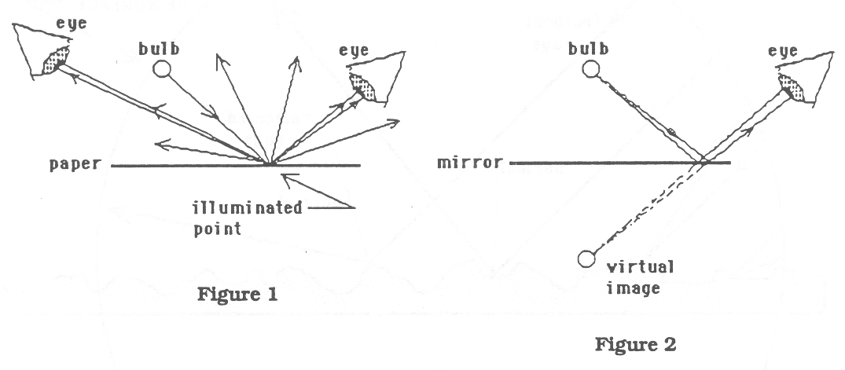

BEHAVIOR OF LIGHT 2D1F

FOCUS ON PHYSICS
DRAWING RAY DIAGRAMS TO DESCRIBE HOW PLANE MIRRORS FORM IMAGES

1. First, we must agree that in order to see an object, light must travel from that object to your eye. If the object is not self-luminous, then we must assume that light first traveled from a light source to the object, and then reflected diffusely off the object and entered the eye. To make our discussion easier, let us assume that we are looking at a small light bulb (one that is turned on and gives off its own light). The sketch below shows two light rays representing light diverging (spreading out) from a point on the bulb and traveling toward a person’s eye. The eye and the brain work together in such a way that the person “sees” the point on the bulb precisely where the two light rays, extended backwards in straight lines, appear to have originated.
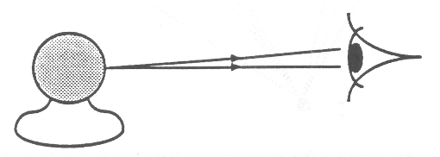

2. In the two activities, “Where is the Mirror Image?” and “How Does Light Reflect From a Mirror Surface?” you discovered where a mirror image is located and how light behaves when reflecting from a mirror surface. In the first case, the location of the mirror image is given by the following rule, which we shall refer to as the Plane Mirror Image Rule: the MIRROR image of an object appears to be located the same distance behind the mirror plane as the object is in front. measured along a line perpendicular to the mirror plane The behavior of light when reflecting from a mirror surface is given by the Law of Reflection, which says that when light reflects from a mirror surface the angle of reflection equals the angle of incidence.

The last few steps of the activity, “How Does Light Reflect From a Mirror Surface?” also showed you the origin of the Mirror Image Rule. The reason why the mirror image of an object appears just as far behind the mirror as the object is in front is because of the Law of Reflection. You can see how this comes about by drawing a light ray diagram. We often find it convenient in drawing ray diagrams for mirrors to use a TOP VIEW of the situation. Using a top view makes it easier to apply the law of refraction for light rays.

On the following page we have drawn a ray diagram showing a small light bulb in front of a plane mirror. We have drawn several light rays diverging (i.e. spreading out) from one point on the light bulb, labeled O and heading toward the mirror. Each light ray reflects from the mirror according to the Law of Reflection. (To construct this diagram we would need to use a protractor to measure the angle of incidence for each case, and then construct the reflected ray so the angle of reflection would equal the angle of incidence.) All the light rays that are shown reflecting from the mirror appear to be coming from a single common point behind the mirror. We have labeled this point, I. It represents the image of the original point on the light bulb, Q.
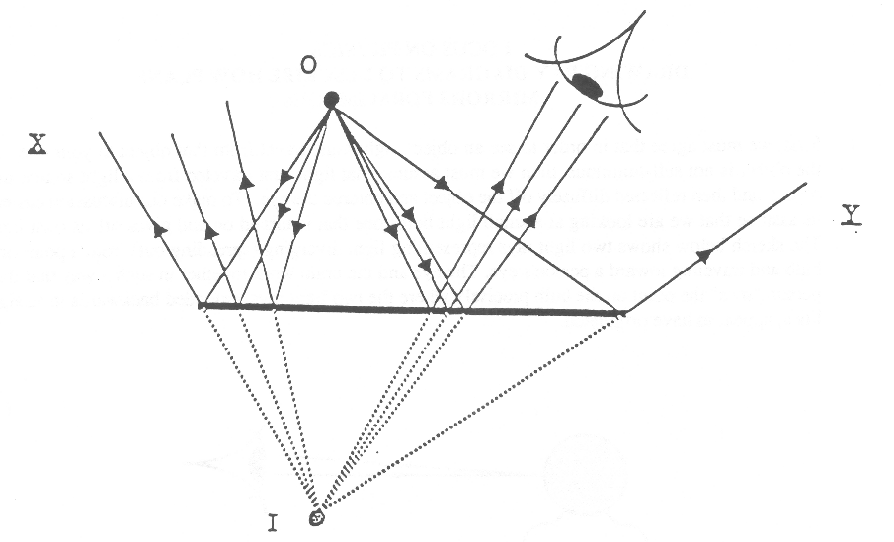

Even though we have drawn only a few representative light rays in the above sketch, all the light leaving the point 0 and heading toward the mirror will reflect off as if coming from the direction of the image point 1. Furthermore, if you measure the perpendicular distance between the mirror and 1, you will find that it equals the perpendicular distance between O and the mirror. This, of course, is just a form of the Plane Mirror Image Rule, so we have shown how this Rule follows from the Law of Reflection.

BEHAVIOR OF LIGHT 2D1F

FOCUS ON PHYSICS
DRAWING RAY DIAGRAMS TO DESCRIBE HOW PLANE MIRRORS FORM IMAGES 2

3. In the previous ray diagram we have also included an eye, which represents a person looking at. the mirror image of the light bulb. We have drawn three of the reflected light rays which enter the eye. The eye and the brain work together in such a way that the person would “see” the mirror image, 1, precisely at that point where the two reflected light rays, extended backwards in straight lines, appear to have originated. The person “sees” the image the same distance behind the mirror plane as the object is in front. This is what you had observed when you were using the half-silvered mirror in the activity “Where is the Mirror Image?”

4. If an object is a certain distance in front of a mirror plane, we could use the Plane Mirror Image Rule as a convenient short-cut method to determine where its image would be located and to draw the ray diagram. We would not need a protractor to measure angles. Instead, to find the image position we need only to use a ruler and apply the Plane Mirror Image Rule. Then, we could draw a few representative rays leaving the object and going to the mirror. To draw each reflected ray we would simply use the ruler to line up the image and the point on the mirror where the ray struck. The reflected ray would then be drawn so it appears to come from the direction of the image.

Below we have drawn TOP VIEWS for two different situations for a light bulb (O) in front of the mirror. We have also used the Plane Mirror Image Rule to locate the images (I) of these two bulbs. (Note that when the object is not directly in front of the mirror, you apply the mirror image rule by extending the mirror line, shown as a dotted line in the diagram below, and measure the perpendicular distances in front of and behind that extended mirror line. In three dimensions, it would be an extended mirror plane.)
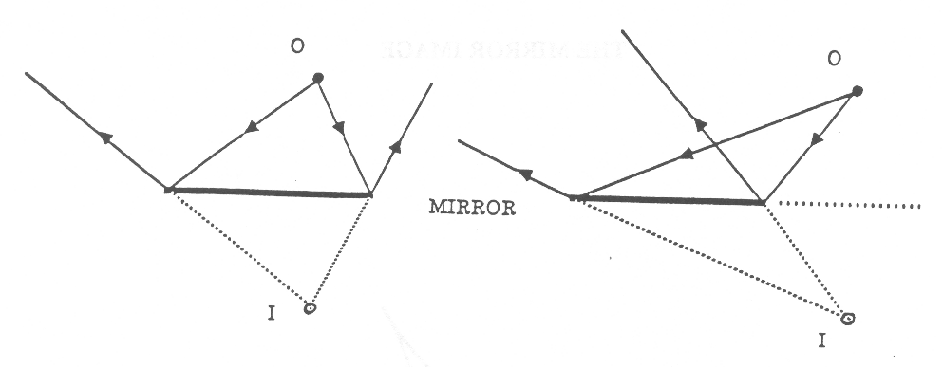

5. Consider again the case of the light bulb in front of the mirror plane. Suppose a person is also in front of the mirror plane and is looking in the direction of the mirror. Will the person be able to see the image of the bulb? We will try to answer that question in general terms.

First of all, we must remember that the position of the image only depends on the position of the object (bulb) relative to the mirror. It does not depend on where the person looking at the mirror happens to be.

However, whether or not the person can see the image does depend on where the person is. If an object is in front of the mirror plane, a person will be able to see the image of the object only if light diverging from the object and reflecting off the mirror enters the person’s eye. If a person is positioned so that no light reflecting off the mirror enters the eye, that person will not be able to see the image, even though he or she may be looking in the direction of the mirror. An eye located at either position X or Y in the ray diagram on the second page of this Focus section will not see the image of the light bulb in the mirror. There are no light rays you can draw from O that, after reflecting from the mirror as if coming from 1, will go in the direction of either X or Y.

Of course, in our everyday experience with mirrors, we always naturally position ourselves appropriately so we can see the images we want to see. Even though we do this “naturally,” there are some important physics principles at work!

6. More information about mirror images is provided in the following reprint of an article that appeared in the November 1986 issue of The Physics Teacher.

BEHAVIOR OF LIGHT 2D2

THE MIRROR IMAGE

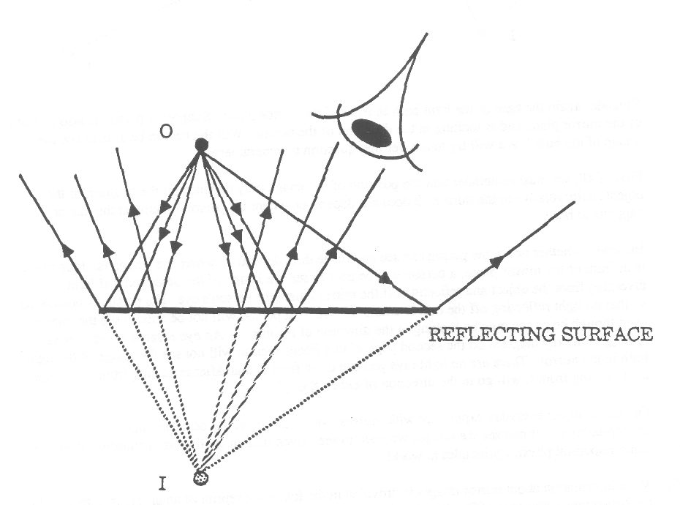

BEHAVIOR OF LIGHT 2D2

CAN AN OBSERVER SEE A MIRROR IMAGE?

Consider now an interesting question. Suppose an object is in front of a mirror and an observer is looking in the direction of the mirror. Will the observer be able to see an image of the object? To find out you must determine whether or not light from the object which reflects from the mirror can enter the observer’s eye. If it can, then the observer will be able to see the mirror image. If it cannot, the observer will not be able to see a mirror image of the object. In the diagram below, observers at El and E2 can see a mirror image, whereas the observer at E3 cannot.

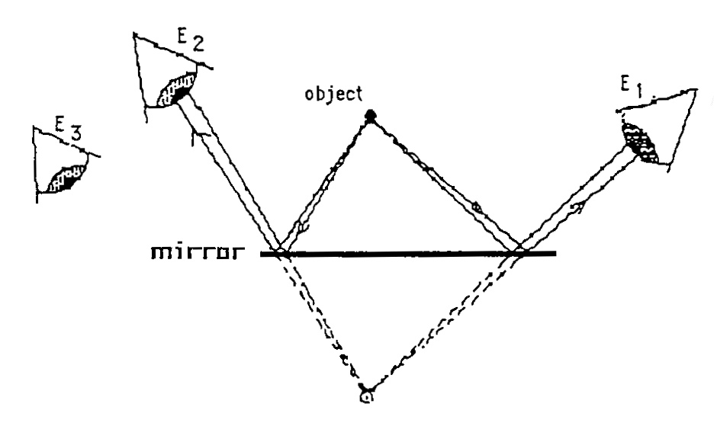
BEHAVIOR OF LIGHT 2E1

WHAT DO CURVED MIRRORS DO?

Materials: highly polished spoon
card with spoon-size oval hole cut out of it, taped onto a flat mirror
pencil

Curved mirrors are fascinating devices. A spoon is not a very good quality curved mirror, but is will still allow you to explore some of the basic properties of curved mirrors.
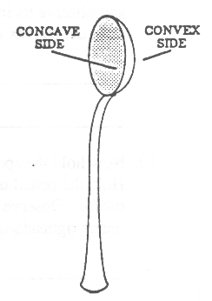
1. Look into the bowl of a shiny spoon with the handle down from the bowl. Describe how you look.
_______________________________________________________________________
_______________________________________________________________________
2. Move the spoon so you can see yourself right side up. Describe how you did it.
_______________________________________________________________________
_______________________________________________________________________
3. The two sides of the spoon represent two types of curved mirrors. As you face the mirror, if its center is farthest from you, it is called a concave mirror (like the inside of a “cave”). If its center is closest to you, and its edges are farthest away, it is called a convex mirror. Identify the concave and convex sides of the spoon.

4. Hold the spoon in your right hand at arms length with the convex side facing you. Hold the ovalshaped plane mirror in you left hand next to the convex mirror. Look in both mirrors. Compare your image in the plane mirror with your image in the convex mirror.
________________________________________________________________________________________________
________________________________________________________________________________________________
5. Can you see more of yourself (and the scene behind you) in the convex mirror or in the plane mirror?
________________________________________________________________________________________________
________________________________________________________________________________________________
6. Repeat Step 2, but this time, have the concave side of the spoon mirror facing you. Compare your image in the plane mirror with your image in the concave mirror.
________________________________________________________________________________________________
________________________________________________________________________________________________
7. Compare your image in the convex mirror with your image in the concave mirror.
________________________________________________________________________________________________
________________________________________________________________________________________________
8. Hold the spoon horizontally in your left hand at arms length with the convex side facing you. Hold the pencil upright in your right hand with the eraser end almost touching the center of the convex mirror. Observe the image of the pencil eraser in the mirror. Is the image rightside-up or upside-down?
________________________________________________________________________________________________
9. Keeping the convex mirror at arms length in your left hand, slowly move the pencil toward your face, and observe its image in the mirror. Describe how the image of the pencil changes as you move it from the convex mirror toward your face.
________________________________________________________________________________________________
________________________________________________________________________________________________
BEHAVIOR OF LIGHT 2E1

WHAT DO CURVED MIRRORS DO? 2

10. Now hold the spoon horizontally in your left hand at arms length with the concave side facing you. Hold the pencil upright in your right hand with the eraser end touching the center of the concave mirror. Observe the image of the pencil eraser in the mirror while it’s touching the spoon. Is the image rightside-up or upside-down?.
________________________________________________________________________________________________
________________________________________________________________________________________________
11. While keeping the concave mirror at arms length in your left hand, slowly move the pencil toward your face, and observe its image in the mirror. Describe how the image of the pencil changes as you move it from the concave mirror toward your face.
________________________________________________________________________________________________
________________________________________________________________________________________________
12. Which type of mirror is used for the following:

a. rear-view mirror on the passenger side of a car ______________________________________________________

b. shaving cosmetic mirror ________________________________________________________________________

c. surveillance mirror in a store _____________________________________________________________________
BEHAVIOR OF LIGHT 2E1TN

WHAT DO CURVED MIRRORS DO?

IDEA: PROCESS SKILLS:
Curved mirrors can form images that may be Observing
either upside-down or rightside-up, and either Inferring
larger or smaller than the object.

LEVEL: U DURATION: 20-30 Min.

STUDENT BACKGROUND: Students should already be familiar with the properties of images formed in plane mirrors.

ADVANCE PREPARATION: The bigger and shinier the spoon, the better. If the spoon is not shiny, then the images will be difficult to observe. If you are fortunate to have regular convex or concave mirrors, they would be better, of course.

For Step 2, you can prepare the oval-shaped, flat mirror in advance.
Better yet, have the students tape the card to the flat mirror.

MANAGEMENT TIPS: For Step 8, students will have to hold the pencil tip very close to (touching) the concave side of the spoon in order to observe the enlarged and rightside-up image. With the pencil just a short distance away from the concave mirror, the image will be upside- down and remain that way as the pencil is pulled farther away.

1 . The image in the bowl of the spoon is upside-down.

2. Most students will rotate the handle until it is above the bowl.
They have the naive idea that the image exists like a photograph
on the spoon. Instead, they should turn the spoon and look at
the back.

4. The image in the convex mirror is much smaller than the image
in the plane mirror.

5. You can see much more of yourself and the scene behind you in
the convex mirror than you can see in the plane mirror.

6. The image in the concave mirror is upside-down and smaller than
the image in the plane mirror.

8. The image in the convex mirror becomes smaller and smaller.
POINTS TO EMPHASIZE
IN SUMMARY DISCUSSION: In a plane mirror, the image is always right side-up and the same size as the object. In a convex mirror, the image is always right side-up, but becomes smaller as the object is farther and farther from the convex mirror. With a concave mirror, the image is right side-up and enlarged when the object is very close to the mirror. As the object moves farther away, the image is upside-down and becomes smaller and smaller.
BEHAVIOR OF LIGHT 2E1TN

WHAT DO CURVED MIRRORS DO?

Even though this activity dealt with curved mirrors, light behaves the same way when reflecting from curved mirrors as it does when reflecting from plane mirrors That is, when light strikes any mirror (curved or flat) the reflected light obeys the Law of Reflection: the angle of reflection equals the angle of incidence. (To actually draw the reflected ray for a curved mirror you would first need to construct a tangent to the curved mirror at the point where the light ray was incident on the mirror. Once you have drawn the tangent, you can treat that as if it were a plane mirror.)

POSSIBLE EXTENSIONS: 1. Suggest to students that they experiment with spoons at home when around the dinner table. The lights from a hanging chandelier are particularly good for forming images with the concave side of the spoon.

2. If students feel comfortable with the concept of where the mirror image is located, you can challenge them to determine where the images are located with both the convex and concave mirrors. They would need to do this experimentally because the rules for determining image location are not as simple as are the rules for a plane mirror. Recall that for a plane mirror the size of the image was always the same size as the object, and the position of the image was always an equal distance behind the mirror as the object was in front. For a curved mirror, the position and size of the image depends on the position and size of the object and on the curvature of the mirror.

In the convex case, the image is always behind the mirror, but the position and size of the image depends on the position and size of the object. The rule for predicting exactly where the image is located is more complicated than for a plane mirror. In the concave case, when the object is close to the mirror, the image is right side up and is behind the mirror. If the object is moved further from the concave mirror, then at some point, the image becomes upside-down and is located out in front of the mirror. You can notice this last effect by the way your eyes change their focus when looking at the image.

3. With a concave mirror and an object outside the focal length, an image is formed that can be projected on a screen.
BEHAVIOR OF LIGHT 3WL

WORKSHOP LEADER’S PLANNING GUIDE
REFRACTION

After an initial discussion of transparent, translucent, and opaque materials, the remaining activities in this section focus on describing refraction and its effects. First, students investigate how light beams refract when passing through a transparent material. Second, they observe the distortion of objects viewed through transparent materials and explain the phenomena in terms of refraction.

Naive Ideas:

1. When light shines on a translucent material and illuminates it, light does not travel from the material to the eye. (3A1D)

2. Light always passes straight through a transparent material without changing direction. (3B1, 3B2F, 3B3)

3. When an object is viewed through a transparent solid or liquid material, the object is seen exactly where it is located. (3C1. 3C2, 3C3, 3D1, 3D2, 3C5F)

A. WHEREAS LIGHT PASSES THROUGH A TRANSPARENT MATERIAL WITHOUT BEING DIFFUSED, IT IS DIFFERENTLY TRANSMITTED THROUGH A TRANSLUCENT MATERIAL.

1. Demonstration/Discussion: What Is the Difference Between Transparent, Translucent, and Opaque Objects?

Students are asked to draw diagrams showing how light behaves when passing through transparent and translucent materials and when striking an opaque material. Use the following overhead to accompany this discussion.

2. Overhead: Transparent, Translucent, and Opaque Materials

B. LIGHT CHANGES DIRECTION (REFRACTS) WHEN CROSSING THE BOUNDARY BETWEEN TWO DIFFERENT TRANSPARENT MATERIALS.

1. Activity: How Does Light Change Direction?

Students study the refraction of a beam of light passing through the front and back surfaces of a transparent rectangular block and a triangular prism.

2. Discussion-Focus On Physics: Refraction Of Light

First, it is mentioned that refraction can occur when light travels between any two different transparent materials, including solids, liquids, and gases. Second, a simple qualitative rule for describing how light refracts is demonstrated for two situations: light traveling from air into a solid or liquid material; and light traveling from a solid or liquid material into air. In the latter situation, the case of total internal reflection is also discussed. The following overheads should be used in conjunction with this discussion.

3. Overheads (4):
a) Rules of Refraction
b) Refraction of Light
c) The Amount of Refraction Depends on the Angle of Incidence
d) The Critical Angle and Total Internal Reflection

BEHAVIOR OF LIGHT 3WL

WORKSHOP LEADER’S PLANNING GUIDE
REFRACTION - 2

C. BECAUSE OF REFRACTION, THE APPARENT POSITION OF AN OBJECT VIEWED THROUGH A TRANSPARENT MATERIAL IS DIFFERENT FROM THE ACTUAL POSITION OF THE OBJECT.

1. Activity: How Do Objects Appear When Seen Through a Transparent Material?

Students investigate three different situations in which an object appears distorted or displaced as a result of refraction. Included in the teachers’ notes for this activity are suggestions for using the following overheads.

2. Overheads (3):
a) The Appearing Coin
b) The Distorted Straw
c) The Displaced Pencil

3. Activity: Where Do You Aim To Spear the Fish?

Students try to shoot a long dowel rod through a sighting tube to hit a coin at the bottom of an aquarium tank. Use the following overhead during the discussion following the activity.

4. Overhead: Where Do You Aim?

5. Discussion - Focus On Physics: Refraction Through a Plexiglas Block

D. SOME MIRAGES AND ATMOSPHERIC DISTORTION PHENOMENA CAN BE EXPLAINED BY REFRACTION OF LIGHT.

1. Discussion - Focus On Physics: Mirages and Twinkling Stars

The “water-on-the-road” mirage and the twinkling of stars are discussed in terms of refraction of light. The following overhead should be used with this Focus section.

2. Overhead: Water on the Road Mirage

BEHAVIOR OF LIGHT 3A1D

WHAT IS THE DIFFERENCE BETWEEN TRANSPARENT, TRANSLUCENT, AND OPAQUE OBJECTS?

Materials: 60 W (or greater) frosted light bulb mounted in socket, with electrical cord
thin sheet of transparent glass or plastic
thin sheet of translucent glass or plastic
thin piece of wood or some other opaque object
overhead: ‘Transparent, Translucent, and Opaque Materials”

The purpose of this demonstration/discussion is to help students classify materials according to their light transmission properties. It would be helpful if students had already read the Focus On Physics section, “Regular and Diffuse Reflection.” 2C3F

1. Have the light bulb turned on in full view of the students. Hold the transparent glass plate so students can see the light bulb through it. Ask students to draw a ray diagram showing how the light from the bulb passes through the glass.

A reasonable diagram might look like the following;
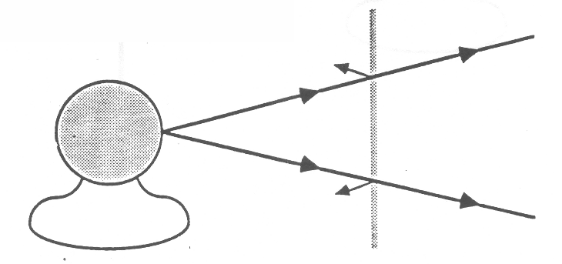

The fact that you can see objects clearly through the glass implies that light travels straight through the glass without spreading out in all directions. A material that behaves this way is called “transparent.”

2. Hold the thin translucent plate in front of the the light bulb, so students can observe that the plate is (almost) uniformly illuminated. Ask the students to draw a diagram showing what happens to the light passing through this material.

This situation will probably be more problematic for the students, A reasonable diagram might look like the following:

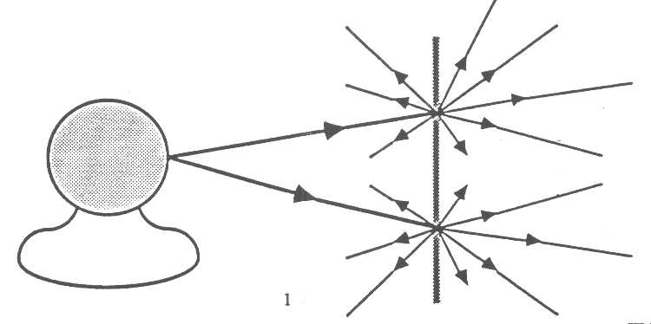

BEHAVIOR OF LIGHT 3A1D

WHAT IS THE DIFFERENCE BETWEEN TRANSPARENT, TRANSLUCENT, AND OPAQUE OBJECTS? 2

In this case, the light is diffusely transmitted through the material i.e. light passes through the material and is spread out in all directions. Such a material is called “translucent.”

3. Finally, hold up the piece of wood so it blocks the bulb from the students’ view. A material which allows no light to pass through it is called “opaque.”

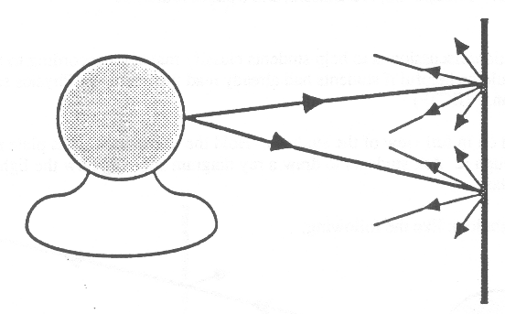

BEHAVIOR OF LIGHT 3A2

TRANSPARENT, TRANSLUCENT, AND OPAQUE MATERIALS

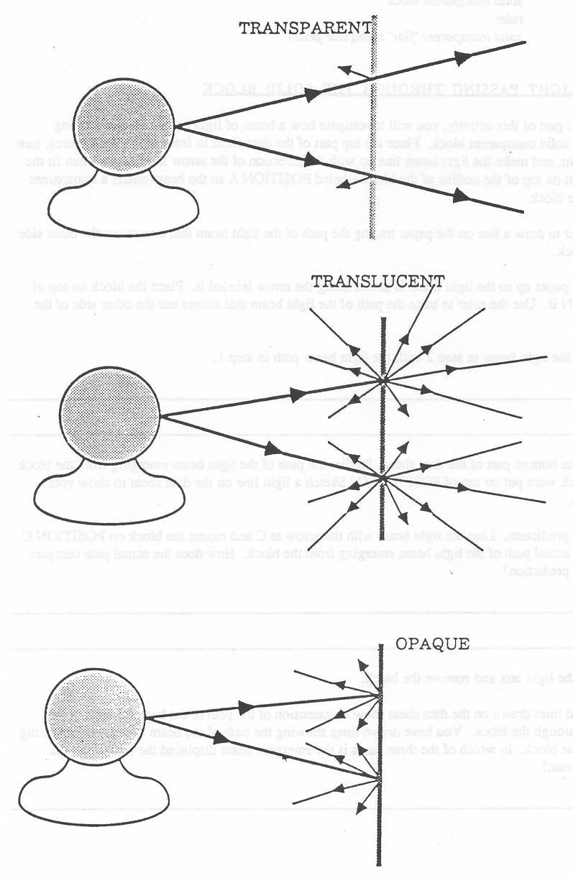
BEHAVIOR OF LIGHT 3B1

HOW DOES LIGHT CHANGE DIRECTION?

Materials: light source producing single narrow beam of light solid transparent block
solid transparent ‘y7at” triangular prism ruler

PART 1: LIGHT PASSING THROUGH THE SOLID BLOCK

1. In the first part of this activity, you will investigate how a beam of light behaves when passing through a solid transparent block. Place the top part of the data sheet in front of the light source, tam on the light, and make the light beam line up with the direction of the arrow labeled A. Then fit the block right on top of the outline of the block labeledposinON A so the beam enters a transparent face of the block.

Use a ruler to draw a line on the paper tracing the path of the light beam that comes out the other side of the block.

2. Move the paper up so the light beam is aimed along the arrow labeled B. Place the block on top of POSITION B. Use the ruler to trace the path of the light beam that comes out the other side of the block.

3. Compare the light beam in step 2 with the light beam path in step 1.
________________________________________________________________________________________________
________________________________________________________________________________________________
4. Look at the bottom part of the data sheet. Predict the path of the light beam emerging from the block if the block were put on top of POSITION C. Sketch a light line on the data sheet to show your prediction.

5. Test your prediction. Line the light beam with the arrow at C and mount the block on POSITION C. Trace the actual path of the light beam emerging from the block. How does the actual path compare with your prediction?
________________________________________________________________________________________________
________________________________________________________________________________________________
Turn off the light box and remove the block.

6. The dotted lines drawn on the data sheet show an extension of the path of the beam of light before passing through the block. You have drawn lines showing the path of the beam of light after passing through the block. In which of the three cases is the emergent beam displaced the most from the incident beam?
________________________________________________________________________________________________
7. As the block is slanted more and more, describe what happens to the emergent beam.
________________________________________________________________________________________________
________________________________________________________________________________________________
8. Inside the drawing of the block for POSITION A, use a ruler and draw a straight line connecting the points where the light beam enters and leaves the block. Then do the same for POSITION B and for POSITION C.

9. The lines you drew in step 7 represent the paths of the light beams inside the block.

For POSITION C compare the direction of the light beam inside the plastic block with the direction of the light beam outside the block.
________________________________________________________________________________________________
________________________________________________________________________________________________
10. The change in direction of the light when it passes FROM one transparent material into another is called refraction. In this experiment, light went from air into the solid block (at the front surface), and then from the solid block back into the air (at that back surface). For the situation in POSITION C, describe how the refraction of light at the front surface compares with the refraction of light at the back surface.
________________________________________________________________________________________________
BEHAVIOR OF LIGHT 3B1

HOW DOES LIGHT CHANGE DIRECTION? 2

11. In which of the three positions was there no apparent refraction of light?
________________________________________________________________________________________________
PART II: LIGHT PASSING THROUGH THE SOLID “FLAT” TRIANGULAR PRISM

In this part of the experiment, you will investigate on your own how light behaves when it passes through a triangular prism. We suggest you lay the prism on a separate sheet of white paper (or on the lower part of this sheet if you wish) and at the base so that it enters and passes through the prism and comes out the other side.

Observe what happens to the light beam upon entering and leaving the prism (paying particular attention to how the light changes direction at the first surface and at the second surface). As part of your observations you should also vary the angle at which the light beam strikes the surface. Trace the outline of the prism on the paper and sketch the path of the light beam for one typical case.

There is one additional observation you should certainly make. Try to arrange the light beam and *prism so that the light passing into the prism is totally reflected when it strikes the second surface. (None of the light passes through the second surface). Trace this situation on the paper in addition to the other case you drew. If you cannot observe this total reflection occurring inside the prism, ask the instructor for some assistance.

DATA SHEET FOR “HOW DOES LIGHT CHANGE DIRECTION?”
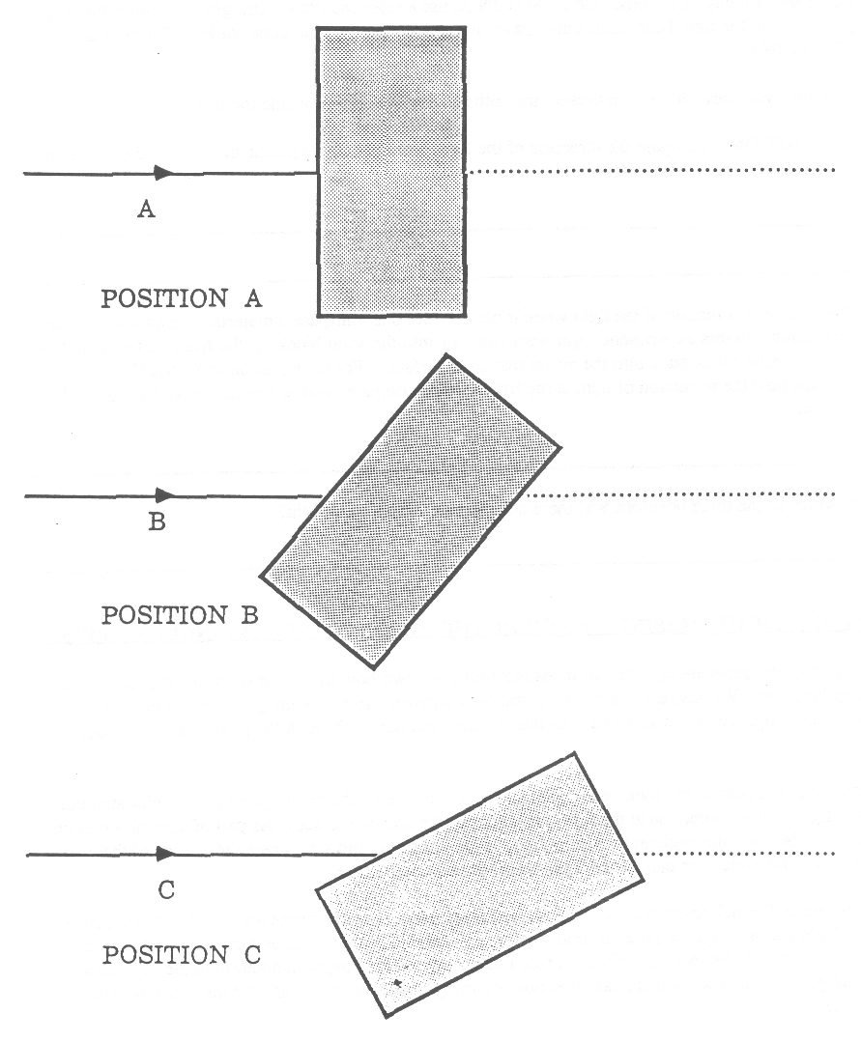

BEHAVIOR OF LIGHT 3B1TN

HOW DOES LIGHT CHANGE DIRECTION?

IDEA: PROCESS SKILLS:
Light changes direction (refracts) when Predicting
crossing the boundary between two different Formulating Models
transparent materials

LEVEL: I./U DURATION: 20-30 Min.

STUDENT BACKGROUND: Because the activity discusses light “entering” the block and “leaving” the block, students should understand that light can travel from one place to another.

ADVANCE PREPARATION: 1 . Each student group will need a light source that produces a single beam of light. One workable, but not so ideal option is to use a flashlight with an appropriate mask. Make the mask out of cardboard. Cut out a circle identical in size to the plastic disc that just fits inside the front of the flashlight. Using a razor (or knife) Cut out a slot about 2 mm wide by 22 mm long in the center of the cardboard disc. Replace the plastic disc with the cardboard disc. You have to experiment with the positioning of the flashlight so the beam it produces will be easily observed along the surface of the paper. (One suggestion is to hold the flashlight near the edge of the table and partially below the surface. This way the light beam will skirt the surface of the table. The reason the flashlight is not an ideal source is that the beam it produces tends to spread out more than would be appropriate for this activity.)

As an alternative source, you can use the cardboard light source box that is designed to be used with the Elementary Science Study kit on Optics. This box has a clear bulb mounted in its center and rectangular windows around the four sides. Cover three of the windows with opaque masks and use a single slot mask for the fourth opening.

2. The solid transparent block can be fabricated out of Lucite. The dimensions of the block used in drawing the outline on the data sheet were (1 in) x (1 in) x (2 in) and the (1 in) x (1 in) faces can be translucent, although it would be best if one of the (1 in) x (2 in) surfaces is transparent. Then the translucent (I in) x (2 in) surface should lay on the paper, and the opposite transparent surface should face upwards. That way, the students could observe the path of the light beam inside the block. If the transparent plastic or glass blocks you find or fabricate have different dimensions than those stated above, you will need to prepare your own data sheets. Simply trace your block’s outlines in the corresponding positions.

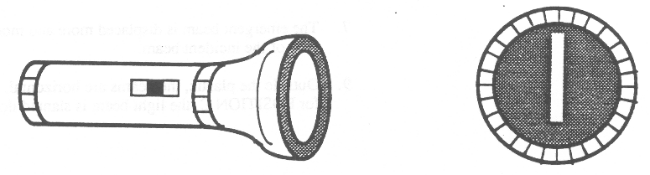

BEHAVIOR OF LIGHT 3B1TN

HOW DOES LIGHT CHANGE DIRECTION? 2

3. The side faces of the “flat” solid triangular prism that the beam travels through must be transparent and should be at least 1 cm thick. A 45º-90º prism would be very convenient. Following is a sketch of a prism that would be suitable for this activity. If the large flat bottom face that lies on the paper is frosted, and the large flat top face is transparent, then the students will be able to observe the path of the beam inside the prism.

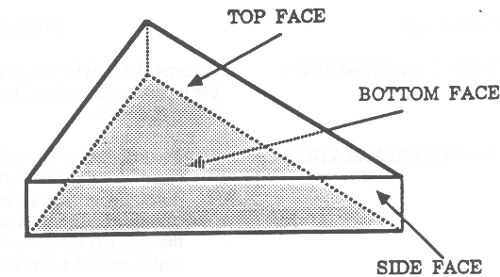

MANAGEMENT TIPS: Make sure that when the students place the block on the data sheet, the beam of light enters and emerges from the transparent faces (and not the translucent faces).

If the light beam is fairly wide, you should suggest to your students that they trace just one edge of the beam or the middle of the beam (and be consistent).

Part II of the activity is open ended, mainly because the type of prism used will depend on local availability. You need to pay close attention to what the students are doing for this part and, in particular, to make sure they observe total internal reflection.

Some of the student groups may also observe that when the emergent beam is nearly along the surface of the prism, it is colored. They may observe the colors of the spectrum: red, orange, yellow, green, blue, and violet. This separation of the white light into its component colors is called dispersion and occurs because the amount of refraction of the light depends on its wavelength (and the different colors of light correspond to different wavelengths). Color phenomena are discussed in detail in the OPERATION PHYSICS Color and Vision book.

RESPONSES TO
SOME QUESTIONS: PART ONE:

1, 2, 5, 8. Representative data are displayed on the following page.

6. Position C

7. The emergent beam is displaced more and more away from the path of the incident beam.

9. Outside the plastic, the beams are horizontal. Inside the plastic for POSITION C, the light beam is slanted downward.
BEHAVIOR OF LIGHT 3B1TN

HOW DOES LIGHT CHANGE DIRECTION? 3

10. The bending (refraction) of the light at the back surface was in the opposite direction to the bending of the light at the front surface. The amount of the bending seemed to be the same at both surfaces.

11. There was no refraction at either the front or back surface for Position A.

PART TWO:

Following are sketches for two situations of light passing through the 45o- 45o- 900 prism. The sketch on the right shows total internal reflection.
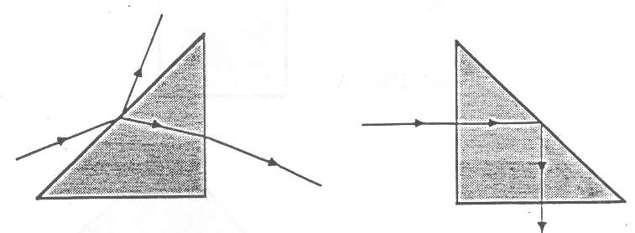

Use the transparency on the following page to facilitate discussion.

POINTS TO EMPHASIZE
IN SUMMARY DISCUSSION: 1. Light changes direction when going from air into another transparent material and when going from a transparent material back into the air.

2. This change in direction is called refraction.

3. The only exception to statement #1 occurs when light enters (or exits) another transparent material and when going from a transparent material back into the air.

4. Light bends (refracts) one way when traveling from air into a transparent material, and it bends the other way when traveling from the transparent material into air. In PART ONE of this activity, the observation that the amount of bending was about the same at both surfaces (but the direction of bending was the opposite) resulted only from the fact that the front and back surfaces of the block were parallel; the amount of bending at the two surfaces would have then been different. This should have been observed in PART TWO when the triangular prism was used.

5. When the light inside the prism struck the back surface at a great enough angle of incidence, no light was transmitted out the back surface into the air. Instead, the light was totally reflected back into the material. This is known as total internal reflection, and will be discussed in more detail in the following Focus On Physics section, “Refraction Of Light”. (Light passes along thin optical fibers by the process of total internal reflection.)

BEHAVIOR OF LIGHT 3B1TN

DATA SHEET FOR “HOW DOES LIGHT CHANGE DIRECTION?” 4

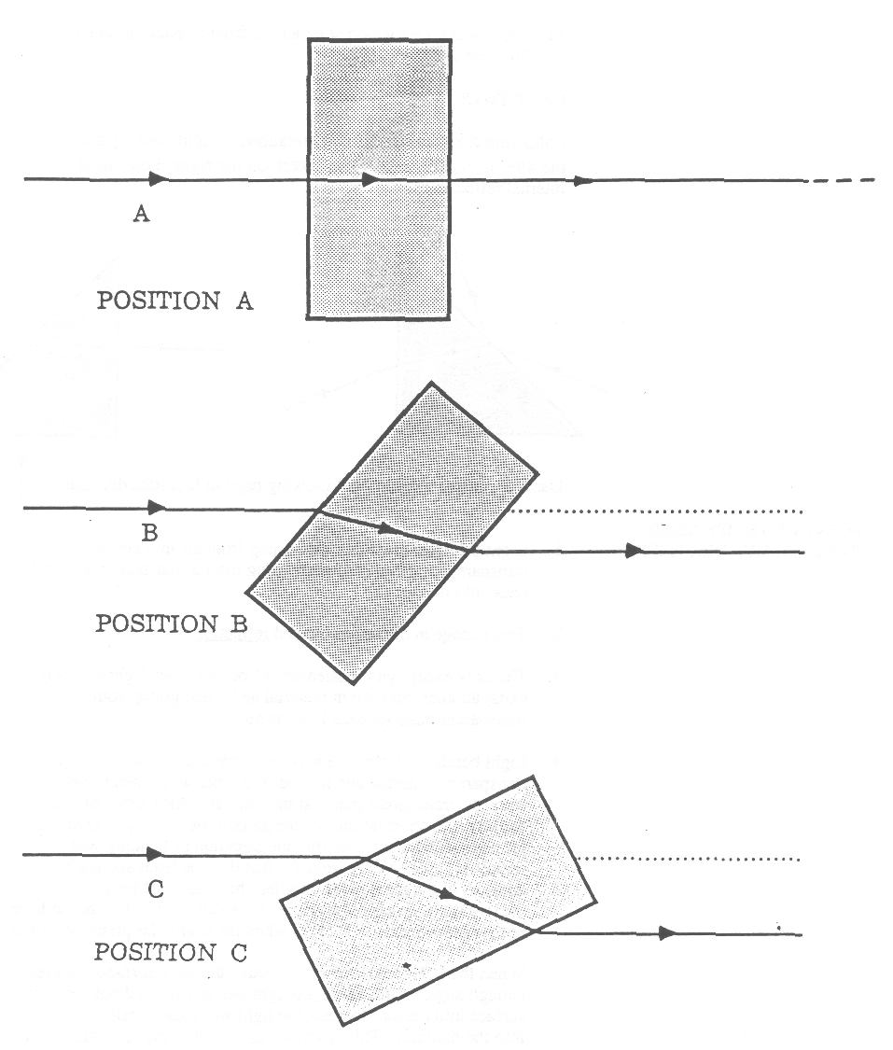

BEHAVIOR OF LIGHT 3B2F

FOCUS ON PHYSICS: REFRACTION OF LIGHT
(Discussion)

1. Light can change direction (refract) whenever it does not travel along the perpendicular from one transparent material into another transparent material with different properties. It makes no difference whether the transparent material is a solid, a liquid, or a gas. Although you have only investigated refraction of light traveling between air and a transparent solid, light may also refract when traveling between any two transparent materials in different states; for example, between air and a liquid (like water), between two different transparent solids (like glass and diamond), between two different liquids (like water and alcohol), or between two different gases or the same gas at very different temperatures (like cold air and hot air).

In this Focus On Physics section, we will describe how to draw ray diagrams to show how light behaves when traveling between air and some transparent solid or liquid material. These diagrams will be qualitative because we will not discuss exactly how much the light changes direction, only how it changes direction. The behavior of light when traveling between two transparent materials is governed by two rules of refraction. We will summarize them here and then illustrate how to apply them through some examples.

First, however, we must define a normal line. The normal line is a line that is constructed perpendicular to the surface at the point where the light enters (or leaves) the solid or liquid material.
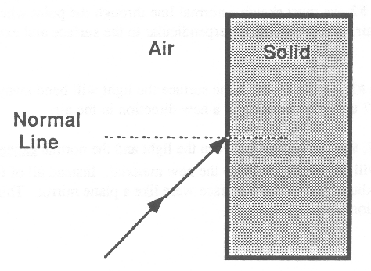

(The angle of incidence is defined as the angle between the light striking the surface and the normal line.)

REFRACTION RULE #1: Whenever light travels from air into a transparent solid or liquid material. (not along the perpendicular the light will always bend toward the normal line.

REFRACTION RULE #2: Whenever light travels obliquely from a transparent-solid or liquid material into air (up to a certain angle of incidence - called the critical angle). the light will always bend away from the normal line. For angles of incidence greater than the critical angle, none of the light will travel out into the air-all of the light will be reflected back into the material.

To illustrate how these rules can be applied, we will consider the situation where light passes through a solid plastic triangular prism. Figures 1-7 represent the entire process, step by step.

BEHAVIOR OF LIGHT 3B2F

FOCUS ON PHYSICS: REFRACTION OF LIGHT
(Discussion)

1. Figure 1 represents light traveling through air and striking the face of a prism.

2. (Figure 2) At the point where the light ray strikes the surface between the air and plastic, we use dashed lines to extend into the plastic the original direction of the light. Because of refraction at the surface, however, the light will not travel in the direction along the dashed lines. Instead, it will change direction and determine how we must apply Refraction Rule #1.

3. (Figure 3) To apply Refraction Rule # 1, we must sketch a normal line through the point where the light passes from the air into the plastic. A normal line is perpendicular to the surface and extends into both the air and the plastic.

4. (Figure 4) Applying Refraction Rule #1, we know that at the surface the light win bend toward the normal line. We show in Figure 4 the light traveling in a new direction inside the prism. (The exac amoun that the light changes direction depends both on the properties of the plastic and the air and also on the angle at which the light strikes the surface. We will not discuss these factors here. Instead, we have shown the new direction to be approximately midway between the original direction and the normal line This is only an approximation.)

5. (Figure 5) The light traveling inside the prism now comes to the boundary between the plastic and the air. We use dashed lines to extend into the air the original direction of the light (in the prism). Because of refraction at the surface, however, the light will not travel in the direction along the dashed lines. Instead, it will change direction and determine how we must apply Refraction Rule #2.

6. (Figure 6) To apply Refraction Rule #2, we must sketch a normal line through the point where the light passes from the plastic into the air. A normal line is perpendicular to the surface and extends into both the air and the plastic.

7. (Figure 7) Applying Refraction Rule #2, we know that at the surface the light will bend away from the normal line. We show in Figure 7 the light traveling in a new direction in the air.

We indicated above, in Refraction Rule #2, that if the angle between the light and the normal exceeds a certain value (about 45º), then the light will not even travel into the new material. Instead all of the light will be reflected back into the original medium, just as if the surface were like a plane mirror. This phenomenon is called total internal reflection.
BEHAVIOR OF LIGHT 3B2F

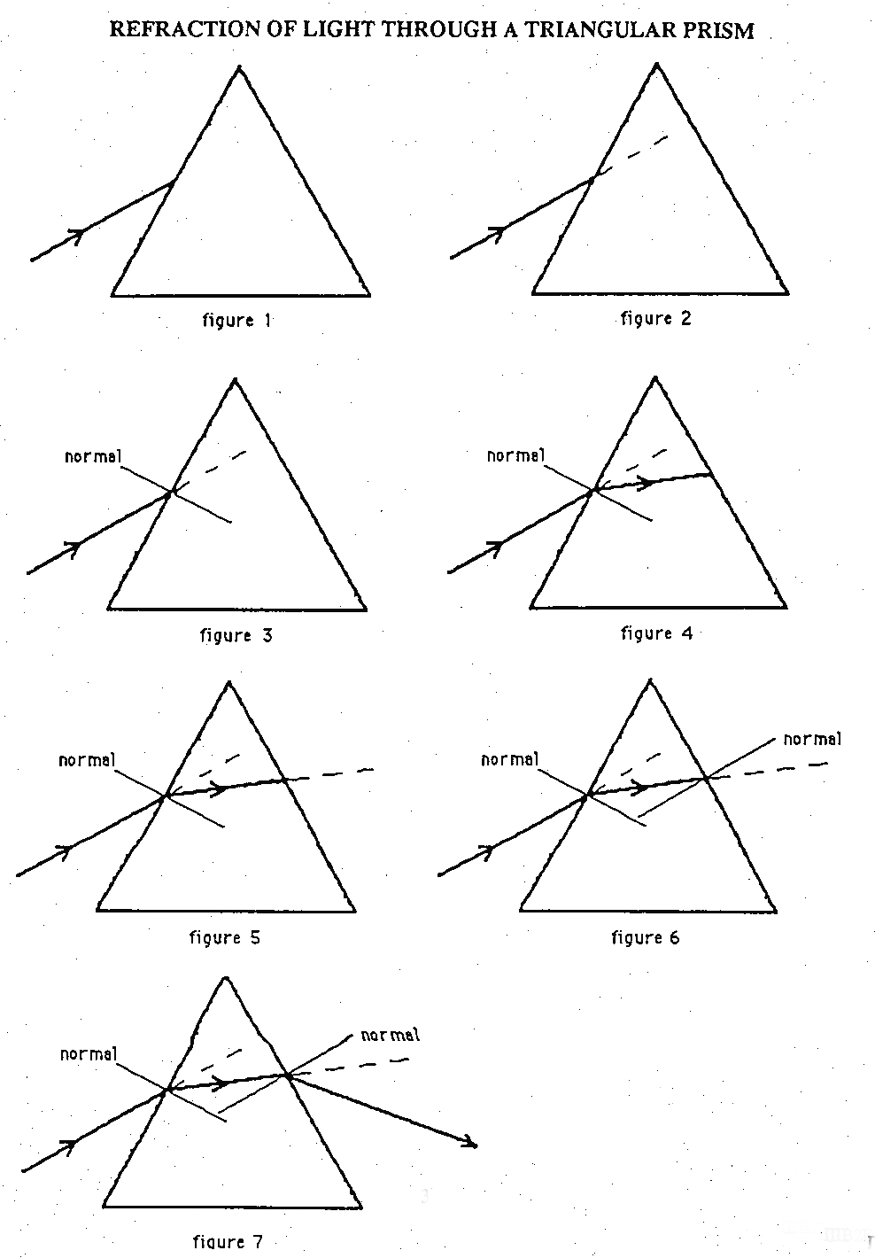

BEHAVIOR OF LIGHT 3B3

RULES OF REFRACTION

REFRACTION RULE #1: WHENEVER LIGHT TRAVELS OBLIQUELY FROM AIR INTO A TRANSPARENT SOLID OR LIQUID MATERIAL, THE LIGHT WILL ALWAYS BEND TOWARDS THE NORMAL LINE.

REFRACTION RULE #2: WHENEVER LIGHT TRAVELS OBLIQUELY FROM A TRANSPARENT SOLID OR LIQUID MATERIAL INTO AIR, THE LIGHT WILL ALWAYS BEND AWAY FROM THE NORMAL LINE.

Note:
Refraction rule # 2 is incomplete. Beyond a certain angle of incidence – around 45 degrees or so – none of the light will go out into the air. Instead, all the light will be reflected at the surface, as if the surface behaved like a plane mirror.

BEHAVIOR OF LIGHT 3B3

REFRACTION OF LIGHT

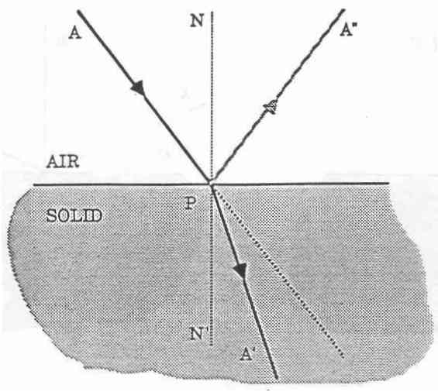
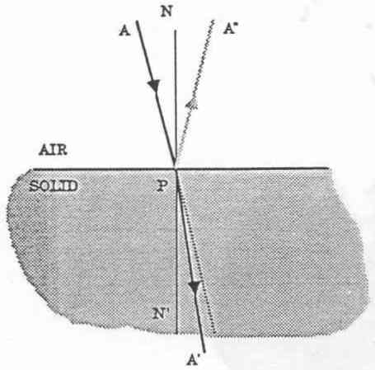
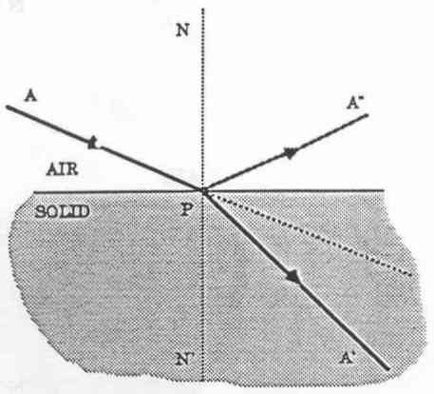

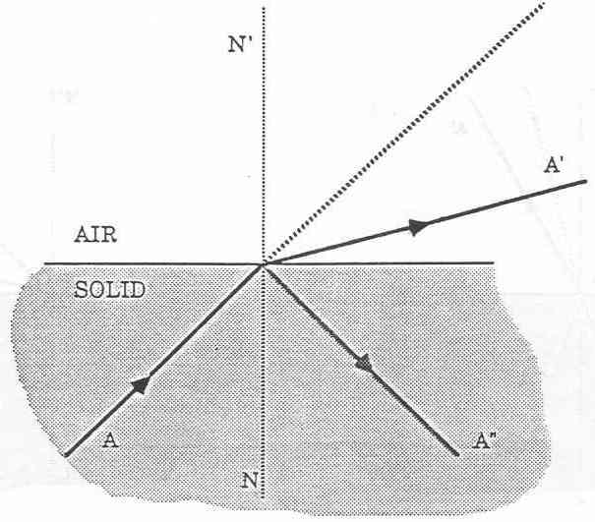
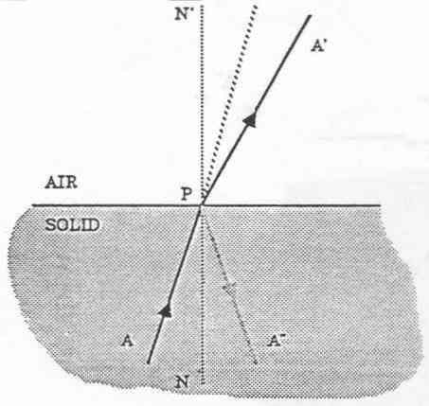
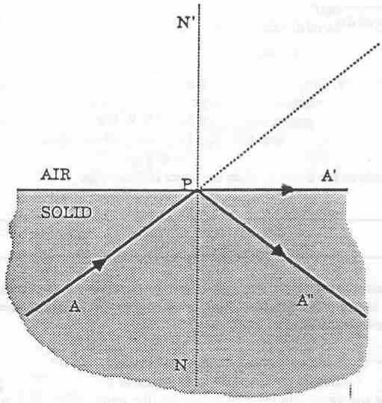
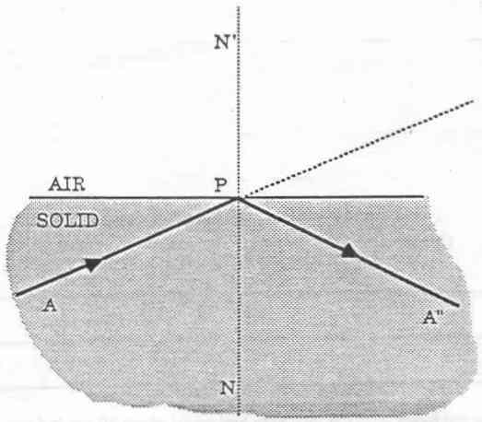

BEHAVIOR OF LIGHT 3C1

HOW DO OBJECTS APPEAR WHEN SEEN THROUGH A TRANSPARENT MATERIAL?

Materials: solid transparent block
coin (penny, nickel or dime)
two paper cups
white or colored DRINKING straw
water

1. Fill one cup 3/4 full of water. Drop the coin into the bottom of the other cup which is empty. Close one eye and look over the edge of the empty cup so you can just see the coin. Now, lower your head slightly so the coin just disappears from view. Keep your head in this position while your partner slowly pours water from the first cup into this cup. Describe what happens.

2. Explain how you are able to see the coin when the water is in the cup.
________________________________________________________________________________________________
________________________________________________________________________________________________
3. Draw a light ray diagram showing how light gets from the coin into your eye, enabling you to see the coin. In your diagram include the cup, coin, water, and your eye. It would be easiest to draw your DIAGRAM from a side view perspective.

4. Fill one of the cups about 2/3 full of water. Put the drinking straw into the water and lean it against the inside edge of the cup. Looking at the straw from just above the edge of the cup, compare the part of the straw seen above the water with the part seen below the water. What do you notice that seems unusual about the shape of the straw? Draw a sketch.
_____________________________________________
_____________________________________________
_____________________________________________
_____________________________________________
5. You should have observed that the straw seems to be bent at the point where it enters the water. Try to explain how this comes about.
________________________________________________________________________________________________
________________________________________________________________________________________________
________________________________________________________________________________________________
6. Hold the solid transparent block with the long side horizontal about 30 cm in front of you. Hold a pencil upright about 10 cm behind the Lucite block so you can see the middle of the pencil through the center of the block.

Slowly twist the block and observe w hat happens to the middle portion of the pencil. Describe your observations and draw a sketch of what you observe.
_____________________________________________
_____________________________________________
_____________________________________________
_____________________________________________
7. Draw a light ray diagram showing how light might travel from the pencil, through the block, and into your eye, so that the apparent position of the pencil (what you see) is displaced from its actual position. It is easiest to take a top view perspective in your drawing.

BEHAVIOR OF LIGHT 3C1TN

HOW DO OBJECTS APPEAR WHEN SEEN THROUGH A TRANSPARENT MATERIAL?

IDEA: PROCESS SKILLS:
Because of refraction, the apparent position of Observing
of an object viewed through a transparent material Using Spatial Relationships
is different from the actual position of the object.

LEVEL: L/U DURATION: 30 Min.

STUDENT BACKGROUND: Students should have previously worked through the lab “How Does
Light Change Direction?”

In order for students to develop a “scientific understanding” of their
observations in this activity, they need to understand the following:

1. In order for an object to be seen, light must travel from the object to your eye.

2. Light travels in straight lines through a single transparent medium. When it comes to a boundary between two different transparent media, part of the light is reflected (according to the Law of Reflection) and part of the light is transmitted. The transmitted light travels in a different direction than the incident light (except when the light is perpendicular to the surface). The amount that the light changes direction when entering the new medium is discussed at length in the Focus On Physics section, “Refraction Of Light.” Being familiar with the material in that section is a prerequisite for this lab activity.

3. When diverging light from an object (or image) enters your eye, you “see” the object (or image) at that point where the light rays, extended backwards in straight lines, appear to have originated.

ADVANCE PREPARATION: The solid block used in this activity is the same one that was used in the lab “How Does Light Change Direction?”

MANAGEMENT TIPS: Students will probably need assistance in making careful observations for step 4. The distortion of the straw is maximized by looking at it from the proper angle. You may need to go around and help students look at it properly.

You might find it helpful to demonstrate to students how to hold the block for step 6. The block should be held in a horizontal plane with a transparent face facing you and the opposite transparent face facing the pencil. When twisting the block, the right edge moves toward you while the left edge moves away from you (or vice versa).
RESPONSES TO
SOME QUESTIONS: 1. As the water is poured into the cup, the coin should gradually come into view.

BEHAVIOR OF LIGHT 3C1TN

HOW DO OBJECTS APPEAR WHEN SEEN THROUGH A TRANSPARENT MATERIAL? 2

2. Many students will say that the coin is “reflected” in the water. Few, if any, will give the scientific explanation in terms of refraction of light. The scientific explanation involves the following: (1) light from the coin travels through the water and up to the surface; (2) at the surface the light changed direction (refracts) and travels towards your eye; (3) the light enters your eye from a different direction than it did when it left the coin; (4) therefore, you “see” the coin at a different position than its actual position.
3. Show the overhead, “The Appearing Coin.”
4. The straw appears bent at the point where it enters the water.
5. To help with the explanation, show the transparency, “The Distorted Straw.”
6. As the Lucite block is twisted, the middle of the pencil appears to move off to the side. The middle does not seem to be connected to the top or bottom part of the pencil.
7. Show the overhead, “The Displaced Pencil.”
POINTS TO EMPHASIZE
IN SUMMARY DISCUSSION: 1. Light changed direction (refracts) when traveling between air and some transparent material (like plastic or water).
2. When looking at an object through a transparent material, the object will either look distorted or will be seen at a different place than it actually is located. This happens because of the refraction of light. Light leaving the object changed direction when passing through the transparent material. (It actually changes direction twice: once when traveling from air into the material, and again when traveling from the material out into the air.) The light then enters our eye coming from a different direction than it had originated. Therefore, what we “see” is an image of the object that is in a different position than the actual position.
3. Having observed the distortion effects in this activity, we can
draw light ray diagrams to describe how light must have behaved

In each of the overheads, we have drawn two light rays diverging from a point on the object. Each of these rays refract upon entering and exiting from the material and then enter the eye. The brain extends these rays back in straight lines to a point where they appear to have originated. It is at this point that the person “sees” the image.

Learning how to draw diagrams similar to the one shown in the overheads requires time. You should not expect the students to draw their diagrams as carefully as the ones shown in the overheads. First of all, the students will not know exactly how much the light changed direction when traveling between air and a transparent material. They have only studied the qualitative behavior of light when refraction occurs. Therefore, at best, their ray diagrams will only be approximate. (Actually, the ray diagrams in the three overheads are also only approximately drawn.) Secondly, the student diagrams may only show a single light ray going from the object to the eye. In such a case, the diagram would only be able to determine the direction that the eye would need to look in order to see the image. At least two diverging light rays would be needed to locate the actual point at which the eye is looking. (Remember from geometry that two crossing lines determine a point.)

POSSIBLE EXTENSIONS:
Have students place the transparent block over a section of writing on one of their instruction sheets. They should be able to look through the transparent faces and see the writing underneath. While they are looking through the block, have them slowly lift up the right edge of the block, keeping the left edge on the paper. Ask them to describe what they observe and then have them explain their observations.

What they should observe is that as they lift up the right edge of the lucite block, the lettering should appear to move to the left. The more they tilt the block, the more the lettering is displaced to the left. The explanation involved the refraction of light and is similar to the displaced pencil observation.

BEHAVIOR OF LIGHT 3C2

THE APPEARING COIN
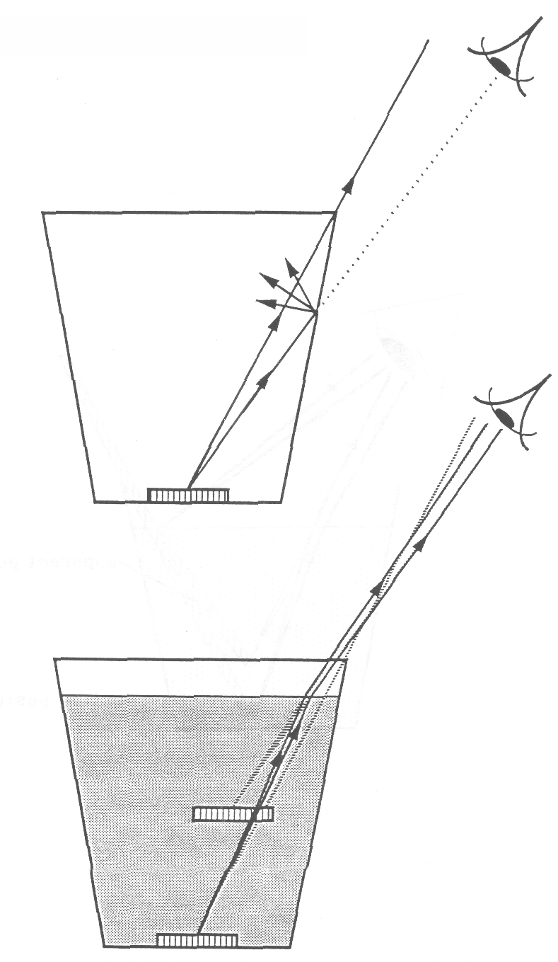

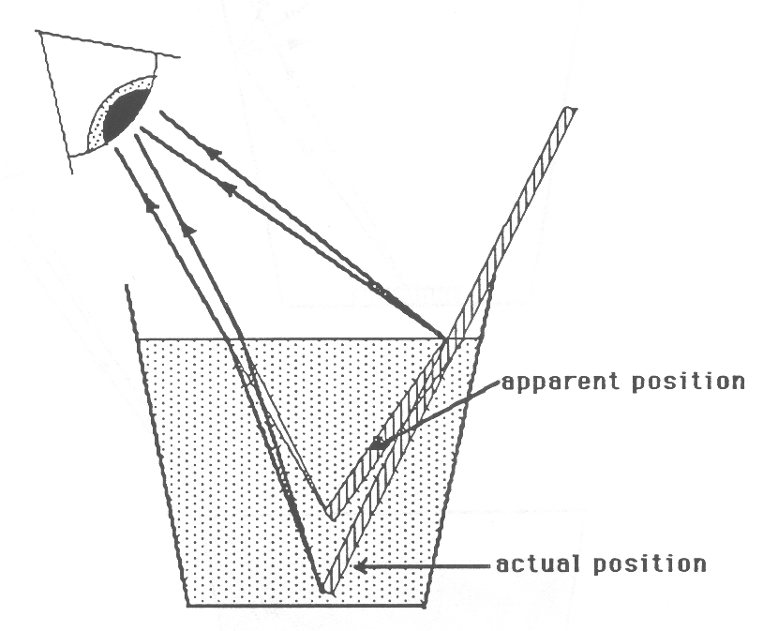
THE DISTORTED STRAW
BEHAVIOR OF LIGHT 3C2

THE DISPLACED PENCIL

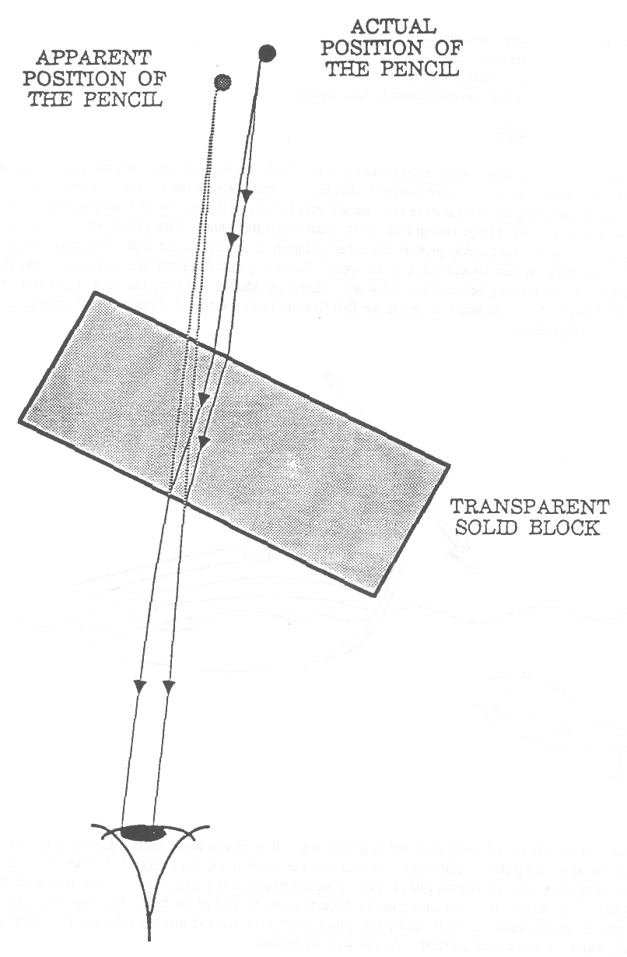
BEHAVIOR OF LIGHT 3C3

WHERE DO YOU AIM TO SPEAR THE FISH?

Materials: large, rectangular aquarium
sighting tube
long, thin dowel rod
stand, rod and clamp to hold sighting tube
coin
water

In this activity, you will apply your understanding of how light changes direction to practice a skill that may some day save your life. Picture yourself stranded in a small boat in the middle of a large lake. You have not eaten anything for several days and you are very hungry All you have in your possession is a spear. Suddenly you see a large fish in front of the boat under the water. With visions of fresh sushi dancing in your head, you quickly pick up the spear and prepare to aim it at the fish. Suddenly you stop and begin thinking. Where should you aim the spear? Because you did experiments in science, you know that light bends when going between air and water. Therefore, should you aim your spear right at the fish, below the fish (closer to the boat), or above the fish (further from the boat)? Your stomach growls as you think about the problem.
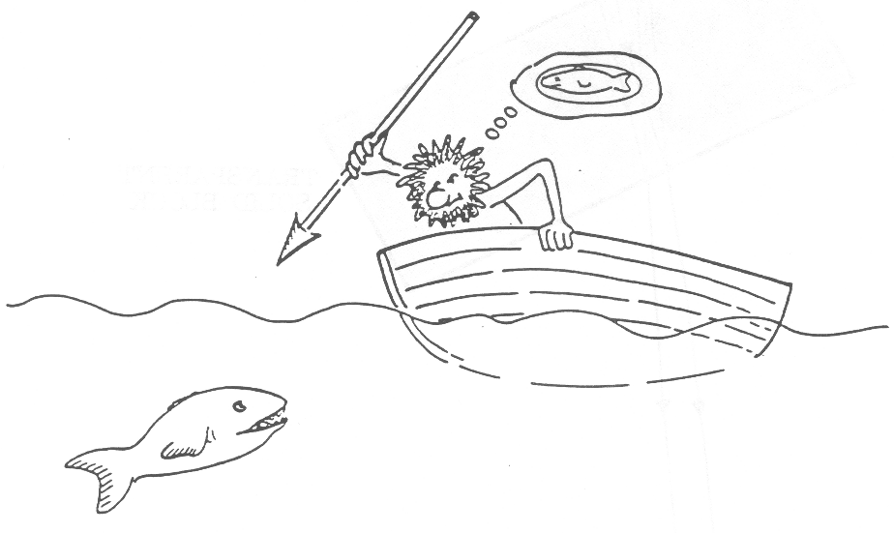

To save you the trouble of being stranded in a boat, we will have you think about a similar problem: how should you aim a long rod so that when it is shot into the water it will hit a target? The set-up consists of a large rectangular tank two thirds full of water, a sighting tube, and a long thin rod. See sketch on the next page. The “target” is a coin sitting on the bottom at the far end of the tank. The idea is to aim through the sighting tube, clamp it rigidly into place, then insert the rod into the tube and let it slide down into the water. If you aimed correctly, the rod will hit the coin.

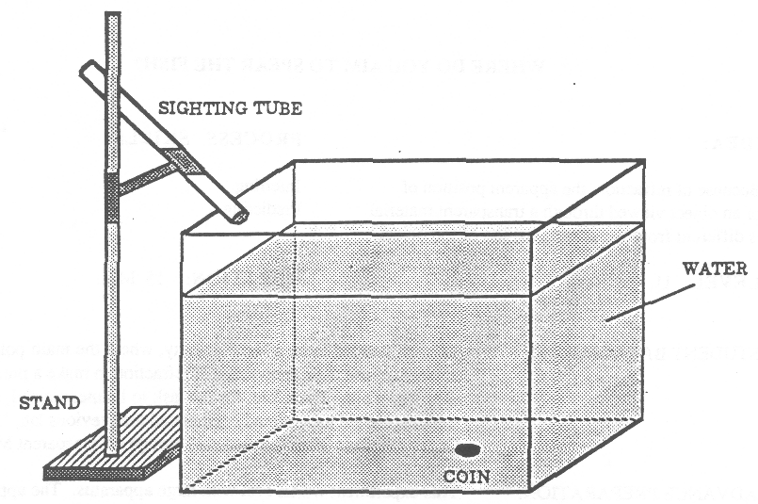
1. Be setting up the equipment or doing the experiment, discuss with your partner(s) your strategy for aiming the sighting tube. Describe your strategy and explain your reasoning.
_________________________________________________________
_________________________________________________________
_________________________________________________________
_________________________________________________________
_________________________________________________________
BEHAVIOR OF LIGHT 3C3

WHERE DO YOU AIM TO SPEAR THE FISH? 2

2. Set up the equipment as shown in the figure. Look through the sighting tube and aim it according to your strategy written above, then clamp it into place. All partners in the group should have the opportunity to look through the sighting tube before you insert the rod into the tube.

3. Go ahead and insert the rod into the tube, then release it. What happened? If you were successful, great! If not, re-think your strategy and try again.
________________________________________________________________________________________________
________________________________________________________________________________________________

BEHAVIOR OF LIGHT 3C3TN
WHERE DO YOU AIM TO SPEAR THE FISH?

IDEA: PROCESS SKILLS:
Because of refraction, the apparent position of Inferring
of an object viewed through a transparent material Predicting
is different from the actual position of the object.
LEVEL: U DURATION: 15 Min.

STUDENT BACKGROUND: This is intended to be a “fun” activity, where the main point is for students to use their knowledge of refraction to make a prediction and then test it out. Therefore, for the task to be meaningful, the students should have already completed the previous lab, “How Do Objects Appear When Looked AtThrough a Transparent Material?”

ADVANCE PREPARATION: This experiment works best with large apparatus. The approximate dimensions of the apparatus we have used are as follows:

Aquarium: 11” x 11” x 21”
Sighting Tube: 7/8” diameter x 15” long
Dowel Rod: 1/4” diameter x 36” long

Since the apparatus is so large, you may only have one set-up. In that case you should plan to have another experiment going on simultaneously that will keep everybody busy. One group at a time can then work with the apparatus.

Make sure that the clamp holding the sighting tube is high enough above the edge of the aquarium so that students have a lot of maneuverability in aiming the tube. Also make sure the whole apparatus is low.enough that even short students ran look through the tube without climbing up on furniture.

MANAGEMENT TIPS: This is a very interesting experiment to perform. When the students actually let the rod go into the water, they may also observe the “apparent” bending of the rod, which is caused by refraction. See the comments under POSSIBLE EXTENSIONS on the following page. If you are around when they perform the experiment, you might want to point this out to them.
RESPONSES TO
SOME QUESTIONS: 1. Some students may decide to aim the sighting tube directly at the coin, thinking that the rod will travel to where they see the coin. The correct response is that you have to aim the sighting tube below the apparent position of the coin. The reason is as follows: light from the coin travels up to the surface and bends away from the normal in going into the air. The light that enters the sighting tube (and goes into your eye) then appears to come from a direction above the actual position of the coin. To compensate for this, you have to aim below the apparent position of the coin. See sketch above which is the same as the following overhead.
POSSIBLE EXTENSIONS:
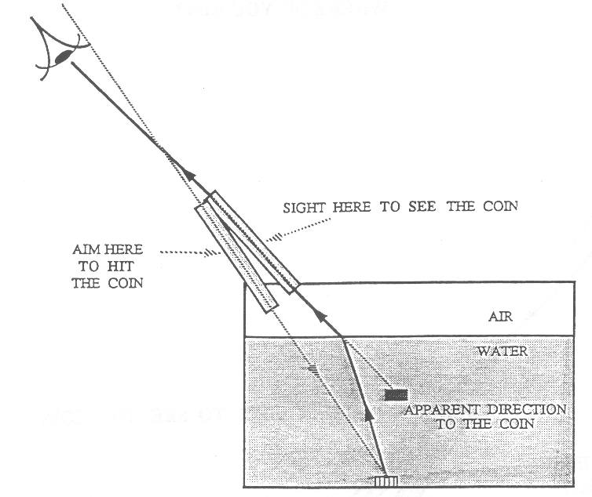
This same apparatus can be used to demonstrate the apparent bending of a stick that is partially immersed in water. Students observed this phenomenon in the lab, “How Do Objects Appear When Looked At Through a Transparent Material.” However, in that activity they inserted a straw in a small cup and the effect may not have been very noticeable. Therefore, by leaning the long dowel rod against the edge of the aquarium so it is partially immersed, the effect looks quite impressive.

BEHAVIOR OF LIGHT 3C4

WHERE DO YOU AIM?

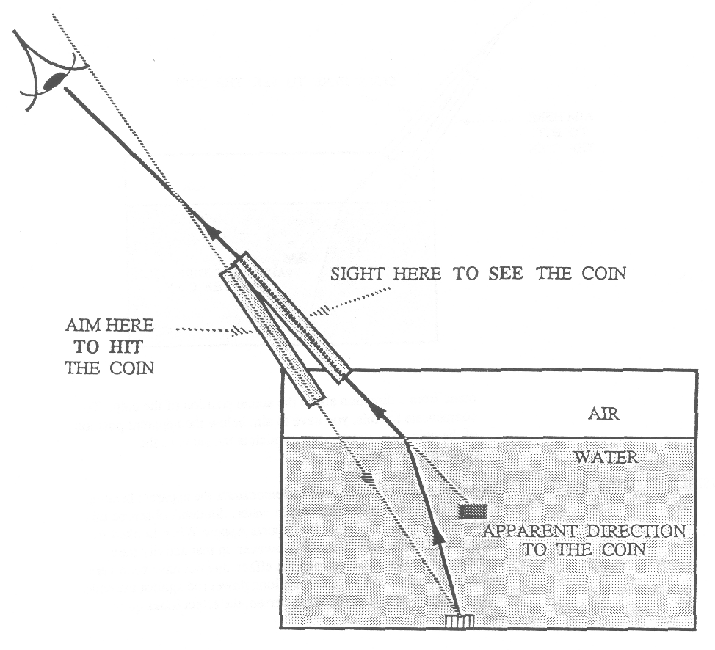
BEHAVIOR OF LIGHT 3C5F

FOCUS ON PHYSICS:
REFRACTION THROUGH A PLEXIGLAS BLOCK

When you look at an object through a transparent solid or liquid material, the object appears distorted or displaced. For example, a coin at the bottom of a cup of water appears to be closer to the surface than it actually is; a stick partially immersed in water appears to be bent. It is important to realize that what you actually perceive when you look through the transparent material is an image of the object.

For example, if you look through a rectangular block of Plexiglas at a pencil held vertically, and twist the block, the pencil will appear to be displaced. On the next page, Figure I shows a top view of the situation, and Figure 2 shows what is seen through the Plexiglas block.

Notice that in Figure 1, we first show two rays leaving the pencil. Second, each of these rays refracts correctly at each of the two surfaces (obeying Refraction Rule #1 when entering the block, and Refraction Rule #2 when exiting). Third, the two diverging rays are shown entering the eye. Fourth, sight lines are drawn that extend back to where the image of the pencil is located. This is where the observer perceives the location of the pencil.

BEHAVIOR OF LIGHT 3C5F

REFRACTION THROUGH A PLEXIGLAS BLOCK

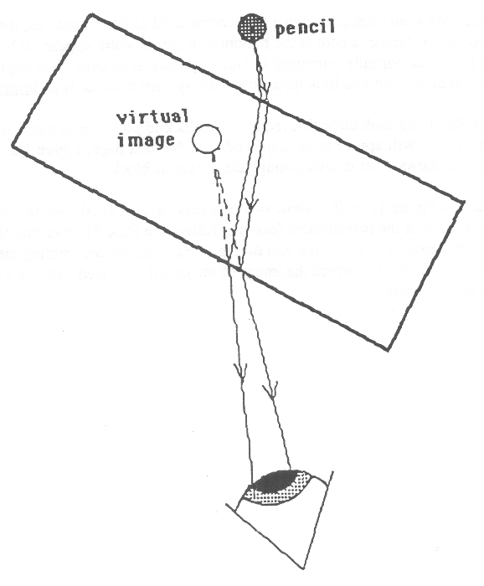
FIGURE 1

TOP VIEW

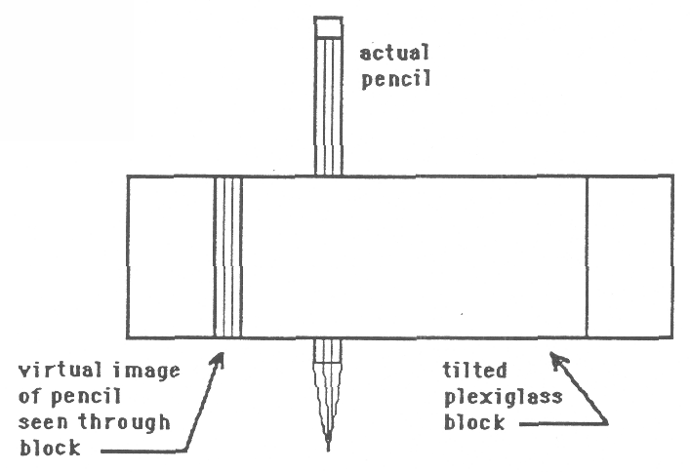
FIGURE 2

SIDE VIEW

BEHAVIOR OF LIGHT 3D1F

FOCUS ON PHYSICS
MIRAGES AND TWINKLING STARS
(Discussion)

1. The previous Focus On Physics section, “Refraction Of Light,” described how light changes direction when passing between two different transparent media. When light travels between two regions of water where the density is different, the light will also change direction. This occurs, for example, when two adjacent layers of air are at different temperatures. When the light travels from the cooler air to the hotter air (or vice versa), the light will change its direction. The change in direction will only be slight, but if it occurs over a large distance, the effect can be noticeable.

2. Many mirages can be explained in terms of the refraction of light passing through layers of air at different temperatures (densities). For example, many people will be familiar with the experience on a hot day of seeing what appears to be water up ahead on the road. The “water” disappears as the car approaches the Spot.

The “water” on the road is actually a mirage. What you are actually seeing is light from the bright sky against the background of the road surface. The sketch on the following page helps explain what is happening. Because the road surface is very hot, the layer of air immediately above the road surface is much warmer than the air higher up. As light from the sky heads down toward the road, it travels from a cooler layer of air into a warmer layer, and therefore, changes direction (refraction). If the difference in temperature between the layers of air is great enough, the light changes direction so much that it can turn back up again and go in the direction of your eye. Your eye-brain system then extends this sky light straight back, and you “see” it against the background of the road. The bright light against the road is interpreted by you to be water because it appears highly reflective just like you expect water would be.

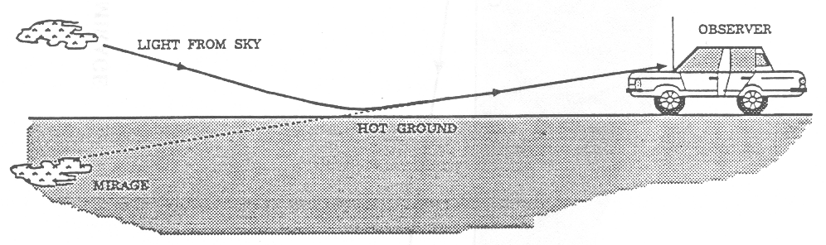
3. The twinkling of stars is due mainly to atmospheric refraction. Light from a distant star changes direction slightly when passing through the atmosphere toward our eyes. Therefore, the apparent position of the star is slightly different from its actual position. Because of the turbulence in the atmosphere, the amount of refraction of the star light is continually changing. Therefore, the apparent position of the star is also continually changing (moving over very small distances), giving the “twinkling” effect.

BEHAVIOR OF LIGHT
4WL
WORKSHOP LEADER’S PLANNING GUIDE FOR LENSES

The activities in this section should lead the participant to an understanding of the general properties of both converging (convex) and diverging (concave) lenses, and the specific image forming properties of converging lenses. This understanding will involve both observations of the behavior of the lenses and also the use of qualitative ray diagrams to describe this behavior. Two simple optical instruments will be studied: the slide projector and the telescope.

Naive Ideas:

Many students who have played with lenses (including a slide projector) may have some of the following ideas about their image forming behavior before formal instruction in science:

1. A lens forms an image of an object in the following way. Students envision that a “potential image” which carries information about the object leaves the self-luminous object and travels through space to the lens. When passing through the lens, the “potential image” is turned upside-down and may be changed in size. (4B1D)

2. A diagram showing how a lens forms an image of an object has only those light rays drawn which leave the object in straight, parallel lines. (4B1D, 4C1F)

3. Blocking part of the lens surface would block the corresponding part of the image. (4B1D)

4. A screen is necessary for an image to be formed. Without a screen, there is no image. (4B4D)

5. An image can be seen on the screen regardless of where the screen is placed relative to a lens. To see a larger image on the screen, the screen should be moved further back. (4B1D, 4B2, 4B3)

6. An image is always formed at the focal point of the lens. (4D1F, 4B2, 4E2F, 4E3)

7. The size of the image depends on the size (diameter) of the lens. (4B2, 4E1)

A. A CONVEX (CONVERGING) LENS CAN FORM AN IMAGE ON A SCREEN AND CAN ALSO BEHAVE AS A MAGNIFYING GLASS. A CONCAVE (DIVERGING) LENS CANNOT FORM AN IMAGE ON A SCREEN. IT MAKES OBJECTS APPEAR SMALLER. AND INCREASES THE FIELD OF VIEW.

1. Activity: What Are the Different Types Of Lenses?

Students will feel the surfaces of both concave (diverging) and convex (converging) lenses and then investigate how (nearly) parallel beams of light behave when passing through the two lenses. Next they will observe whether the two lenses can form an image of a distant scene on a screen. Then they will look through each lens at printed letters and will describe how the letters appear. Finally, they will observe that a diverging lens increases the field of view. (This last characteristic of a diverging lens can be described with the following overhead.)

2. Overheads (2):
a) Types Of Lenses
b) A Diverging Lens Increases the Field Of View

BEHAVIOR OF LIGHT
4WL
WORKSHOP LEADER’S PLANNING GUIDE FOR LENSES - 2

B. VARYING THE DISTANCE BETWEEN A CONVERGING LENS AND AN ILLUMINATED OBJECT CAUSES THE IMAGE TO VARY IN SIZE AND TO BE FORMED AT DIFFERENT DISTANCES FROM THE LENS. FOR A FIXED DISTANCE BETWEEN THE LENS AND THE OBJECT. THE POSITION OF THE IMAGE IS UNIQUE.

1. Demonstration/Discussion: What Do You Know About the Image Formed By a Converging Lens?

After setting up a light bulb, lens and screen (with an upside down image of the bulb clearly seen on the screen), the instructor asks students to predict what they would observe on the screen if. (1) the lens were removed; (2) the screen were moved closer and closer to the lens; and (3) half of the lens was covered with cardboard. Then the demonstration will be performed and the outcome discussed.

2. Activity: How Does a Slide Projector Work?

Students will carry out a set of measurements to investigate how the size and location of the image depends on the distance between the lens and the illuminated object. Then they will connect their observations to the operation of a slide projector. This is an important activity, and many of the following Focus On Physics sections refer to it.

3. Overhead: The Slide Projector

4. Demonstration/Discussion: Is the Screen Necessary?

The instructor first asks students to predict what will happen to the image if the screen is removed. Then he/she will discuss and demonstrate that the screen only serves as a convenience for viewing the image from different positions. The image still exists even if the screen is removed.

C. RAY DIAGRAMS CAN BE USED TO DESCRIBE HOW CONVERGING LENSES FORM IMAGES.

1. Discussion-Focus On Physics: Using Ray Diagrams To Describe Image Formation By Lenses

(Allow 30 - 40 minutes for this discussion.) The light ray is introduced as a geometrical representation of the direction that light travels. The criterion for forming an image is discussed: light diverging from each point on an illuminated object must be made to converge to a corresponding single point, called the image point. The demonstrations perfonmed in acdvities 4B1D and 4B4D are “explained” with the use of ray diagrams. It would be most effective if the instructor used an actual set-up (illuminated arrow or light bulb, lens, and screen) to demonstrate each phenomenon as it is discussed. The following overheads should be used in conjunction with this discussion.

2. Overheads (7): a) Light Rays
b) There Is No Image Without a Lens
c) Prisms and a Converging Lens
d) Image Formation By a Converging Lens
e) Moving the Screen
f) Blocking Part Of the Lens
g) Seeing the Image With and Without the Screen

BEHAVIOR OF LIGHT
4WL
WORKSHOP LEADER’S PLANNING GUIDE FOR LENSES - 3

D. THE “POWER” OF A LENS US A MEASURE OF ITS EFFECTUVEBESS TN BENDING LIGHT. LIGHT INCIDENT ON A LENS PARALLEL TO ITS AXIS CONVERGES TO A POINT WHOSE DISTANCE BEHIND THF. LENS EQUALS THE FOCAL LENGTH. THE POWER AND FOCAL LENGTH OF A LEN; ARE INVERSELY RELATED.

1. Discussion-Focus On Physics: Power and Focal Length

The power of a lens is defined qualitatively in terms of its effectiveness in bending light. The power is determined (mainly) by the relative thickness of the lens at its center compared to its edges. Focal point and focal length are then defined in terms of the convergence of incident parallel light. This definition of focal length is then related to its operational definition: the distance between the lens and the image when the object is very far away. Finally, the effect of lens diameter is discussed. (Use with the following overhead.)

2. Overhead: Power and Focal Length Of Converging Lenses

3. Discussion-Focus On Physics: Corrective Lenses For Eye Defects

First the normal eye is discussed. Following this is a description of farsightedness and how a converging lens can be used to correct the problem. Nearsightedness is then described, and this is followed by a discussion of how a diverging lens can correct the problem. The following three overheads should be used.

4. Overheads: (3):

a) The Normal Eye
b) The Farsighted Eye
c) The Nearsighted Eye

5. Discussion-Focus On Physic: Seeing a Point

E. WHEN A OBJECT IS CLOSER TO A CONVERGING LENS THAN ITS FOCAL POINT, THE IMAGE 19 ENLARGED RIGHTSIDE-UP AND VIRTUAL.

1. Activity: How Does a Telescope Work?

Students will first observe that the diameter of the lens does not affect either the size of the image or the distance behind the lens at which it is formed. Following this. they determine a qualitative relationship between the focal length of a lens and the size of the image it forms of a distant object. They then determine a qualitative relationship between the focal length of a lens and its magnifying power. Finally, they construct a simple telescope consisting of a long focal length objective lens and a short focal length eyepiece.

2. Discussion-Focus On Physics: Virtual Images and the Magnifying Glass

A virtual image is described and the ray diagram for a magnifying glass is drawn.

3. Overhead: Where Is the Image Seen Through a Magnifying Glass?

BEHAVIOR OF LIGHT 4A1

WHAT ARE THE DIFFERENT TYPES OF LENSES?

Materials: light source producing two closely-spaced narrow beams of light
convex lens
concave lens (same diameter as convex lens)
3 “ x 5 “ blank index card
4 “ x 6 “ blank, index card
8 112 “ x I I “ sheet of white paper
scissors
piece of soft tissue

1. Use the lens tissue to feel the surfaces of the two lenses. Describe how the shapes of the two lenses differ.
_______________________________________________________________________________________________
_______________________________________________________________________________________________
The lens which bulges outward in the middle is called a “convex-shaped” lens or just a “convex” lens. The lens which bows inward in the middle is called a “concave-shaped” lens or just a “concave” lens.

2. Arrange the light source so two closely-spaced beams of light can be clearly seen on the piece of white paper. Below, sketch the appearance of the two light beams on the paper.

3. Hold the convex lens in front of the light source and describe how the two beams of light on the paper change.

4. Remove the convex lens and place the concave lens in front of the projector. Describe how the two beams of light on the paper compare to the case with no lens in front of the projector.

5. The convex lens which causes the two beams of light to come together (or converge) is also called a converging lens. The concave lens which causes the two beams of light to spread further apart (diverge) is also called a diverging lens.

6. Hold the converging lens at arms length and aim it toward a window at some outdoor scene. Hold the blank cardboard screen in the other hand between the lens and your eyes. Move the card back and forth until you can see a clear image on it. (See illustration on next page.) Describe how the image appears.
_______________________________________________________________________________________________
_______________________________________________________________________________________________
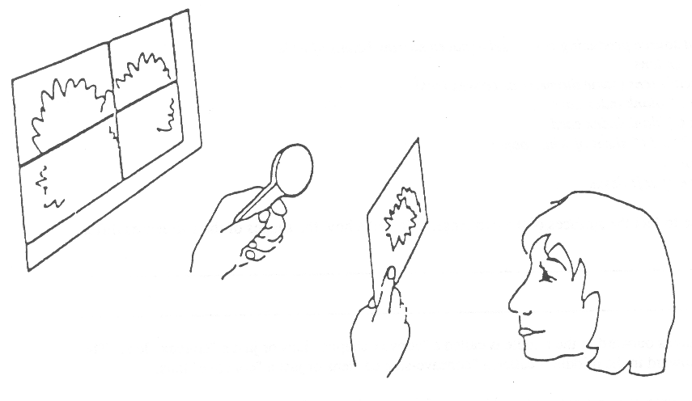

BEHAVIOR OF LIGHT 4A1

WHAT ARE THE DIFFERENT TYPES OF LENSES? 2

7. Replace the converging lens with the diverging lens. While holding the diverging lens, can you see an image on the screen that looks the, same as it did in step 3? Describe your observations.
_______________________________________________________________________________________________
_______________________________________________________________________________________________
8. Lay the converging lens down on this page of print. Position yourself so your eye is at arms length from the paper. Look through the converging lens as you slowly raise the lens from the paper toward your eye. Describe how the lettering on the paper seems to change.
_______________________________________________________________________________________________
_______________________________________________________________________________________________
_______________________________________________________________________________________________
9. Now remove the converging lens, and put the diverging lens on the paper in its place. Look through the lens as you slowly raise the lens from the paper toward your eye. Describe how the lettering on the paper seems to change.
_______________________________________________________________________________________________
_______________________________________________________________________________________________
10. Draw a circle in the center of the 4” x 6” blank index card with a diameter that is a little less than the diameter of the smaller of the two lenses (convex or concave). You may find it convenient to use one of the lenses to trace the circle. Cut out the circle.

11. Hold the card at arms length out in front of you and look through the hole at some distant scene (out the window or on the other side of the room). Note how much of the scene you can observe through the hole. The amount you can see is called the field of view through the hole.

12. Now hold the diverging lens (concave lens) against the hole and compare the field of view of the diverging lens with the field of view of just the hole.
_______________________________________________________________________________________________
_______________________________________________________________________________________________
13. Based on your observations in this activity, describe three ways that a converging lens behaves differently than a diverging lens.

(1) ___________________________________________________________________________________________

(2) ___________________________________________________________________________________________

(3) ___________________________________________________________________________________________

BEHAVIOR OF LIGHT 4A1TN

WHAT ARE THE DIFFERENT TYPES OF LENSES?

IDEA: PROCESS SKILLS:
A converging lens can be used to form an Observing
image on a screen, and as a magnifying Classifying
glass. A diverging lens can do neither,
but it does increase the field of view.
LEVEL: L / U DURATION: 40 Min.

STUDENTBACKGROUND: This is an introductory laboratory activity for lenses. No background is assumed.

ADVANCED PREPARATION: For Step 6, it is best to have at least one window with an interesting outside view. If no window is available, a ceiling light can be used instead. Use a light source as described in the Management Tips Section of the Teachers Notes for the previous activity 2C1: “How Does Light Reflect From a Mirror Surface.” If you make the mask out of cardboard, cut out two parallel slots each about 2 mm wide by 22 mm long and separated by about 3 min in the center of the cardboard disc.
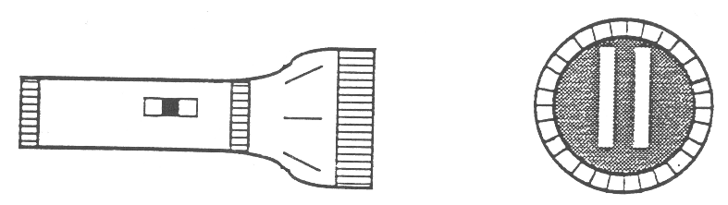

A commercially available double magnifier (with 3X and 6X lenses) would be a good source as a convex lens for the three lab activities in this section on lenses. For this activity, however, the bottom (smaller) plastic lens needs to be covered so it won’t interfere with the experiment. One way to do this is to wrap a strip of paper around the bottom lens and tape it closed. You can do this ahead of time or have students do it at the beginning of the lab activity.

MANAGEMENT TIPS: If you are using the cardboard light boxes for the light sources, since there are four openings on each light box, you can have four groups of two students working around each box. You need plenty of room for the four groups to spread out, so they won’t get in each other’s way. Therefore, it’s best to place the box either at the center of a table or on the floor.

When having the students aim their lenses out the window to form images of an outdoor scene, it is best to turn the fights off in the room and have the students stand far away from the window. This will enhance the contrast between the image formed on the screen (that the students want to see) and the surrounding illumination.

RESPONSES TO
SOME QUESTIONS: 1. One of the lenses bulges outward in the center. It is thicker in the middle than at the edges. The other lens caves inward at the center. It is much thinner at the center than at the edges.

3. With the convex lens, the two beams should come closer together (converge) and perhaps cross.

4. With the concave lens, the two beams should get further apart. Each of the beams may also become wider.

BEHAVIOR OF LIGHT 4A1TN

WHAT ARE THE DIFFERENT TYPES OF LENSES? 2

6. There is a clear image of the outdoor scene (as well as the window) observed on the card. The image is in full color (which is surprising to some students) and is upside-down. Only when the card is in a certain position will the image be clear and recognizable.

7. No, nothing special is seen on the card, except perhaps a shadow. There is NO image seen on the card at all.

8. As the lens is lifted up from the paper, the lettering appears right side up and gets larger and larger. At some point the lettering seems to Lake up the whole lens and cannot be seen clearly. As the lens is moved closer to the eye, the lettering appears upside-down and begins to get smaller and smaller. When the lens gets close to the eye, the lettering begins to get very blurry.

9. As the lens is raised above the paper, the lettering remains right side up, but gets smaller and smaller and you can see more. and more of the page of print.

12. With the diverging lens, the field of view is significantly increased.

13. a. A converging lens can form an image on a screen. A diverging lens cannot.

b. The shapes of the two lenses are quite different. The converging lens is thicker at the center and thinner at the edges. The diverging lens is thinner at the center and thicker at the edges.

c. Two beams of light come together after passing through a converging lens. The two beams spread farther apart after passing through a diverging lens.

d. Converging lenses can be used to make letters appear larger (for a certain range of distances between the lens and the letters). Diverging lenses always make the letters appear smaller.
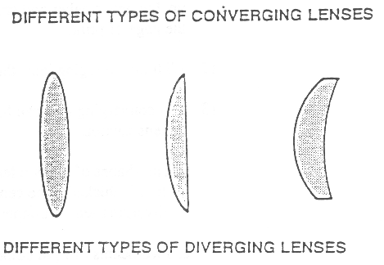

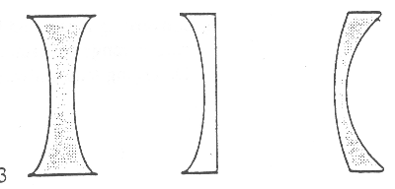

e. A converging lens may blur letters that are seen through it. Letters are never blurred when looking at them through a diverging lens,
BEHAVIOR OF LIGHT 4A1TN

WHAT ARE THE DIFFERENT TYPES OF LENSES? 3

POINTS TO EMPHASIZE
IN SUMMARY DISCUSSION 1. A lens is a piece of transparent material that can bend light and form images. Most lenses have surfaces which are curved. Converging lenses are thicker in the middle than at the edges; diverging lenses are thinner in the middle than at the edges. Both lenses come in various shapes. See the illustration on the next page, and the overhead “Types of Lenses.”

2. A diverging (concave) lens is often used to increase the field of view. Looking at a scene through a diverging lens enables you to see more of the scene than you could see without the lens. Use the overhead “A Diverging Lens Increases the Field of View” to show how this happens.

3. Converging and diverging lenses can be distinguished from each other, both by their shapes and how they affect light.

a. Converging lenses are thicker in the middle than at the edges; diverging lenses are thinner in the middle than at the edges.

b. Beams of light are bent together when passing through a converging lens; they are spread further apart when passing through a diverging lens.

c. A converging lens can be used to form an image on a screen; a diverging lens cannot.

d. A converging lens can be used to make objects appear larger (a magnifying glass); a diverging lens always makes objects appear smaller.

BEHAVIOR OF LIGHT 4A2
TYPES OF LENSES

DIFFERENT TYPES OF CONVERGING LENSES
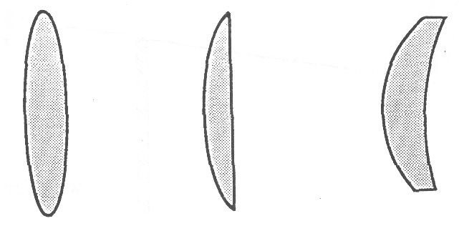

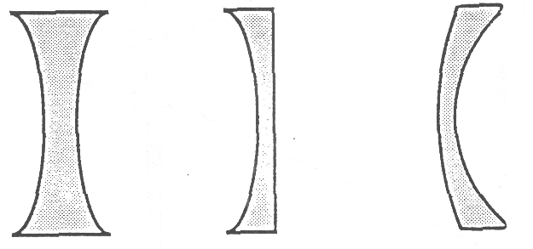

DIFFERENT TYPES OF DIVERGING LENSES

BEHAVIOR OF LIGHT 4A2

A DIVERGING LENS INCREASES THE FIELD OF VIEW

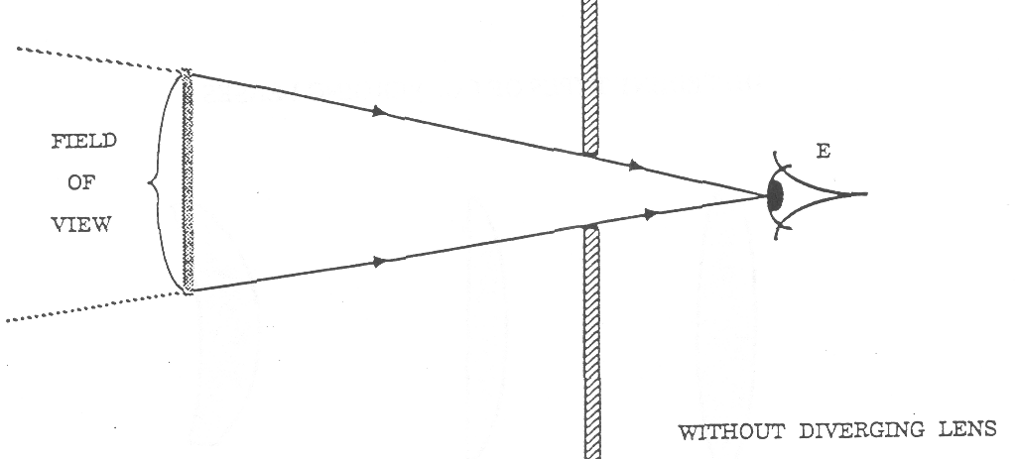
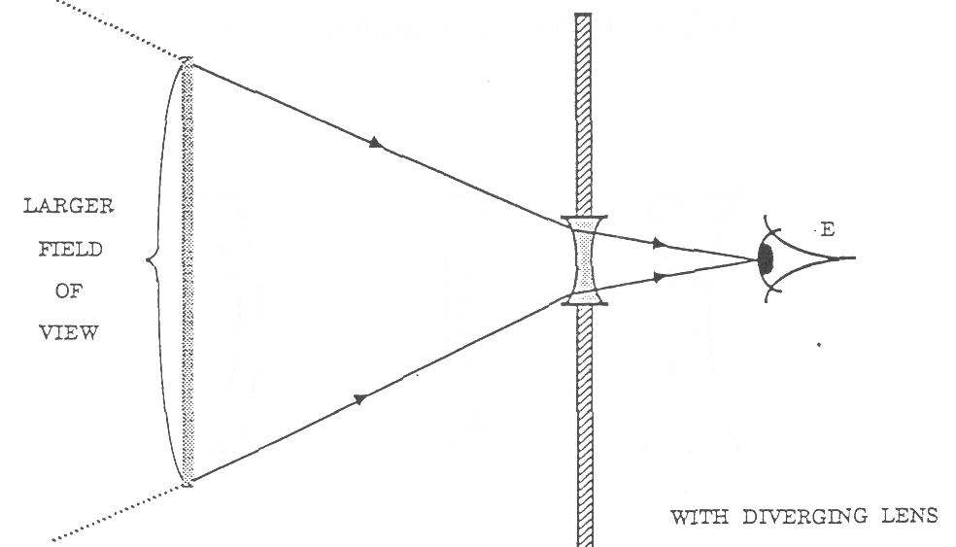
BEHAVIOR OF LIGHT 4B1D

WHAT DO YOU KNOW ABOUT THE IMAGE FORMED
BY A CONVERGING LENS
(Demonstration/Discussion)

Materials: large diameter converging lens mounted in a holder
100 wait “soft white” frosied light bulb mounted upright in socket
piece of cardboard to cover lens
translucent screen

The purpose of this demonstration is to elicit students’ naive ideas about some of the image-forming properties of a converging lens. After you ask each of the following three questions, have students write down their predictions and explanations. After students have had a chance to respond to all three questions, then have a class discussion where students will share their responses. Finally, you should demonstrate what actually happens in each of the three cases, but don’t provide a full explanation. The “explanation” for why a lens behaves this way will be provided after students work through some lab activities.

Set up the “soft white” frosted bulb so it is mounted in a vertical plane. The converging lens should have a large enough diameter, and the translucent screen should be situated so all students can observe a bright, inverted image of the bulb on the screen. We suggest using a “soft white” bulb (or its equivalent) so that the image of the entire bulb surface appears to be uniformly bright.

Ask each of the following questions, one at a time. Students should write their predictions and explanations for each question.

1. “Notice the upside-down image of the bulb on the screen. Suppose I were to take away the lens, leaving the bulb and screen where they are. Would anything change on the screen?”

2. “Suppose I were to keep the bulb and lens where they are, but were to slowly move the screen from its present position closer and closer to the lens - all the way to the lens. As I moved the screen, would anything change on the screen?”

3. Pick up the piece of cardboard and hold it above the lens (but do not cover the lens). “Suppose I were to use this card to cover the upper half of the lens, leaving the lower half of the lens uncovered. Would anything change on the screen?”

After the students have written down their responses individually, discuss each question in turn, and elicit students’ predictions and reasons. Following are some common responses that students might present:

1. If the lens is removed, some students predict that a right-side-up bulb image will appear on the screen. They apparently are thinking only about the inverting property of the lens and not its focusing property; thus, they say that the without the lens there will be no inversion, and the image will appear right side-up.

2. As the screen is moved towards the lens, many students will indicate that there will still be a well recognized image on the screen. Some will say that it will get bigger, others will say that it may get smaller. They may be thinking about previous experiences with a slide projector (move the screen to get a larger or smaller size image), but they are forgetting the fact that as the screen was moved the slide projector had to be refocused. They may also be thinking about their observations with the pinhole images. In that case, when the screen was moved further away from the pinhole the image became larger in size but remained sharp.

3. If the top of the lens is covered, many students will predict that half the image would vanish. Furthermore, some may say that the half of the image that vanishes (either the top half of the bottom half) would depend on whether you coveted the front surface of the lens (facing the object) or the back surface (facing the screen). The students who provide this response are probably thinking of a potential image that travels from the object and then is inverted as it passes through the lens.

BEHAVIOR OF LIGHT 4B1D

WHAT DO YOU KNOW ABOUT THE IMAGE FORMED
BY A CONVERGING LENS 2

After discussing the students’ responses (without passing judgment), you should actually carry out the three demonstrations, and briefly comment on the results:

1. When the lens is removed the image vanished. The lens is necessary to focus light to form an image.

2. As the screen is moved toward the lens, the image first becomes blurry and then disappears - all that remains is a diffused patch of light. For a given object and lens position, there is a unique position for the image. You should comment that this situation is very different from that with the pinhole image. In the latter case, a sharp image was seen on the screen regardless of the screen position. Here the image is seen sharpest at only one Position. The difference in behavior has to do with how the images come about in the two cases.

3. When half of the lens is covered, the entire image remains intact. Only its brightness diminishes. It would be worthwhile to continue the demonstration by showing that as you cover more and more of the lens surface, the image just becomes dimmer and dimmer. As long as light from the bulb can pass through at least part of the lens, the entire image will be formed.

BEHAVIOR OF LIGHT 4C1F

FOCUS ON PHYSICS
USING RAY DIAGRAMS TO DESCRIBE IMAGE FORMATION BY LENSES
(Discussion)

In this Focus suction we will use my diagrams to describe how a lens forms an image. We will begin by considering how light leaves a light bulb.

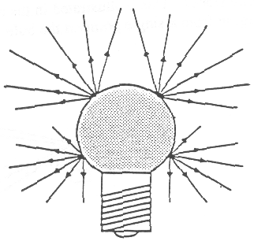
1 When a bulb is turned on, we assume that from each point on the bulb light travels outward in all directions in straight lines. That is, we assume light diverges from each point on the bulb.

To represent the direction that light travels we draw light rays, which are straight line segments with arrows. The light ray is a convenient geometric representation of the direction that light travels.

Even though in the sketch to the right we only draw a few light rays leaving just four points on the bulb, we must remember that light actually travels outward (i.e. diverges) from every point on the. bulb.

2. If we turn on a light bulb near a screen we know that the screen becomes uniformly illuminated. (No image of the bulb is formed on the screen.) We can explain this by assuming that light diverging from each point on the bulb travels outward in all directions and therefore strikes every point on the screen.
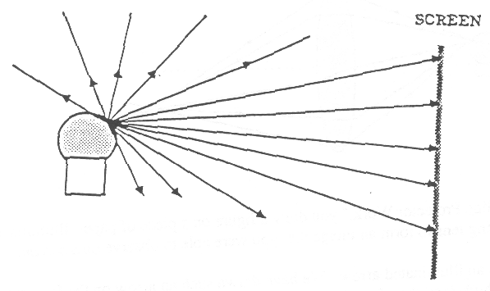
To make our following drawing simple, we have considered light diverging from only one representative point on the bulb. Of course we must remember that light is emitted from all over the bulb surface and all that light contributes to the screen illumination. We have simplified the picture because showing light rays originating from all over the bulb would make the picture much too complicated.

3. If we want to form a clear image of the bulb, the following criterion must be met: light diverging from each point on the bulb must be made to converge to a corresponding single point called an image point. To accomplish this, we must change the direction of the light. In a previous activity, “How Does Light Change Direction,” you may have observed how light refracts (changes direction) when passing through a prism. In the top sketch on the following page we have drawn two inverted prisms, one on top of the other, and we show four light rays diverging from a single point on the bulb. The rays converge after passing through the prisms. However, the light rays do not all converge to the same point, which is a necessary condition to form an image point. To ensure that light diverging from a single point on the bulb converges to a single image point, we would have to use a sequence of prisms with varying slopes. A converging lens is a device which can be thought of as being made from such a sequence of prisms with continuously varying slopes. This is illustrated in the middle two sketches. The bottom sketch shows how light diverging from a single point on the bulb will, after passing through a converging lens, converge to a single point.

4. In the activity, ‘‘How Does a Slide Projector Work-,” you drew a figure on a piece of paper, illuminated the paper, and then used a converging lens to form an image that you were able to observe on a screen.

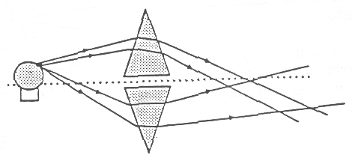
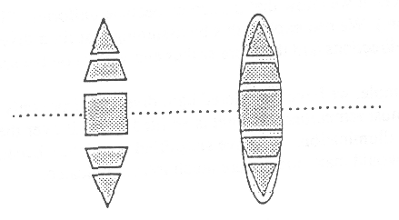
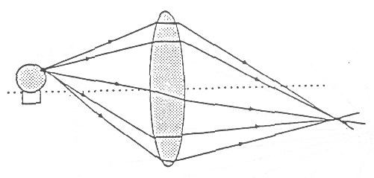

Let us assume that our figure is an illuminated arrow. We have drawn such an arrow on the following page. Even though this is not a light bulb (and therefore does not emit its own light), the fact that you can see it implies that light
BEHAVIOR OF LIGHT 4C1F

FOCUS ON PHYSICS
USING RAY DIAGRAMS TO DESCRIBE IMAGE FORMATION BY LENSES 2

must diffusely reflect off each point of the arrow and travel outward in all directions. We represent this by sketching light rays diverging from the LOP of the arrow.
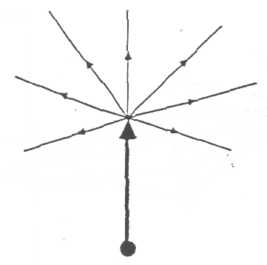
(We have not shown the light that shines on the arrow to illuminate it, because that would just make the sketch too confusing. Nor have we drawn light rays representing fight diverging from all the other pans of the arrow. Instead, for simplicity, we only show the light diverging from the top of the arrow.

5. Below we have drawn a diagram for the case of the illuminated arrow figure in front of a converging lens.
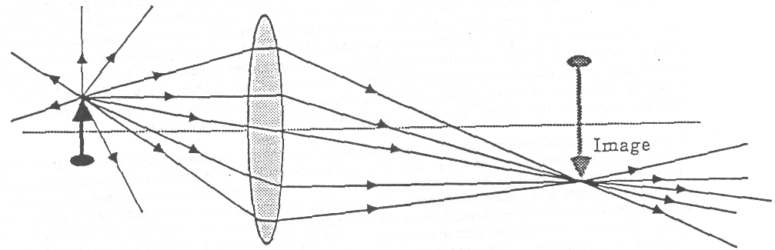

6. In the diagram above, we have shown how light leaves the top of the arrow and converges to its image point. We assume that light leaving every other point on the arrow also converges to its corresponding image point. We have not drawn any of these other light rays in the diagram because it would make the diagram too complicated. Instead we have just sketched where the entire image would be. This type of diagram, in which we show a few representative rays diverging from a point on an object, passing through the lens, and converging to a corresponding image point, is called a ray diagram for a converging lens.

(You might be curious as to how we know when drawing a diagram, exactly where the image will be. It turns out that there are a set of rules that enable us to figure it out. But we will not discuss those rules here. Our purpose in drawing the ray diagram was not to show you how to figure out where the image is located; instead, the purpose was to show you how light behaves when an image is formed.)

7. As you discovered in the lab, “How Does a Slide Projector Work,” for a given distance between the illuminated arrow figure and the lens, there is a unique position for the image. That unique position is where light leaving each point on the arrow converges to a corresponding single point. If the screen is placed at that unique position, a clear image will be seen on it (labeled CLEAR in the following sketch). Similarly, if the screen is moved farther from the lens, the light has already converged to a point and has begun to diverge again, so what appears on the screen is again a blurry patch of light (also labeled BLURRY).
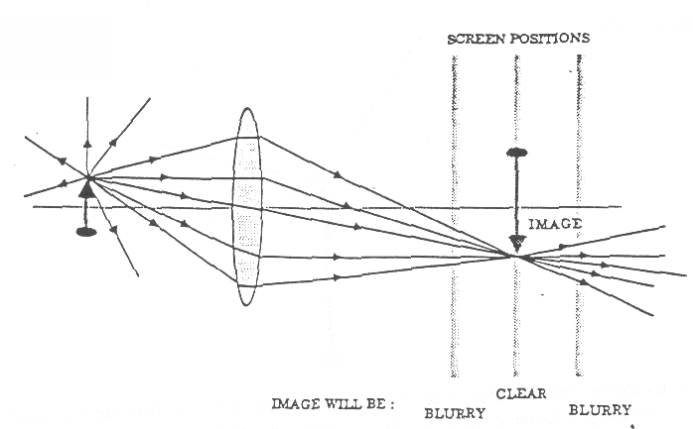

BEHAVIOR OF LIGHT 4C1F

FOCUS ON PHYSICS
USING RAY DIAGRAMS TO DESCRIBE IMAGE FORMATION BY LENSES 3

The situation with a pinhole image is quite different from the situation with a lens image. Recall that with the pinhole you were able to see a sharp pinhole image regardless of the distance the screen was from the pinhole. (As the screen was moved farther away, however, the pinhole image became larger and fainter.) In a sense, the pinhole image is a different kind of “image” than the one formed with a converging lens. In the lens case, light from each point on a object is refracted when passing through the lens, and converges to an image point at a single location. The screen, therefore, needs to be at that position for the sharpest image. In the pinhole case, however, light is not refracted when passing through the pinhole. Instead, from each pint on the object, only light traveling along the straight line from the object point to the pinhole will get through, and then it continues on the straight line to one point on the screen. Each point of illumination on the screen, then, corresponds to only one point on the object. That is why we see an “image” of the object on the screen. However, since light from a single object point does not converge when passing through the pinhole, the “image” will appear on the screen regardless of its position.

8. If a piece of cardboard were to cover the upper half of the lens, leaving the lower half uncovered, there would still be a complete image seen on the screen. It would just be dimmer. To understand how this comes about you must remember that light leaving each point on the arrow passes through the entire lens surface, and all that light converges to the same. image point. If part of the lens surface is covered, then light leaving each point on the arrow still passes through the uncovered part of the lens, and all that light still converges to the image. Because less total light gets to the image, it will appear less bright. Following, we show two ray diagrams for this situation. The top diagram shows light leaving the top of the arrow. The bottom diagram shows light leaving the bottom of the arrow.
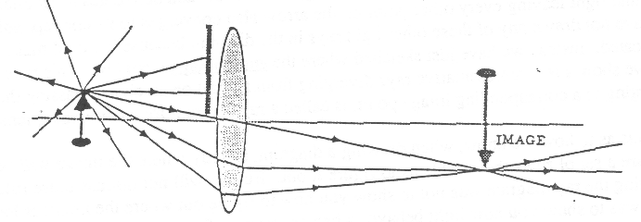

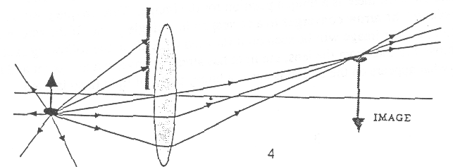

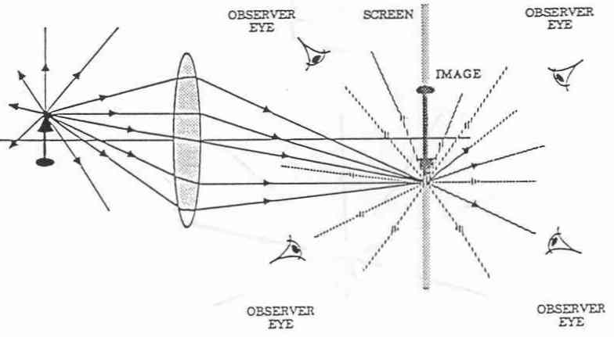
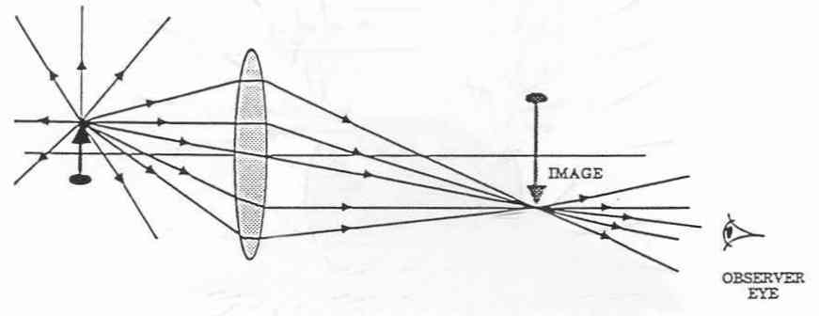
9. When the translucent screens is in the proper position for the image, light from each image point will be diffusely reflected from the screen or diffusely transmitted through the screen so that observers looking at the screen from many positions will see the image. (See the top Picture below.) If the screen is removed, however, light converging to each image point will not be stopped. Instead, the light will then diverge from each is positioned to receive this light, then the observer will be able to see the image. (See bottom sketch below.) It is still located at the exact same place as the screen had been previously. Therefore, the screen is really just a convenience to enable many people to observe the image at one time. The image can still be seen without the screen; it is just less convenient.

BEHAVIOR OF LIGHT 4D1F

FOCUS ON PHYSICS
POWER AND FOCAL LENGTH OF CONVERGING LENSES
(Discussion)

1. The power of a lens is a measure of the strength of the lens; that is, its effectiveness in bending light. The higher the power of a lens, the more it can bend light. The unit for lens power is the diopter abbreviated D. An 8 D lens has twice the power of a 4 D lens. (Prescriptions for corrective eye glasses are usually given in terms of diopters.)

2. All converging lenses are thicker at the center compared to the edges. The higher the ratio of the center thickness to the edge thickness, the higher the power of the lens. See the two side view sketches below.

3. A line drawn through the center of the lens, perpendicular to its two faces, is called the lens axis.

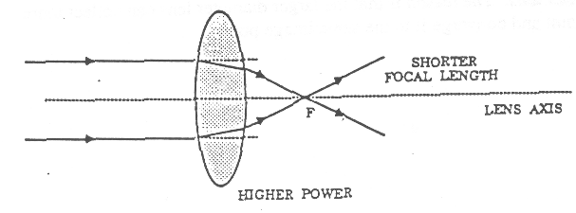
4. Light traveling toward the lens in a direction parallel to the lens axis will be bent by the lens so as to cross the. axis at a point defined to be the focal point of the lens. The focal point of each lens is labeled with an "F" in the sketch. (Actually a lens has two focal points, one on each side. Only one of them is shown in the sketch.) The distance between the center of the lens and the focal point is the focal length of the lens.

5. There is a simple relationship between the power of a lens and its focal length. The higher the power of a lens, the shorter its focal length. Conversely, the lower the power, the longer the focal length. This relationship is shown in the sketch.

6. In the activity, "How Does a Slide Projector Work," you found that. given a converging lens and an illuminated object, the position of the image (as well as its size) depends on the distance between the object and the lens. As you move the lens further away from the illuminated object, the distance between the lens and the image becomes smaller, but only up to a certain minimum value. If the illuminated object is very far away (like viewing an outdoor scene through a window), the distance between the lens and the image approaches its smallest value. This minimum distance corresponds to the focal length of the lens.

An experimental method for measuring the approximate focal length of a converging lens is the following. Aim the lens at a very distant object, like an outdoor scene through a window. Use a card or piece of paper for a screen and locate the position where the image is sharpest Measure the distance between the lens and the screen. This distance will be a good approximation to the focal length of the lens.

7. If you look over your data table for the activity, "How Does a Slide Projector Work," the last entry in the table under the last column, "Distance Between Lens and Screen Image," should have a value close to the value of the focal length of the lens. (That is because the lens was fairly far away from the illuminated object.) Notice also, that the first few entries in the same column have values that are greater than this. In other words, only when the lens is very far away from the illuminated object will the image be formed at a distance behind the lens that approaches the focal length. If the lens is not very far away, the image is formed further from the lens than the focal point.

8. Another characteristic of a lens, different from its focal length (or power), is its diameter . Whereas the focal length of a lens controls how far behind the lens an image will be formed, the diameter of the lens controls the brightness of the image. Consider two lenses of the same focal lengths, but different diameters. If they are both held the same distance in front of an illuminated object, they will both form images the same distance behind the lenses. The image formed by the larger diameter lens, however, will be brighter than the image formed by the smaller diameter lens. The reason is that the larger diameter lens can collect more light diverging from each object point and converge it to the same image point.

BEHAVIOR OF LIGHT 4D1F

POWER AND FOCAL LENGTH OF CONVERGING LENSES 2

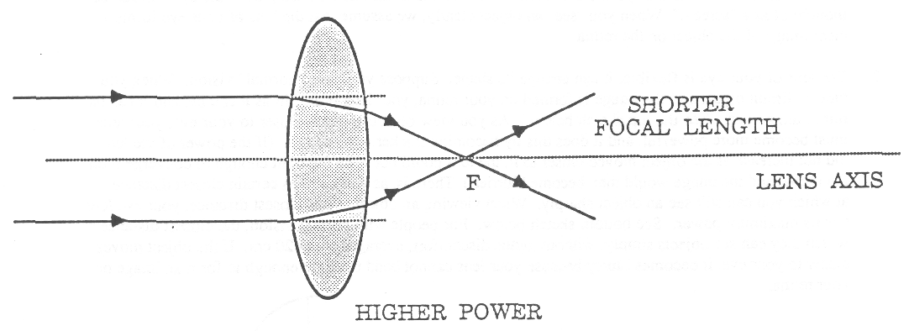

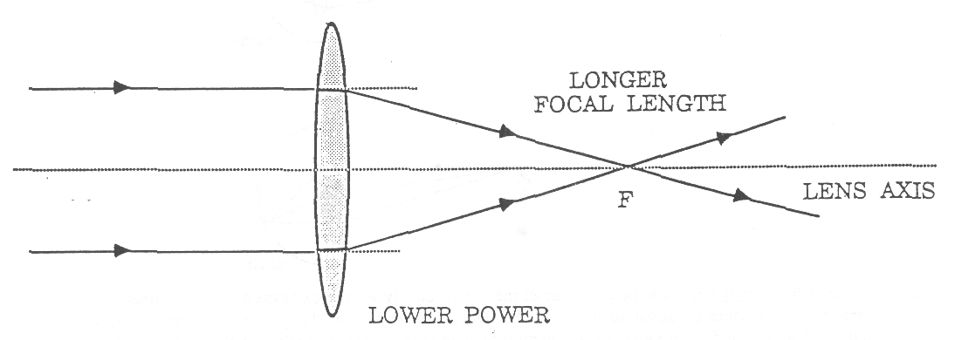

BEHAVIOR OF LIGHT 4D3F

FOCUS ON PHYSICS CORRECTIVE LENSES FOR EYE DEFECTS
(Discussion)

1. The eye consists of many parts, all of which work together to enable you to see objects clearly. (For more detail, see the OPERATION PHYSICS Color and Vision book.) To simplify our discussion, we will consider only the lens of the eye and the retina. The retina is located at the back part of the eye and ran be thought of as a "screen." When you "see" an object clearly, we assume that the lens of your eye forms a clear image of the object on the retina.

2. The lens of your eye is flexible, it can change its shape. Suppose you have "normal" vision. When you view a distant object and the image is formed on your retina, your lens is as thin as it can be, and it has its minimum power. (See the top sketch below.) As you view objects that are closer to your eye, your lens must become more powerful, and it does this by becoming thicker in its center. (If the power of the lens did not increase as the object moved closer to it, the lens could not bend the light enough to converge it on the retina, and the image would then become blurrier.) There is, as you know, a certain closest distance at which you can still see an object sharply. When viewing an object at this closest distance, your eye lens has its maximum power. See bottom sketch below. For people with normal vision, the closest distance at which they can see objects simply, without undue discomfort, averages about 20 cm. If the object moves closer to your eye, it becomes blurry because your lens cannot bend the light enough to form an image on your retina.

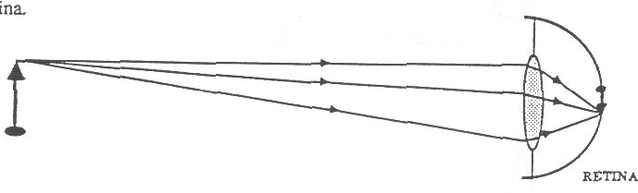
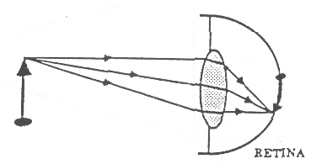

3. A person who is farsighted (or hyperopic) cannot see objects clearly when the objects are at the normal closest viewing distance (of about 20 cm or so). Farsighted people must hold objects much further away to see them clearly. The further away the person must hold an object to see it clearly, the greater the amount of farsightedness. This happens because the maximum power of the lens in the farsighted eye is lower than the maximum power of the lens in a normal eye. When an object is 20 cm or so in front of a farsighted eye, the lens cannot bend the light enough to form an image on the retina. (See the top sketch on the following page.)

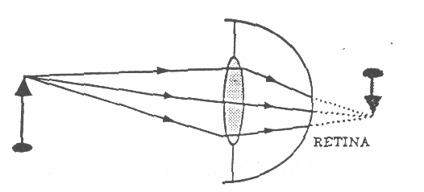
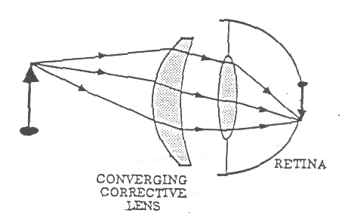
4. To enable a farsighted person to see nearby objects clearly, the person must add additional power (or extra bending ability) to the lens system of his or her eye. This can be accomplished by putting a converging lens in front of the eye. ( See the bottom sketch on the next page.) The greater the amount of farsightedness, the greater must be the power of the corrective converging lens.

BEHAVIOR OF LIGHT 4D3F

FOCUS ON PHYSICS CORRECTIVE LENSES FOR EYE DEFECTS 2
(Discussion)

5. A person who is nearsighted (or myopic) sees distant objects as being blurry. Without corrective lenses, there is a certain maximum distance at which the person can see objects clearly. Beyond this maximum distance the objects blur. The shorter this maximum distance is, the greater the amount of nearsightedness. The reason for nearsightedness is that the minimum power of the eye lens is too high. Light from the distant object bends too much, and the image of the distant object is formed in front of the retina. (See the top illustration below.)

6. To enable a nearsighted person to see distant objects clearly, the person must subtract power from the lens system of his or her eye. This can be accomplished by putting a diverging lens in front of the eye. Diverging lenses have negative power. The diverging lens will cause the light from the distant object to spread out more before entering the eye. (See the bottom sketch below.) The greater the amount of nearsightedness, the greater must be the negative power of the corrective diverging lens.
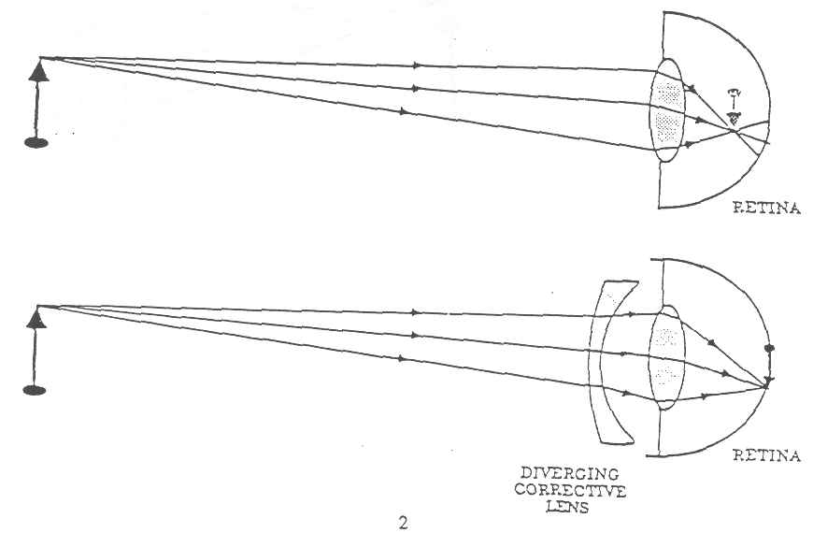

BEHAVIOR OF LIGHT 4D3F

THE NORMAL EYE
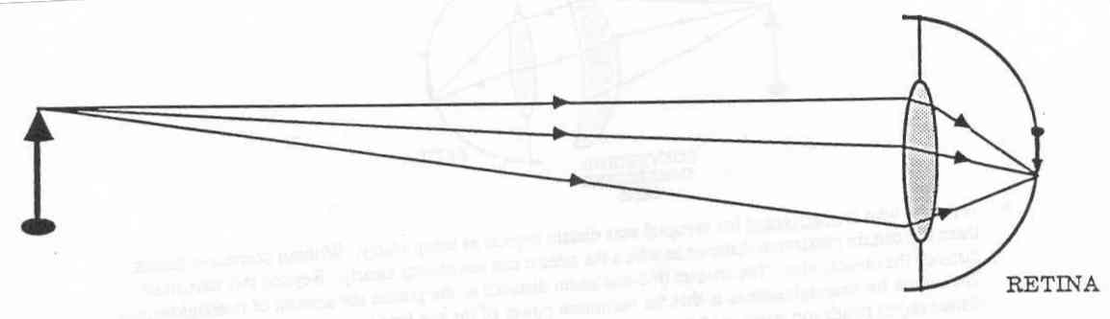

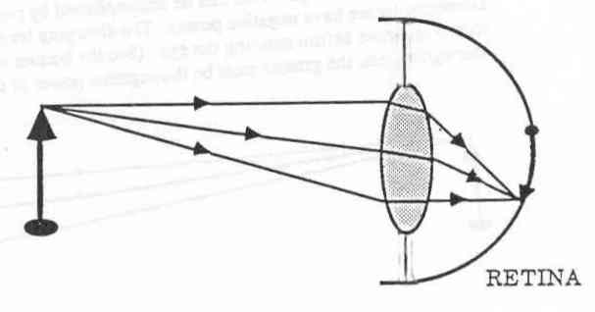

THE FARSIGHTED EYE
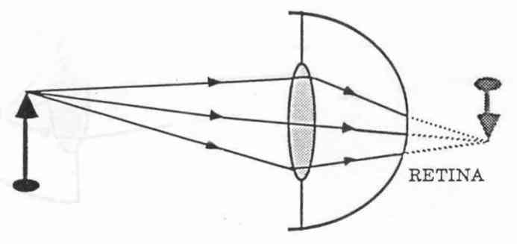

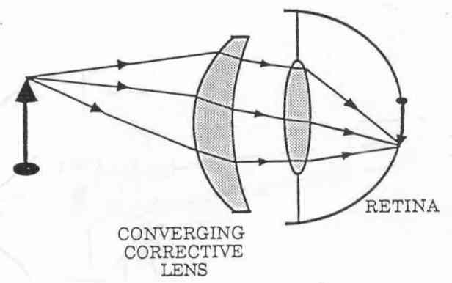

THE NEARSIGHTED EYE
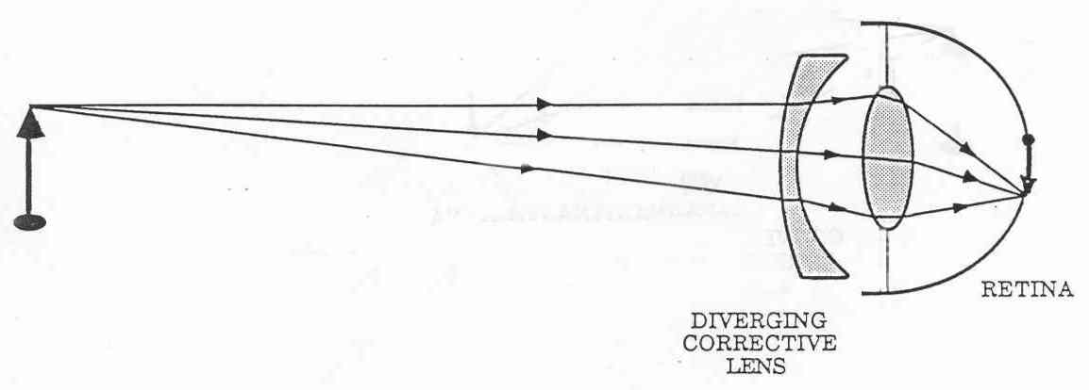
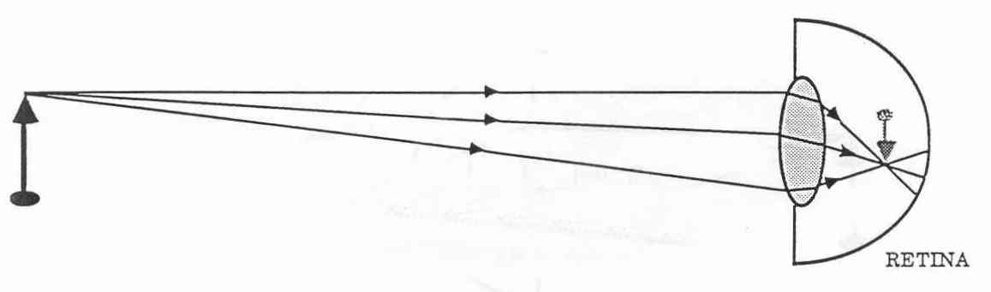

BEHAVIOR OF LIGHT 4D5

FOCUS ON PHYSICS
SEEING A POINT

In order to "see" a point on an object, light diverging from that point must enter the eye, pass through the lens, and be converged to a point at the surface of the retina. Figure 1 on the next page shows a ray diagram to represent this convergence. (We only represent light leaving the Lop of the object, but the same process occurs for every point on the object that will be "seen.")

Unlike solid glass or plastic lenses, the lens of the eye is made of flexible material, which enables it to change its shape. As an object moves closer to the observer, the lens of the eye must increase its power in order to converge the light to the retina. The lens increases its power by increasing its thickness at its center. Figures I through 3 represent the situation as an object moves closer to the lens.

There is a limit to how thick the lens can become, and hence, there is a maximum value for its power. This is why each person can see an object clearly only up to a certain minimum distance from the eye. If the object were closer to the eye than this near point distance, the object would appear blurry. (The value of the near point distance varies from person to person. A farsighted person has a greater near point distance than a person with normal vision.)
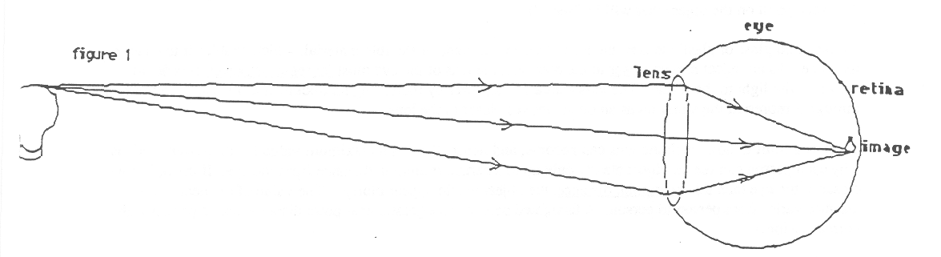

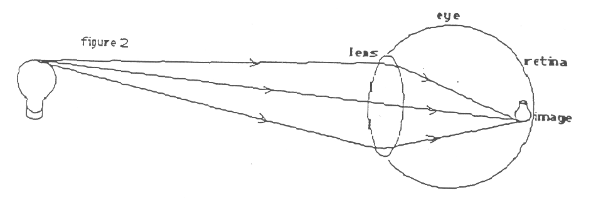

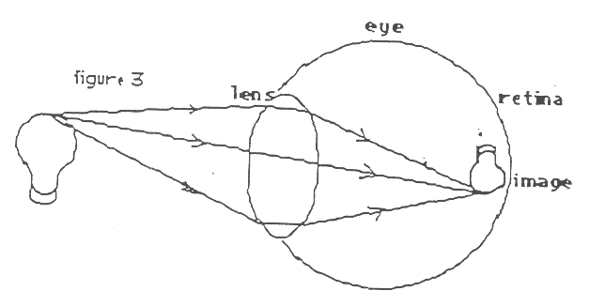

BEHAVIOR OF LIGHT 4E1

HOW DOES A TELESCOPE WORK?

Materials: 2 sets of double magnifiers
plain white card to use as a screen
card with hole the diameter of the smallest of the converging lenses
ruler
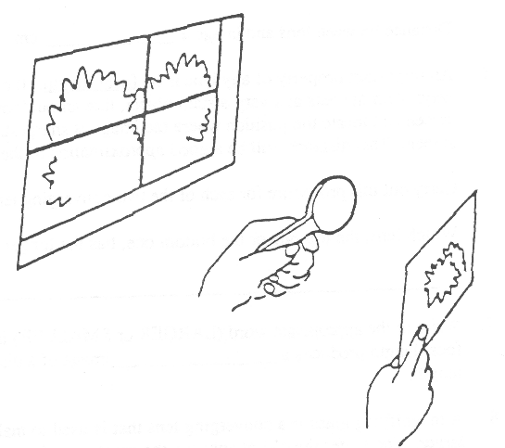
1 The double magnifier has two lenses, a larger "top" lens and a smaller "bottom" lens. For this part of the activity, you will use only the top lens. Cover the bottom lens with your fingers and aim the top lens toward an outdoor scene through a window. Using the blank card as a screen, move it back and forth behind the lens until you see a clear image on the card. Using the ruler, measure both the size (height) of the image and its distance behind the lens. Record your values here (in cm):

TOP LENS
Size of image = _______________cm
Distance between lens and image = __________________ CM cm

2. Notice the card with the hole. Do not pick it up yet. We want you first to make a prediction. If you were to put the card against the front of the top lens, with the hole over the center of the lens, what do you predict will happen to the image on the screen?
________________________________________________________________________________________________
________________________________________________________________________________________________
3. Test your prediction by actually putting the card against the front surface of the top lens. Describe how the image on the screen is different, if at all, from the way it was without the card (in step 1).
________________________________________________________________________________________________
________________________________________________________________________________________________
4. Based on your observations in steps I through 3, answer the following question. For a given lens, does the amount of its surface that is exposed to the light affect either the size of the image on the screen or the distance that the image is formed behind the lens?

5. Now cover the top lens with your hand and aim the bottom lens at the same outdoor scene through the window. Move the screen back and forth be " hind the lens until you see a clear image on the screen. Measure and record below both the size of the image (its height) and its distance behind the lens.

BOTTOM LENS
Size of image = ____________ cm
Distance between lens and image = ____________ cm
6. An important property of any lens is its focal length. It can be estimated experimentally in the following way: Aim the lens at a very distant object, like an outdoor scene through a window. Use a white card as a screen and locate the position where the image is sharpest. Measure the distance between the lens and the screen. This distance will be a good approximation to the focal length of the lens.

Carry out this procedure for each of the two converging lenses.

Which lens, the top one or the bottom one, has the longer focal length?
________________________________________________________________________________________________
BEHAVIOR OF LIGHT 4E1

HOW DOES A TELESCOPE WORK? 2

7. Write in the appropriate word (LARGER or SMALLER) in the following sentence. A lens with a longer focal length produces a image of a distant scene than does a lens with a shorter focal length.

8. A magnifying glass is a converging lens that is used to make a small object that is close to your eye appear larger. The larger the object appears, the greater the "magnifying power" of the lens. You will now determine which of the two converging lenses, either the top lens or the bottom lens, has the greater magnifying power.

You will use each of the converging lenses as a magnifying glass to look at some of the letters on this page of print. The proper way to use a magnifying glass is to hold the lens against your eye and get as close as You possibly can to the letters until the letters appear as large and as clear as possible.

First use the top lens as a magnifying glass, and then use the bottom lens as a magnifying glass. For which lens do the letters appear the largest?
________________________________________________________________________________________________
9. Which lens, then, seems to have the greater magnifying power?
________________________________________________________________________________________________
10. Write in the appropriate word (LONGER or SHORTER) in the following sentence. When choosing a lens to use
as a magnifying glass, to have the object appear as large as possible, use the lens with the ______________________ focal length.

11. (For the remainder of this activity, you will need both magnifier sets.) A telescope is used to look at objects that are very far away. It usually consists of two lenses. The lens that is aimed at the distant object is called the objective; the lens closest to your eye is called the eyepiece.

For an objective, you should choose the lens that produces the largest image of distant objects. Which of the two lenses, the top one or the bottom one, would be the best objective lens?
________________________________________________________________________________________________
12. For the eyepiece of a telescope, you should choose the lens which would be the best magnifying glass. Which of the two lenses, the top one or the bottom one, would be the best eyepiece?
________________________________________________________________________________________________
13. To make a telescope, you and your partner will have to work together. Your partner should hold the objective lens in one hand and the blank card screen in the other. He or she should then aim the objective lens out the window at a distant scene and move the card back and forth until a clear image is seen on it. You should stand directly behind the card. Hold the eyepiece against your eye and use, it as a magnifying glass to view the image seen on the card, just like you did in step 8 when you viewed the letters on this page.
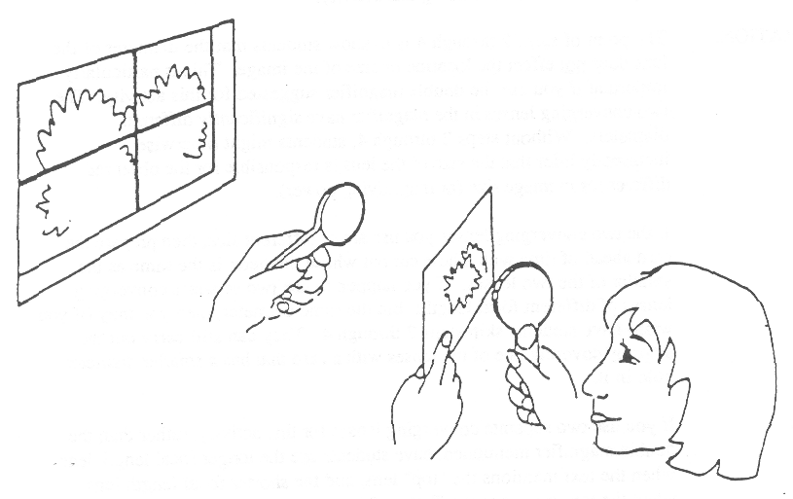

When you are lined up properly, have your partner remove, the card! - You may have to adjust your head or eyepiece slightly, but you should still be able to see a magnified image of the distant scene. If so, you are looking through a telescope!

BEHAVIOR OF LIGHT 4E1TN

HOW DOES A TELESCOPE WORK?

IDEA: PROCESS SKILLS:
An important characteristic of a lens is its focal Inferring
length. Longer focal length lenses form larger Predicting
images of distant objects. Shorter focal length
lenses are better magnifying glasses. A
telescope consists of a long focal length
objective and a short focal length eyepiece.

LEVEL: U DURATION: 40 Minutes

STUDENT BACKGROUND: Students should have completed the activity on “How Does a Slide Projector Work” before doing this activity.

ADVANCED PREPARATION: The point of steps 2 through 4 is to show students that the diameter of the lens does not effect the location or size of the image. This is particularly important if you use the double magnifier suggested for this activity. The two converging lenses in the magnifier have significantly different diameters. Without steps 2 through 4, students might otherwise incorrectly infer that the size, of the lens is responsible for the observed differences in image size (or magnifying power).

If the two converging lenses you use are of different size, then prepare the card ahead of Lime with a hole cut out whose diameter is the same as the smaller of the two lenses. If you happen to use two separate converging lenses of different focal lengths, but the same diameter, then you may (if you wish) have students skip steps 2 through 4. They can still carry out the steps by covering one of the lenses with a card that has a smaller diameter hole in it.

MANAGEMENT TIPS: If you use two separate converging lenses for this activity, rather than the double magnifier mentioned, have students use the longer focal length lens when the text mentions the “top” lens, and the shorter focal length lens when the text mentions the “bottom” lens.

In step 8, make sure that the students are using the converging lens correctly as a magnifying glass. They should hold it against their eye and should be getting very close to the paper. Students who wear eyeglasses might want to remove them for this step in the activity.

In step 13, the students may need some help in setting up the two lenses. Make sure that the student who is looking through the eyepiece is holding the bottom lens right up against his or her eye. Also, when the cardboard screen is removed, in order for the student to see what is expected, it is important that the distant scene, the objective lens, and the eyepiece all lay in a straight line.
RESPONSES TO
SOME QUESTIONS: 1. Size of image = varies, but typically 3-5 cm. Distance between lens and image = 8 cm

2. Many people will predict that the entire image will be smaller, or that less of the image (only the central part) will be seen.

3. It will only appear a little dimmer. The size of the image and its distance from the lens will be the same as it was before.
BEHAVIOR OF LIGHT 4E1TN

HOW DOES A TELESCOPE WORK? 2

4. No, it does not.
5. Size of image = varies, but should be about one half as large as the image with the top lens. Distance between lens and image 4 cm

6. The top lens has the longer focal length because it formed the larger image of the outdoor scene on the card.

8. When looking through the bottom lens, the letters appear larger than when looking through the top lens.

9. The bottom lens would have the greater magnifying power because it makes the letters appear larger.

11. The top lens (because it has the longest focal length and therefore produces the largest image of a distant scene).

12. The bottom lens (because it has the shortest focal length and therefore would be the best magnifying glass).

POINTS TO EMPHASIZE
IN SUMMARY DISCUSSION: 1. The longer the focal length of a lens, the larger an image it forms of a distant scene.

2. The shorter the focal length of a lens, the greater its magnifying power when used as a magnifying glass.

3. The two converging lenses are used in a telescope in the following way. The long focal length “objective” lens gives you a relatively large image of a distant scene. Then the short focal length “eyepiece” lens magnifies the image for you so you can see the details more clearly.

4. The size (diameter) of the lens does not determine its focal length. Nor does the size of the lens determine the size or location of an image formed on a screen. The size of the lens only determines the brightness of the image. Telescopes with the largest diameter objective lenses can produce the brightest images of distant stars.

POSSIBLE EXTENSIONS: The focal length of a lens is determined mainly by the ratio of the thickness of the lens at its center, to the thickness at its edges. The greater this ratio, the shorter will be the focal length. (This idea is discussed in the Focus On Physics section, “Power and Focal Length.”) This can be demonstrated by making available for student handling several converging lenses of approximately equal diameters, but widely varying focal lengths. If the students can feel these lenses, they should notice that the shorter focal length lenses tend to be much thicker than the longer focal length lenses.

BEHAVIOR OF LIGHT 4E2F

FOCUS ON PHYSICS
VIRTUAL IMAGES AND THE MAGNIFYING GLASS
(Discussion)

When a converging lens is used as a magnifying glass, the lens is always held so that the distance between the lens and the (small) object is less than (or equal to) the focal length of the lens. Under these circumstances, light leaving each point on the object passes through the lens and diverges, rather than converging to a point. The light spreads out so as to appear to originate from an image on the same side of the lens as the object. If you put your eye near the lens, you will then see the image at this position. Because light from the object never actually passes through this image, it is called a virtual image. See the sketch below.

(You have observed other examples of virtual images. Plane mirrors, convex mirrors, and diverging lenses always produce virtual images. A concave mirror only produces a virtual image if the object is close enough to it.)
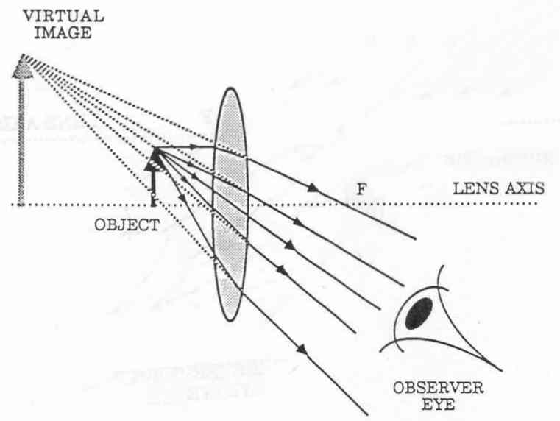

BEHAVIOR OF LIGHT 4E3

WHERE IS THE IMAGE SEEN THROUGH A MAGNIFYING GLASS ?

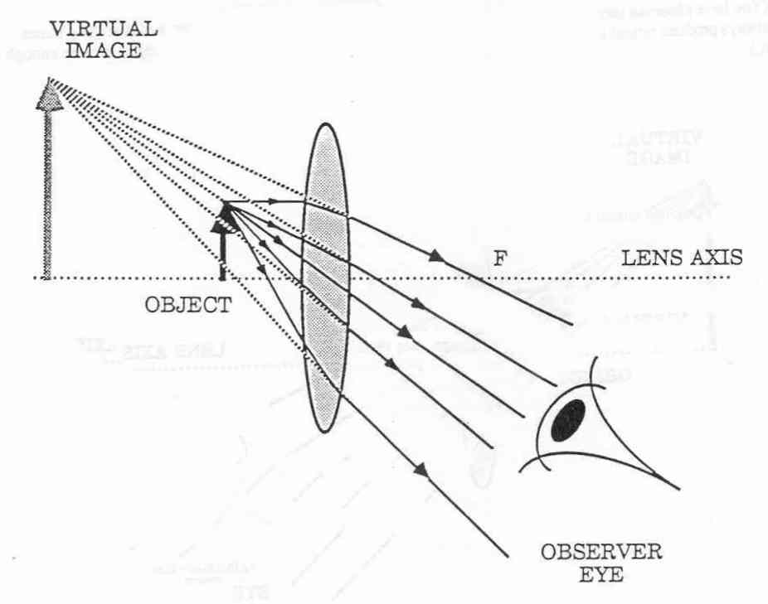

BEHAVIOR OF LIGHT 5WL

WORKSHOP LEADER’S PLANNING GUIDE
WAVE PROPERTIES OF LIGHT

In this section students will study some of the properties of transverse waves on a spring. These properties will then be discussed in terms of light (and electromagnetic waves in general). Two examples of optical phenomena will then be investigated: interference and polarization, Both of these can only be explained by assuming that light is a form of wave motion. Polarization also provides evidence that light is a transverse wave. This entire section is conceptually more difficult than previous sections of this book, and is suitable only for students with the appropriate background.

An additional section on wave motion, including observations of water waves, and a discussion of longitudinal type waves, is provided in the OPERATION PHYSICS Sound book.

Naive Ideas:

1. When a wave moves through a medium, particles of the medium move along with the wave. (5A1, 5B1)

2. Gamma rays, X-rays, ultraviolet light, visible light, infrared light, microwaves, and radio waves are all very different entities. (5B2F)

3. When two pulses traveling in opposite directions along a spring (or rope) meet, they bounce off each other and go back in the opposite direction. (5C1)

4. Colors appearing in soap films are the same colors that appear in a rainbow. (5C3)

5. Polaroid sunglasses are just dark glass or dark plastic. (5D1)

A. WAVE MOTION IS A METHOD TO TRANSFER ENERGY FROM ONE PLACE TO ANOTHER WITHOUT THE MOVEMENT OF MATTER. THE GREATER THE AMPLITUDE OF THE WAVE (OR PULSE), THE GREATER THE ENERGY CARRIED BY THE WAVE (OR PULSE). WAVES TRAVEL WITH A CERTAIN SPEED AND CAN BE REFLECTED FROM BOUNDARIES,

I. Activity: What Are Some Of the Properties Of Pulses?

Students generate pulses that travel along a long spring or slinky, and observe some of the pulse’s properties: mode of propagation, speed, reflection, and energy transfer.

B. WAVES CAN BE CHARACTERIZED AS HAVING AN AMPLITUDE. WAVELENGTH. FREQUENCY, AND A WAVE SPEED. WAVELENGTH AND FREQUENCY ARE INVERSELY RELATED.

1. Activity: What Are Some Of the Properties Of Waves?

This activity is carried out as a demonstration. The instructor demonstrates traveling waves and the terms amplitude, wavelength, frequency, and wave speed are defined. Then, the students infer a general relationship between wavelength and frequency. There is an option for students to do some numerical calculations using the relationship: wave speed = wavelength times frequency.

2. Focus On Physics: Thinking Of Light As Waves

The general properties of waves discussed in 5B1 are related to light. There is also a brief discussion of electromagnetic waves.

BEHAVIOR OF LIGHT 5WL

WORKSHOP LEADER’S PLANNING GUIDE
WAVE PROPERTIES OF LIGHT - 2

C. INTERFERENCE OF WAVES OCCURS WHENEVER TWO WAVES PASS THROUGH THE SAME PLACE AT THE SAME TIME. DEPENDING ON HOW THE TWO WAVES COME TOGETHER. THE RESULT WILL BE A SINGLE WAVE WITH EITHER AN ENHANCED AMPLITUDE, A DIMINISHED AMPLITUDE, OR ZERO AMPLITUDE (NO WAVE AT ALL).

1. Activity: How Do Pulses Interfere?

This activity will be demonstrated by the instructor, with help from some students. Constructive and destructive interference of pulses traveling along a long, coiled spring are observed.

2. Demonstration/Discussion: Addition and Subtraction Of Colored Lights

This demonstration should be carried out only if the following activity, “What Makes the Colors In Soap Bubbles?” is going to be performed by the students. Otherwise, this demonstration can be skipped. ‘Me purpose of the demonstration is to show students the simple rules for color addition and color subtraction, so they will be able to understand how some of the interference colors arise in the soap bubble activity.

3. Activity: What Makes the Colors In Soap Bubbles?

Students assemble a flat bubble-maker, and observe interference fringes first using colored light, and then white light. In the first case, the fringes are alternately the color of the light and dark; in the second case, the fringes are different colors, but they are not all the same colors that are seen in a rainbow.

4. Overheads (2):
a) Constructive and Destructive Interference
b) Destructive Interference in a Soap Film

D. A POLARIZED WAVE Is ONE IN WHICH ALL THE VIBRATIONS IN THE WAVE ARE IN ONE PLANE, THE OBSERVATION THAT LIGHT CAN BE POLARIZED PROVIDES EVIDENCE THAT IT IS A TRANSVERSE TYPE WAVE, POLARIZED LIGHT WILL VARY IN BRIGHTNESS WHEN VIEWED THROUGH A POLAROID FILTER THAT IS BEING ROTATED.

1. Activity: What Is Polarized Light?

Students use Polaroid filters to study several examples of polarized light, including transmission through two Polaroids, the polarization of reflected light and of sky light, and what happens when cellophane tape is viewed between two Polaroids.

2. Overhead: Polarized Light Analogy

This overhead shows a wave along a rope passing through a rectangular slot. This situation is analogous to light waves passing through sheets of Polaroid. The direction of the vertical slot for the waves on the rope is analogous to the transmission axis of the Polaroid for light.

